
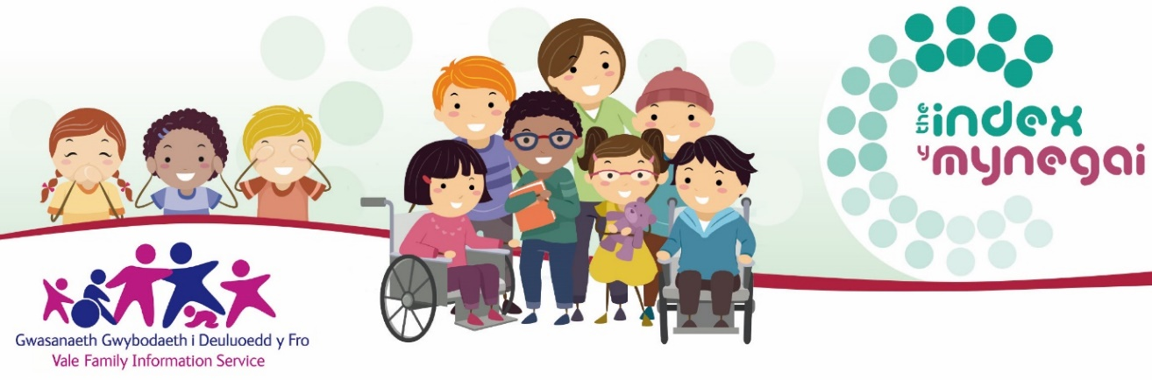
Step by Step Instructions to the Childcare Information Wales website
Enter this link into your browser: http://www.childcareinformation.wales/home
    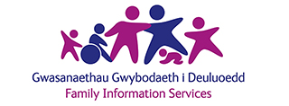   | What is the Childcare Information Wales website?  This website offers you free, trusted information on what matters to you and your family from your local family information service.  The website is developed and hosted by Data Cymru on behalf of the Family Information Service Network in Wales.  It is powered by Dewis Cymru, The place for well-being information in Wales.
 | What do I do next?  Select Vale of Glamorgan from the drop down menu.
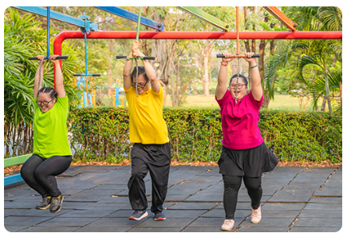 | How do I find activities for children with disabilities or additional needs?  Scroll down to the bottom of the page. The final tile* with the same picture here is there for you to select.  *A tile is a clickable button on an image.
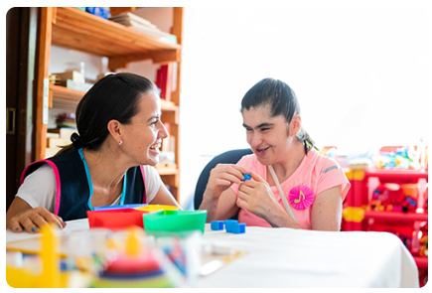 | How do I find specialist support services for children with disabilities or additional needs?  Scroll down to the bottom of the page. The final tile with the same picture here is there for you to select.  *A tile is a clickable button on an image.
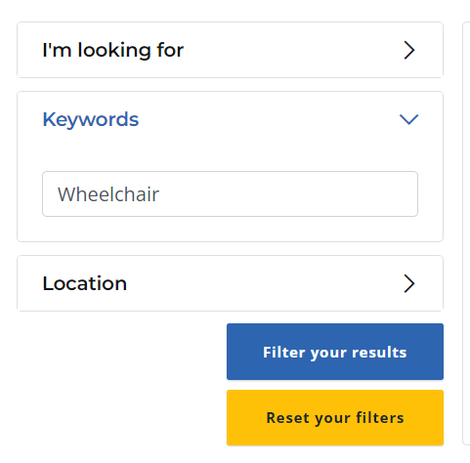 | I am looking for Wheelchair training, how can I check such a thing exists in the Vale of Glamorgan?  - Go to the activities tile.  - Look to the left side of the page.  - Select the down arrow next to keywords to open the box.  - Add the word wheelchair into the box.  - Select the Filter your results blue button at the bottom of this menu. This will filter all activities for wheelchair users.
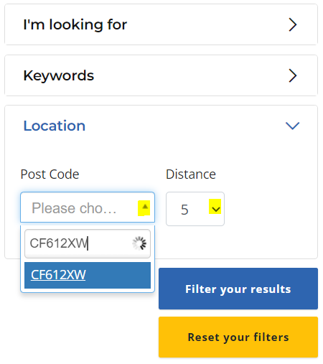 | I am looking for a gymnastics club that can cater for my childs additional learning needs and is close to home or easily accessed on a public transport route as I do not drive?  - Go to the activities tile.  - Look to the left side of the page.  - Select the down arrow next to keywords to open the box.  - Add the word Gymnastics into the box.  - Select the down arrow in the Post Code box.  - Enter your home post code and how many miles away from home you are looking to consider.  - Select the Filter your results blue button at the bottom of this menu. This will filter all accessible gymnastics clubs within that distance to your home postcode.  - Click any of the options that come up to learn more about it and to get further contact details should you wish to get in touch.
 | I’m really struggling to find the information I am looking for. Who can help me?  You can speak to any member of staff at the Vale Family Information Service.  Telephone: 01446 704704  Opening hours: 08:30am – 5:00pm

