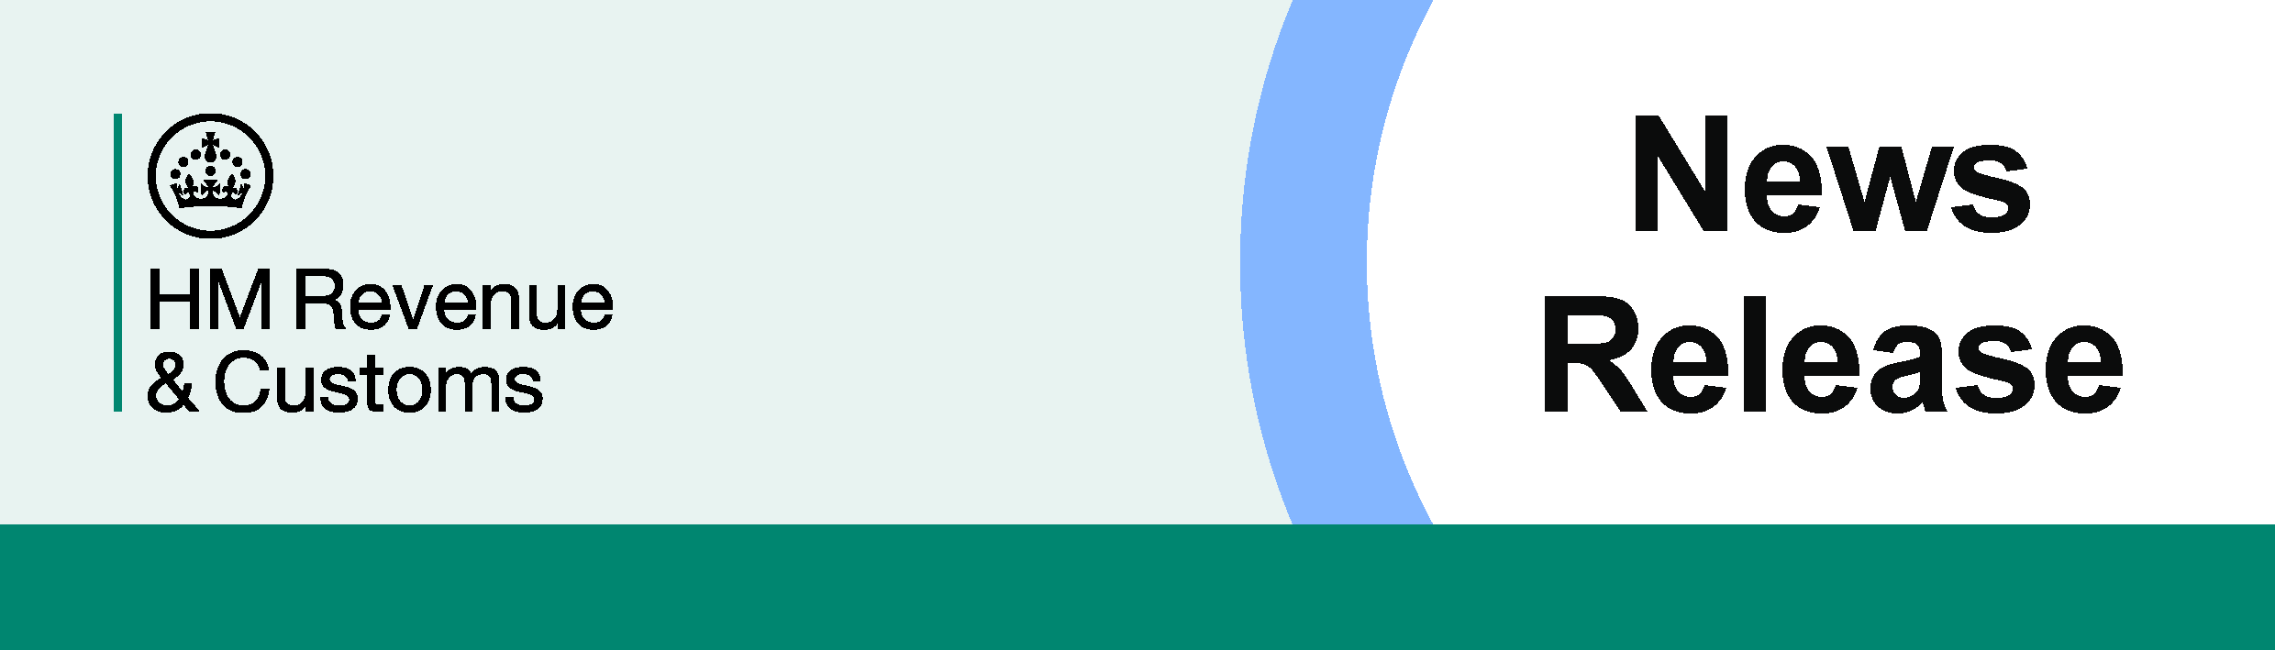
1.5 million

For the attention of News Desks No. of pages: XX
Date:18 May 2026 Ref: NATXX/26

New parents urged to claim Child Benefit for their baby now

- 6.8 million families are claiming Child Benefit.
- More than 30% of new parents are missing out on payments by not claiming in their baby’s first year.
- Parents urged to claim via the HMRC app to ensure they get their payment as quickly as possible.

One in three new parents are missing out on Child Benefit payments in their baby’s first year, new figures reveal.
HM Revenue and Customs (HMRC) is urging parents who welcomed a baby this Spring to claim now via the HMRC app or online at GOV.UK.
While more than 6.8 million parents received Child Benefit in the year to August 2025, only 68.8% of them claimed the crucial government support before their baby’s first birthday.
More than 140,000 babies were born between April and June last year and while many parents are enjoying new beginnings this Spring, the latest statistics show thousands of families could be missing out on much-needed cash by delaying their claim.
Child Benefit is worth £27.05 per week - or £1,406.60 a year - for the eldest or only child and £17.90 per week - or £930.80 a year - for each additional child, with no limit as to how many children parents can claim for.
Myrtle Lloyd, HMRC’s Chief Customer Officer, said:
“Spring is a wonderful time to welcome a baby and claiming Child Benefit as soon as possible means your family can benefit from much-needed financial support.
“It is quick and easy to claim Child Benefit via the HMRC app at a time that suits you.”
Child Benefit can be claimed 48 hours after the baby’s birth is registered but can only be backdated for up to 3 months from the date HMRC receives the claim, meaning thousands of families are not getting what they’re entitled to receive.
Parents can access their Child Benefit account quickly and easily via the HMRC app.
In a recent survey, half of parents with children under the age of 18 said that they would like to be able to conduct all of their tax matters digitally.
To make a new claim for Child Benefit, parents can create an online HMRC account and will need:
- child’s birth or adoption certificate
- bank details
- National Insurance number for themselves and their partner, if they have one
- child's original birth or adoption certificate and passport or travel document, for children born outside the UK.

HMRC has released a YouTube video explaining how parents can make a claim, with payments usually paid every 4 weeks automatically into a bank account.
If a claimant or their partner has an income of more than £60,000 a year, they will be liable to pay the High-Income Child Benefit Charge (HICBC), with more information including about how to pay on the HICBC PAYE digital service on GOV.UK.

Notes to Editors
- Latest statistics to August 2025 were released in April 2026.
- Birth rate figures.
- More information on Child Benefit.
- Child Benefit claimants receive National Insurance (NI) credits which count towards their future eligibility for the State Pension. This can help people who are not in paid employment and not receiving NI credits through their employer or other routes, such as Universal Credit.
- Claiming Child Benefit also makes sure the child automatically gets their National Insurance number when they turn 16.
- The Child Benefit award notice can be used to prove you qualify for Child Benefit and can be downloaded and printed from the HMRC app or from GOV.UK. Parents and carers may need proof of entitlement to access other benefits and services.
- The HICBC PAYE digital service gives eligible parents the option to pay the charge through their salary, rather than completing a Self Assessment tax return, if they have no other reason to file a tax return.
- People who switch to HICBC PAYE digital service need to call HMRC to deregister from Self Assessment.
- Families who have previously opted out of Child Benefit payments can opt back in and restart their payments quickly and easily on the HMRC app or online.
- A person living in a household subject to the HICBC will still receive National Insurance credits if they claim Child Benefit but choose to opt out of receiving payments.
- An HMRC survey found that 49.83% of 1,468 surveyed parents with dependent children aged under 18 and living at home, would prefer to conduct all their tax affairs online or digitally.
- Follow HMRC’s Press Office on X @HMRCpressoffice

Issued by HM Revenue & Customs Press Office

Press enquiries only please contact:
Press Officer:
Tel:
Email:
Out of hours
Tel: 03000 538 775
Website www.gov.uk/hmrc

