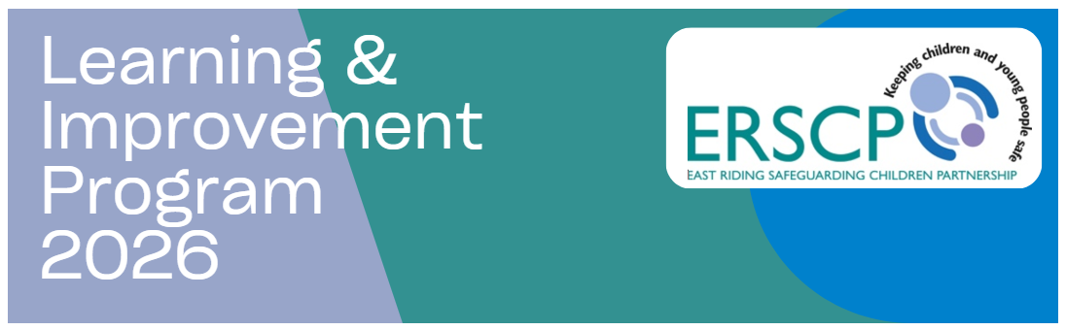
The ERSCP are pleased to announce the following calendar of free training for colleagues across the Partnership.
We are delighted to be able to provide such a varied offer and would like to extend our thanks to all the partner agencies who help to make this possible.

To book your place please click on the date that you require for any of the training sessions below.

Training Event | Date | Time | Venue
Briefing on the RIT Risk Indicator Tool (virtual) | 03/02/26  19/05/26  11/08/26  03/11/26 | 09:30 – 10:30  16:00 – 17:00  09:30 – 10:30  16:00 – 17:00 | Microsoft Teams  Microsoft Teams  Microsoft Teams  Microsoft Teams
Child Exploitation including Modern Slavery and NRM (face to face) | 11/02/26  10/06/26  14/10/26 | 09:30 – 16:30  09:30 – 16:30  09:30 – 16:30 | Westwood Room, County Hall  Room 11, County Hall  Kreis Lippe, County Hall
Child Protection Medicals (virtual) | 18/02/26  18/06/26  18/11/26 | 15:30 – 16:30  15:30 – 16:30  15:30 – 16:30 | Microsoft Teams  Microsoft Teams  Microsoft Teams
Coercive Control Workshop (virtual) | 10/02/26  10/06/26  19/10/26 | 09:30 – 11:00  15:00 – 16:30  10:30 – 12:00 | Microsoft Teams  Microsoft Teams  Microsoft Teams
DASH Checklist and MARAC Workshop (virtual) | 21/01/26  19/05/26  15/10/26 | 09:30 – 12:30  09:30 – 12:30  09:30 – 12:30 | Microsoft Teams  Microsoft Teams  Microsoft Teams
Domestic Abuse Practitioner Standard Training L1: Domestic Abuse Awareness (virtual) | 06/02/26  27/04/26  17/06/26  22/09/26  05/11/26 | 09:00 – 12:30  13:00 – 16:30  09:00 – 12:30  13:00 – 16:30  09:00 – 12:30 | Microsoft Teams  Microsoft Teams  Microsoft Teams  Microsoft Teams  Microsoft Teams
Domestic Abuse Practitioner Standard Training L2: Ask & Action (face to face) | 21/04/26  02/07/26  28/10/26  17/11/26 | 09:30 – 16:30  09:30 – 16:30  09:30 – 16:30  09:30 – 16:30 | Bridlington North Library  County Hall Beverley  Adult Ed Goole  Beverley TBC
Domestic Abuse Practitioner Standard Training L3: The Trusted Professional (face to face 3 x full days plus 1 x half day follow up*)  *Please note: Level 3 is comprised over three separate modules. These last a full day each and all three days need attending to complete the training. Please ensure that you are available on each module day and book each day separately.  The Level 3 modules are available in the following packages:  - 03 March, 15 April, 14 May  - 01 June, 14 July and 15 September  - 01 October, 03 November and 02 December  Learners are also expected to attend the follow up Module 4 Reflective Practice session which is half a day. Please ensure you can attend the half day follow up that corresponds with your 3-day training:  - 03 March, 15 April, 14 May = 26 June follow up  - 01 June, 14 July and 15 September = 22 October follow up  - 01 October, 03 November and 02 December = 14 January 2027 follow up | Module 1 x 1 day  03/03/26  01/06/26  01/10/26  Module 2 x 1 day  15/04/26  14/07/26  03/11/26  Module 3 x 1 day  14/05/26  15/09/26  02/12/26  Reflective Practice x 1 half day  26/06/26  22/10/26  14/01/27 | 09:00 – 16:30  09:00 – 16:30  09:00 – 16:30  09:00 – 16:30  09:00 – 16:30  09:00 – 16:30  09:00 – 16:30  09:00 – 16:30  09:00 – 16:30  09:30 – 12:30  13:30 – 16:30  09:30 – 12:30 | Bridlington North Library  County Hall Beverley  Work Link Cottingham  Bridlington North Library  County Hall Beverley  Work Link Cottingham  Bridlington North Library  Beverley TBC  Beverley TBC  Microsoft Teams  Microsoft Teams  Microsoft Teams
Drug & Alcohol Awareness Training NEW | 13/03/26  More dates TBC | 09:30 – 12:30 | County Hall Beverley
Gambling and Gaming Workshop (virtual) | 19/03/26  More dates TBC | 10:00 – 11:30 | Microsoft Teams
Graded Care Profile Training (GCP2 Tool) (face to face) | 13/05/26  14/10/26 | 09:30 – 16:30  09:30 – 16:30 | County Hall Beverley  Beverley TBC
Learning From the Past: Local Serious Safeguarding Incidents and Partnership Working (virtual) | These will be announced throughout the year in line with emerging relevant audit themes.
Oral Health Practitioner Awareness | 09/04/26  18/11/26 | 09:30 – 11:00  15:00 – 16:30 | Microsoft Teams  Microsoft Teams
Safeguarding Children with Disability (face to face) | 03/03/26  08/07/26  08/12/26 | 09:30 – 16:30  09:30 – 16:30  09:30 – 16:30 | County Hall Beverley  County Hall Beverley  Beverley TBC

Stronger Together Approach: Signs of Safety Training (face to face) 2 x CONSECUTIVE FULL DAYS | 04 and 05/02/26  05 and 06/05/26  22 and 23/09/26  12 and 13/11/26 | 09:30 - 16:30  09:30 – 16:30  09:30 – 16:30  09:30 – 16:30 | County Hall Beverley  County Hall Beverley  County Hall Beverley  County Hall Beverley
Working Together to Safeguard Children (face to face) | 27/01/26  09/03/26  01/07/26  16/10/26  09/02/27 | 09:30 – 16:30  09:30 – 16:30  09:30 – 16:30  09:30 – 16:30  09:30 – 16:30 | County Hall Beverley  County Hall Beverley  County Hall Beverley  County Hall Beverley  County Hall Beverley
Vulnerability of Babies and Young Children (face to face) | 23/03/26  23/06/26  15/09/26  27/11/26  23/02/27 | 09:30 – 16:30  09:30 – 16:30  09:30 – 16:30  09:30 – 16:30  09:30 – 16:30 | County Hall Beverley County Hall Beverley  Beverley TBC  Beverley TBC  Beverley TBC
Promoting Restorative Justice (face to face) | 20/02/26  24/06/26  22/10/26 | 09:30 – 12:30  09:30 – 12:30  13:30 – 16:30 | County Hall Beverley  County Hall Beverley  County Hall Beverley
Reducing Parental Conflict Training | 04/02/26  14/05/26  30/09/26  22/01/27 | 09:30 – 16:30  09:30 – 16:30  09:30 – 16:30  09:30 – 16:30 | County Hall Beverley  County Hall Beverley  Beverley TBC  Beverley TBC
Virtual Reality (VR) Knife Crime and the Impact on Children and Families | 19/01/26  13/02/26 | 09:30 – 12:30  09:30 – 12:30 | County Hall Beverley  County Hall Beverley
Virtual Reality (VR) The Digital World for Children and Families | 29/01/26  11/02/26 | 13:00 – 14:30  09:30 – 11:00 | County Hall Beverley  County Hall Beverley
Virtual Reality (VR) Trauma Through the Eyes of a Child Workshop  *Please note that these dates have the option of a 09:30 – 12:30 slot and a 13:30 – 16:30 slot except for 06/03/26. | 14/01/26  18/02/26  06/03/26* | AM and PM  AM and PM  09:30 – 12:30 | County Hall Beverley  County Hall Beverley  County Hall Beverley
Introduction to Harmful Sexual Behaviour (HSB) | 03/02/26 FULL  02/06/26  16/09/26  10/11/26 | 09:30 – 12:30  13:30 – 16:30  09:30 – 12:30  13:30 – 16:30 | County Hall Beverley  County Hall Beverley  Beverley TBC  Beverley TBC
Youth Mental Health First Aid Champion (One Day Awareness Course) | 23/02/26  22/04/26  08/07/26 | 09:30 – 16:30  09:30 – 16:30  09:30 – 16:30 | Microsoft Teams  Work Link Cottingham  ERL Haltemprice
Youth Mental Health First Aider – Certified Accreditation (Two Day Course) | 29/06/26 and 06/07/26 | 09:30 – 16:30  X 2 days | Goole
Youth Mental Health First Aider – Certified Accreditation (Four Half Day Sessions)  *Please note: This course is delivered across 4 x half day virtual sessions. All four half days need attending to complete the training. Please ensure that you are available on each module day; by enrolling on 09/06/26 you are automatically agreeing to attend on 11, 16 and 18/06/26 also. | 21, 23, 28 and 30/01/26* | 09:00 – 12:00  X 4 half days | Microsoft Teams

External Training

- ARC Children and Young People’s Trauma Informed Care Programme
delivered by Humber & North Yorkshire Health and Care Partnership.

- ARC 2 Day Champion Training Hull: 28 & 29/01/26
- ARC Full Day Training Hull: 22/01/26
- ARC Senior Leaders Session 2 Hull: 30/01/26
- ARC Full Day Training Hull: 12/03/26
- ARC Full Day Training Hornsea: 14/01/26 ~ 02/03/26

Full details of the programme are found via https://humberandnorthyorkshire.org.uk/cyp-training/

~

- #LookCloser Programme of Learning events
delivered by The Children’s Society in partnership with The National County Lines Coordination Centre
and British Transport Police.

- Financial Exploitation online: 13/01/26 10:00 – 12:00
- The Digital Lives of Children & Young People online: 10/02/26 10:00 – 12:00
- Overcoming Gender Assumptions to tackle Child Exploitation online: 05/03/26 13:00 – 15:00

If you have any questions about the #LookCloser campaign please email prevention@childrenssociety.org.uk

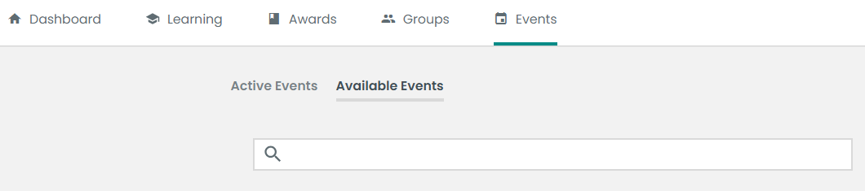
Face to face training can also be found via your LMS account dashboard by selecting Events > Available Events:

Online eLearning Modules

Child Exploitation
Fabricated Illness
GCP2 eLearning
GCP2A Tool (due Feb 2026)
Group Admin Guide
L1 Safeguarding
L2 Safeguarding
L3 Safeguarding
Mold and Damp Awareness
Online Safety (was previously called E-Safety)
Parental Mental Health
Parental Domestic Abuse, Substance Misuse and Parental Mental Illness (was previously called Trio of Vulnerabilities)
Parental Mental Health
Safeguarding in Education
Safer Sleep for Babies
Self-Harm
Stronger Together eLearning
Suicidal Thoughts
Young Minds

To browse our online modules in more detail and request a module, please go to
https://eastridingscp.vc-enable.co.uk/Learn/Learning/Available

Learning Briefs
We have a selection of Learning Briefs available on the LMS Learning Platform under Available Learning via your Dashboard. These modules do not need to be requested and can be accessed by all practitioners at any time. The summaries feature examples of good practice, key learning points and emerging themes identified during Safeguarding Assurance Group audits and JTAI Partner audits.

Please check in regularly for the most recent Learning Briefs which will be published monthly, or use the link below:

ERSCP Learning Briefs

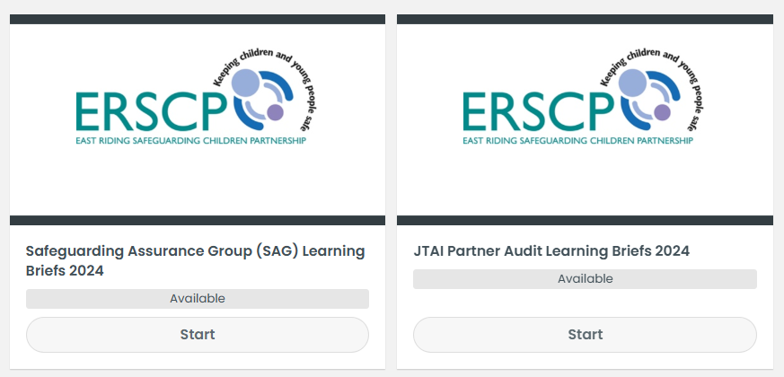

Useful Resources:
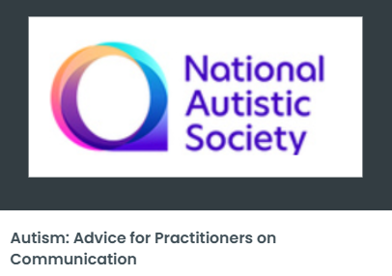
There are a range of useful guides and resources for practitioners on our learning platform, including:

- ERSCP Basic Awareness of Neglect and the NEST Tool
- Advice for Practitioners on Communication and Autism
- Living and Working in the UK: Protection from Exploitation
- Probation Service Pathway
- Improving the Quality of Joint CP Investigations
- East Riding Multiagency Contact Guide for Licensing
- Forensic Considerations and SARC

These resources are for practitioners across all multiagency and can be accessed and downloaded at any time. To browse the range, go to ERSCP Guides.

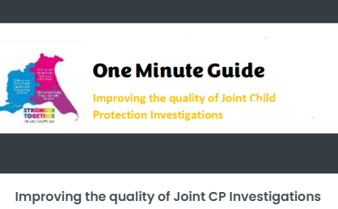

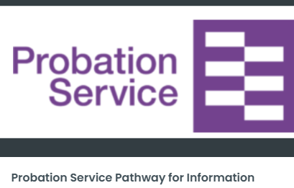

Training modules, learning briefs and resources can also be found via your LMS account dashboard by selecting Learning > Available Learning:
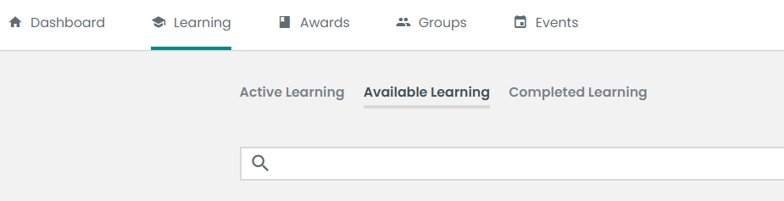

To Note:

- All of our online modules have a 6-week timeframe for completion. If you are unable to complete the module before the allocated deadline, please inform us, otherwise we must claim the license back.
- Guides, resources and learning briefs do not have a completion date; they can be accessed any time and downloaded for reference.
- If you are unable to attend face-to-face training on which you have booked, please let us know in advance. Any absences which we are unaware of prior to the training will be followed up with line managers.

Registration on the LMS Learning Platform:
To book a place on any of our training or to request a virtual module, you will need to have signed up for an account on our platform, the Enable Learning Management System (LMS), hosted by Virtual College. To register, simply to go https://www.erscp.co.uk/training/learner-management-system-lms/. Once the form is completed, you will receive an email from Virtual College which will ask you to log on and set up a password, then your account will be live - all training and resources will then be fully accessible.

Full details about our training, including how to use the LMS, can be found on our ERSCP website at https://www.erscp.co.uk/training/ or by scanning our QR code. Please send any queries to erscp.training@eastriding.gov.uk

