Submitting Census - Termly
- Login as usual
- Click “My Details”
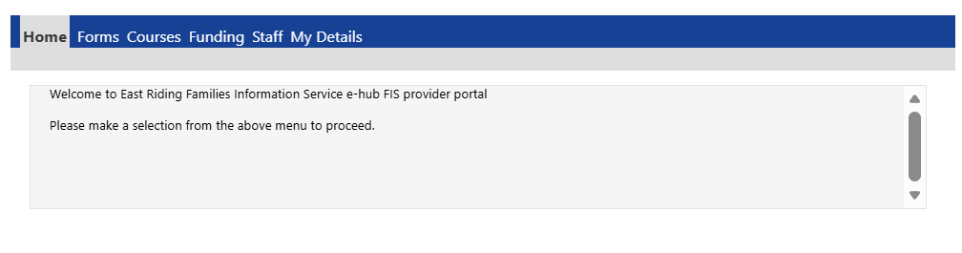
- Click on the appropriate term and it will open the below screen
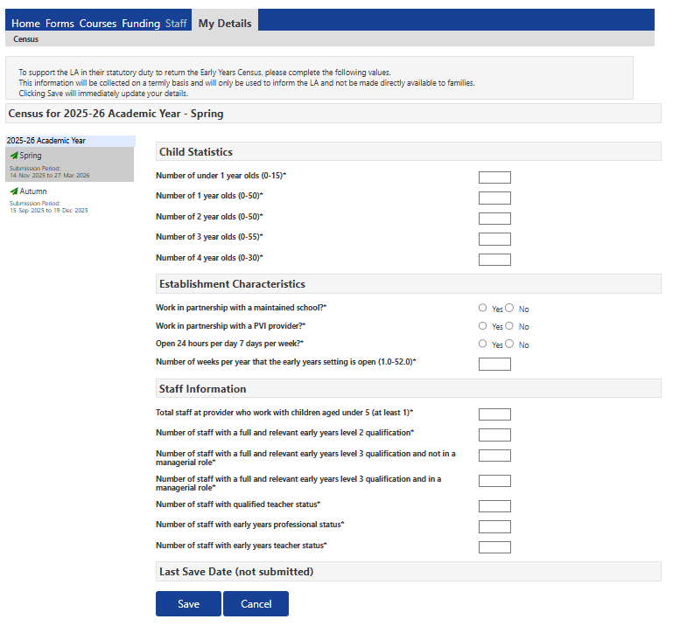
- Populate the information requested (please see next page for guidance)
- Click submit
- This will be done termly and MUST to be completed before you submit headcount.
****You MUST complete the termly census before submitting headcount otherwise you will not be able to submit headcount and you will receive the below error message****
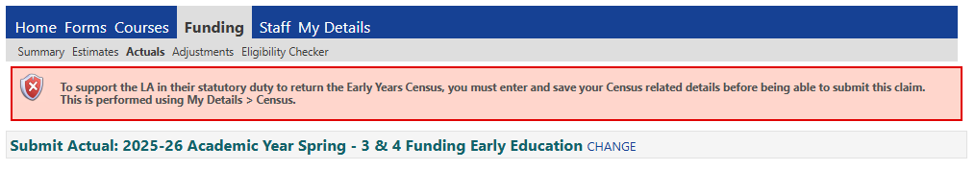

Child Statistics:
Data being asked | What it means/data needed
Number of under 1 year olds (0-15) | Total number children aged under 1 in your care (this inc funded and non-funded children).  Zero submission means you have none at this age.
Number of 1 year olds (0-50) | Total number of 1-year-olds in your care (this inc funded and non-funded children).  Zero submission means you have none at this age.
Number of 2 year olds (0-50) | Total number of 2-year-olds in your care (this inc funded and non-funded children).  Zero submission means you have none at this age.
Number of 3 year old (0-50) | Total number of 3-year-olds in your care (this inc funded and non-funded children).  Zero submission means you have none at this age.
Number of 4 year olds (0-50) | Total number of 4-year-olds in your care (this inc funded and non-funded children).  Zero submission means you have none at this age.

Establishment Characteristics:
Data being asked | What it means/data needed
Work in partnership with maintained school? | Indicates whether you are working with a state-funded school (local authority maintained, academy or free school) through a contract or partnership agreement.  This should include all partnership working between a provider or childminder and a school including situations where the partners are based on a different site.
Work in partnership with a PVI/Provider? | Indicates whether you are working with another provider through a contract or partnership agreement. It should include all partnership working between providers and includes situations where providers are based on different sites.
Open 24 hours per day 7 days a week? | Yes means you open 24 hours a day 7 days a week  No means you do not open for that time
Number of weeks per year that the early year setting is open (1.0 – 52.0) | Please completed with the number of weeks you are open for childcare.

Staff information:
Data being asked | What it means/data needed
Total staff at provider who work with children aged under 5 (at least 1) | This data item records the total number of staff at the provider who work with children aged under 5.  - For a childminder, this would include themselves, any co-childminders and any assistants.  - Both qualified and unqualified staff are included within this total.
Number of staff wit a full and relevant early years level 2 qualification | This data item records the number of staff at the provider with a full and relevant early years level 2 qualification who work with children aged under 5.  Definitions of full and relevant qualifications are available in the guidance on checking early years qualifications.
Number of staff with a full and relevant early years level 3 qualification and not in a managerial role | This data item records the number of staff at the provider with a full and relevant early years level 3 qualification who are not in a management role and work with children aged under 5.  Definitions of full and relevant qualifications are available in the guidance on checking early years qualifications.
Number of staff with a full and relevant early years level 3 qualification and in a managerial role | This data item records the number of staff at the provider with a full and relevant early years level 3 qualification who are in a management role and work with children aged under 5.  Definitions of full and relevant qualifications are available in the guidance on checking early years qualifications.  - Staff with graduate-level qualifications excluding ‘EYPS’, ‘EYTS’ and ‘QTS’ (for example BA Early Childhood Studies, Foundation Degree) should be recorded as level 3 as their qualifications allow them to practice at level 3 staffing ratios.  - A manager is the person undertaking the role of ‘setting manager’ as prescribed in the early years foundation stage framework. This does not include room leaders or senior members who are not the setting manager.  - Any registered childminder is considered to have a managerial role even if they are not working with any other adults. However, if they hold a higher level of qualification they should be recorded under the relevant qualification.
Number of staff with qualified teacher status | This data item records the number of staff at the provider with qualified teacher status who work with children aged under 5.  - Qualified teacher status (QTS) is an accredited graduate status endorsed by the government. Holders of this status will have met the Teachers Standards, hold a certificate issued by DfE and a teacher reference number (TRN).
Number of staff with early years professional status | This data item records the number of staff at the provider with early years professional status who work with children aged under 5.  - Early years professional status (EYPS) was an accredited graduate status endorsed by the government between 2007 and 2013. Holders of this status will have met the early years professional status standards and hold an EYPS certificate. The status was replaced by early years teacher status in 2013.
Number of staff with early years teacher status | This data item records the number of staff at the provider with early years teacher status who work with children aged under 5.  - Early years teacher status (EYTS) is an accredited graduate status endorsed by the government since 2013. Holders of this status will have met the Teachers Standards (Early Years) and hold an EYTS certificate issued by DfE. The status is not the same as qualified teacher status (QTS).

