FREE PARENT WEBINAR: THE FLU VACCINE IN CHILDREN & YOUNG PEOPLE


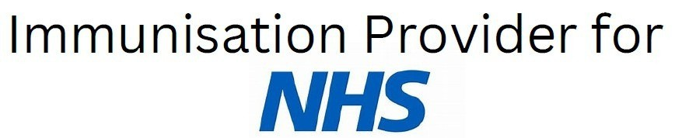


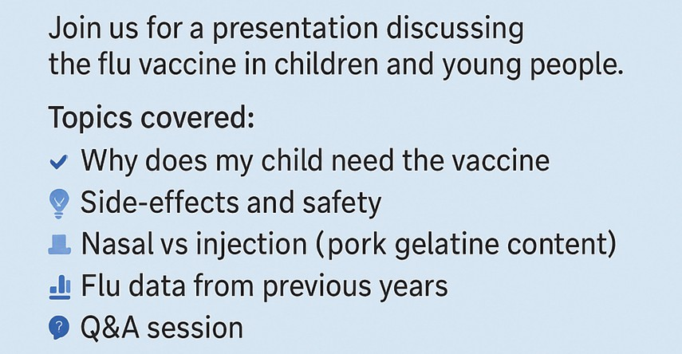

Wednesday 17th Sept 8:00 - 9:00pm
Microsoft Teams 363 003 291 454
jc3J83z5
Thursday 18th Sept 6:00 - 7:00pm
Microsoft Teams 310 543 675 2095
gT7P9ci3

