East Riding Children’s Centres Infant Mental Health Parent Pack
Welcome to the Infant Mental Health Parent Pack! This guide is designed to provide parents and caregivers with valuable insights into the mental health and emotional well-being of infants. Understanding and nurturing your child's mental health from an early age is crucial in fostering a healthy and happy development.
What is Infant Mental Health?
Infant mental health refers to the social, emotional, and cognitive well-being of children from birth to age three. It involves the ability to form secure relationships, experience and regulate emotions, and explore the environment. These early years are foundational for establishing healthy patterns that can last a lifetime.
Why is Infant Mental Health Important?
- Foundation for Future Development: Early mental health influences cognitive skills, emotional regulation, and social abilities.
- Parent-Child Bonding: Positive mental health supports strong, secure attachments between infants and caregivers.
- Resilience and Coping: Early experiences shape a child's ability to handle stress and adversity later in life.
Key Aspects of Infant Mental Health
Secure Attachment
- Definition: A strong emotional bond between the infant and primary caregiver.
- Importance: Helps infants feel safe and secure, promoting exploration and learning.
Emotional Regulation
- Definition: The ability to manage and respond to an emotional experience in an appropriate way.
- Development: Begins with caregivers soothing the infant and progresses to self-regulation.
Communication and Language
- Pre-verbal Communication: Includes crying, cooing, and babbling as forms of expression, as well as body language and nonverbal cues.
- Language Development and emotional reciprocity: Encouraged by talking, reading, and singing to your infant, as well as reading when to engage with your baby.
By understanding and prioritizing your infant's mental health, you are laying the groundwork for a lifetime of health and well-being. Remember, every child is unique, and your love and support are the most significant gifts you can provide.

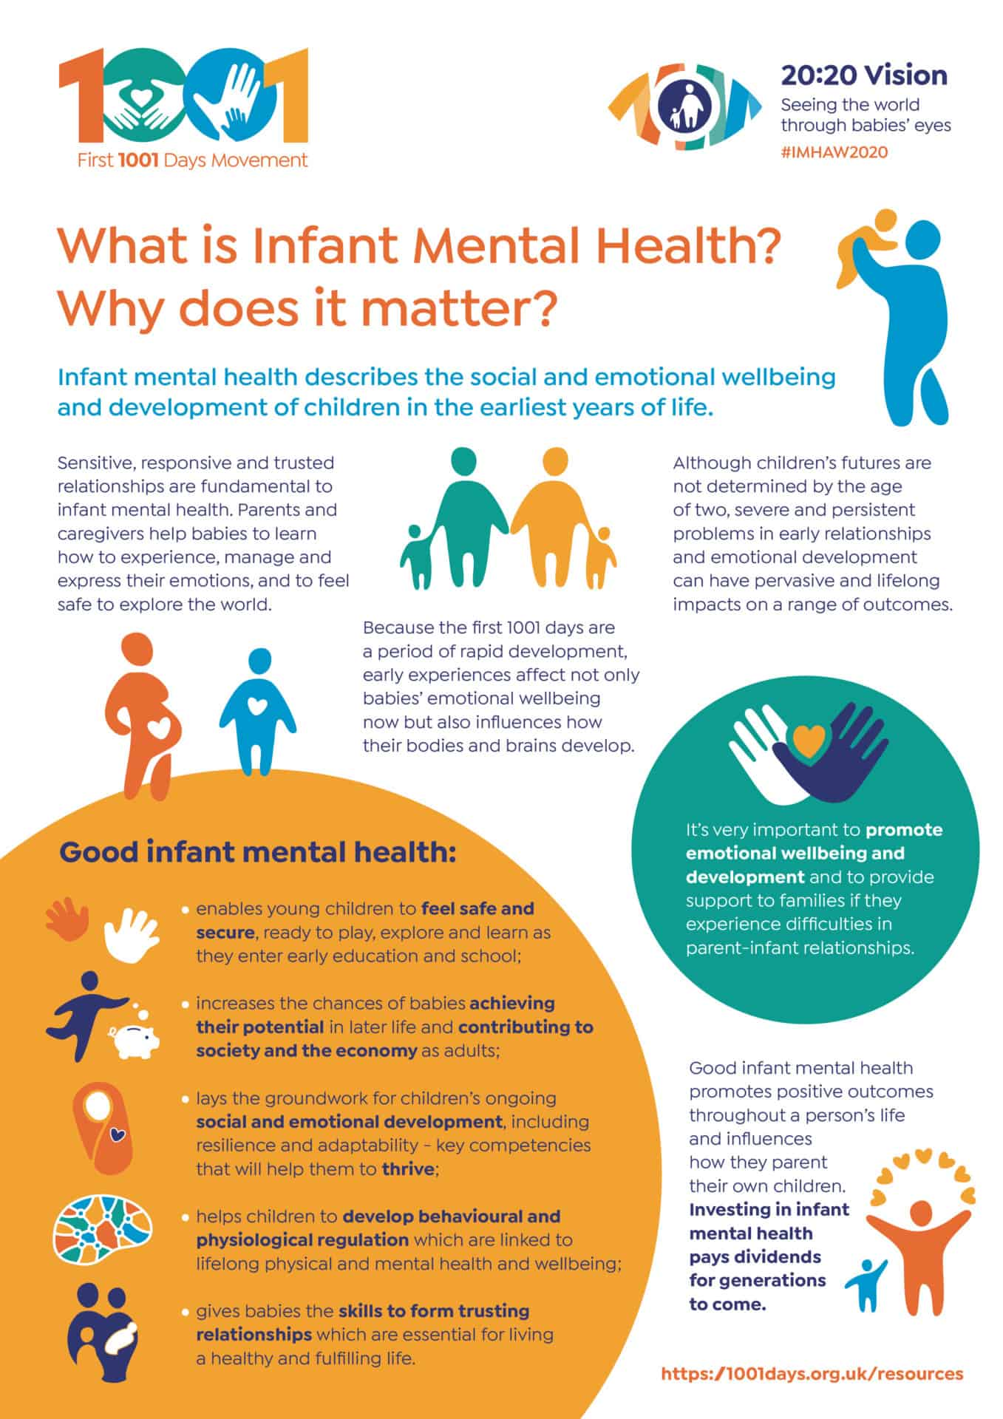

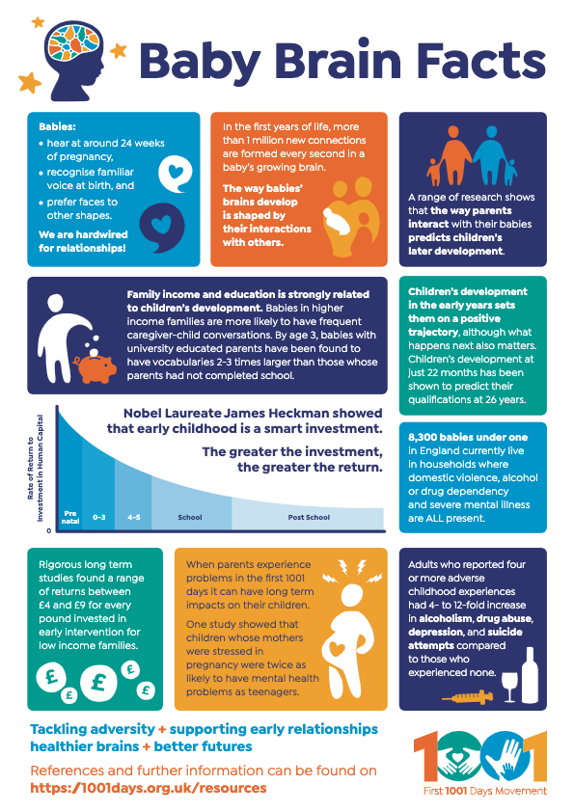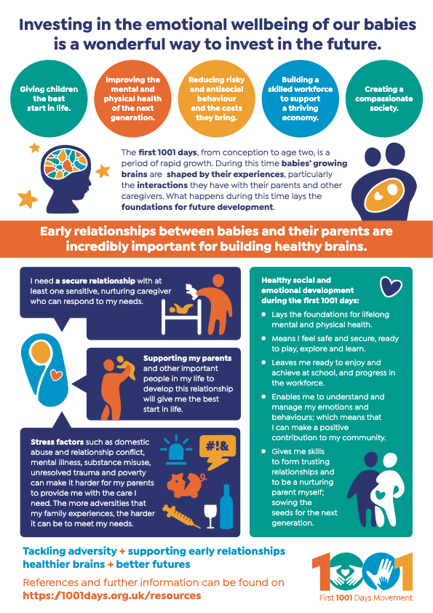

🌱 The 1001 Critical Days: Giving Your Baby the Best Start in Life

👶 What Are the 1001 Critical Days?
The 1001 critical days span from conception to your child’s second birthday. This time is incredibly important for your baby’s brain development, emotional wellbeing, and physical health. What happens during this period lays the foundation for the rest of their life.

💡 Why These Days Matter
- Brain growth is fastest during this time—by age 2, your baby’s brain is already 80% the size of an adult’s!
- Strong early bonds help your baby feel safe, loved, and ready to learn.
- Healthy habits formed now—like feeding, sleeping, and playing—can shape lifelong wellbeing.

🧡 How You Can Support Your Baby
Here are some simple, powerful ways to support your baby during these early days:

1. Build a Loving Bond
- Cuddle, talk, and sing to your baby often.
- Respond to their cries with comfort and care.
- Skin-to-skin contact helps with bonding and calming.

2. Feed with Love
- Whether you breastfeed, formula feed, or both—feeding is a chance to connect.
- Your local Children’s Centre, midwife or Health Visitor can support infant feeding if you need help.

3. Create a Safe, Calm Space
- Babies thrive in calm, predictable environments.
- Try to keep routines gentle and consistent.

4. Play and Talk Together
- Newborns love to hear your voice and see your face.
- Play helps babies learn about the world and build trust. Even if you feel your baby is too young to play, or understand, they are learning all the time! Interaction builds your baby’s brain!

5. Look After Yourself Too
- Your wellbeing matters. Ask for help when you need it.
- Talk to your midwife, health visitor, or GP if you’re feeling low or overwhelmed. See below for more tips on supporting yourself and your relationship.

🏡 What Support Is Available?
- Children’s Centres: welcoming places to get advice and support.
Children's Centres
- Online and telephone support: for feeding, sleep, mental health, and more.
The Baby Buddy app
DadPad | The Essential Guide for New Dads | Support Guide for New Dads
Home - Relationship Matters
- Skilled professionals: like midwives, health visitors, and early years workers.
Local Maternity System - Home
Health Visiting - East Riding Health Visiting and School Nursing - Connect NHS
🏡 The Solihull Approach Free Online Learning
East Riding of Yorkshire Council Early Help, in partnership with the Solihull Approach, offers free access to In Our Place evidence-based online courses expertly designed by NHS professionals. Sign up to better understand your child’s feelings and behaviour and raise them to be emotionally aware, sociable and confident. Courses are tailored for all stages of a child’s development to help all family members through reflective, supportive learning without judgment.
Become a more confident parent by learning about child brain development, challenging behaviour, communication and your own wellbeing needs because parenting is a journey that is always changing! inourplace | Solihull Approach – East Riding | inourplace

📚 More Helpful Resources for Parents

🧸 Parent-Infant Foundation
A charity focused on babies’ emotional wellbeing. They offer:
- Easy-to-read infographics
- Evidence briefs on early development
- The 1001 Days Manifesto
- Campaigning tools for better early years support
🔗 Visit the Parent-Infant Foundation [1]
🧸 Further Reading
- The Best Start for Life – GOV.UK
- UNICEF Baby Friendly Initiative
- [1001 Critical Days Campaign]

🌟 Tips for New Parents

💤 1. Sleep: Yours and Theirs
- Newborns sleep a lot—but not always when you want them to!
- Try to rest when your baby sleeps, even if it’s just a short nap.
- Safe sleep is key: always place your baby on their back in a clear, flat sleep space.

🧘 2. Take Care of Your Mental Health
- It’s common to feel overwhelmed—parenting is a big change.
- Talk to someone you trust or a health professional if you’re struggling.
- You’re not alone—many parents feel this way.

🧼 3. Keep Things Simple
- You don’t need fancy toys or gadgets—your voice, face, and cuddles are what your baby loves most.
- Trust your instincts. You know your baby better than anyone.

🧑‍🤝‍🧑 4. Build a Support Network
- Connect with other parents through local groups or online communities. Your local Children’s Centre has a variety of sessions and classes you can attend with baby to meet new parents just like you.
- Don’t be afraid to ask for help—from friends, family, or professionals.

🤱5. Feeding Is a Learning Curve
- Whether breastfeeding, bottle-feeding, or both—every baby is different.
- Be kind to yourself. It’s okay to ask for help from a midwife, health visitor, or Children’s Centre.

🎶 6. Talk, Sing, and Read
- Babies love the sound of your voice—even if they don’t understand the words yet.
- Reading simple books, singing lullabies, and chatting about your day helps their brain grow. Babies can hear in the womb from 24 weeks gestation so hearing your voice in the outside world is comforting to baby. And even though it may seem strange at such a young age, you’ll also be developing their speech and language skills!

🧩 7. Every Baby Develops Differently
- Don’t worry if your baby isn’t doing exactly what others are.
- If you’re concerned, speak to your health visitor—they’re there to help.

🌈 Tips for Managing Stress
Becoming a parent is a big life change—and it’s completely normal to feel stressed sometimes. Here are some gentle, practical ways to look after your mental wellbeing:

🧘‍♀️ 1. Take a Few Minutes for Yourself
- Even 5 minutes of quiet time can help. Try deep breathing, stretching, or just sitting with a cup of tea.
- Ask your partner, friend or family member to watch the baby, or take them for a walk, whilst you take some time for yourself.

🗣️ 2. Talk About How You’re Feeling
- Share your thoughts with a partner, friend, or family member.
- Don’t bottle things up—you’re not alone, and talking can really help. Your local Family Centre, Health Visitor, Midwife or GP are also great sources of support.

📅 3. Lower the Pressure
- You don’t have to do everything perfectly. Focus on what matters the most: your emotional wellbeing and your baby’s love and care.
- Let go of the to-do list when you need to.

🧑‍🤝‍🧑 4. Ask for Help
- Whether it’s someone holding the baby while you nap or helping with meals—accepting help is a strength, not a weakness. People generally love to help and who doesn’t like baby cuddles!
- Reach out to your health visitor or GP if you’re feeling overwhelmed. They will have supported many others in the same situation so don’t be afraid.

🌿 5. Get Outside
- A short walk in the fresh air can lift your mood and help your baby settle too.
- Nature, even in small doses, is a great stress reliever.

📱 6. Limit Social Media
- It’s easy to compare yourself to others online—but every family is different, and remember, what is seen on social media isn’t always a reflection of ‘real life’.
- Follow accounts that make you feel supported, not pressured.

Your Relationship as New Parents

Being a new parent often brings changes to your relationship. New responsibilities coupled with less sleep, hormonal changes and changes to the lifestyle you experienced before your little one came along, can make it easy to put your relationship at the bottom of the ‘to do’ list. We’ve created some tips below on how to navigate these common relationship changes. Remember babies pick up vibes, and a supportive parental relationship with good communication will help your baby’s emotional wellbeing as well as your own.

🧠 Emotional Connection
- Communicate openly: Share your feelings, fears, and joys regularly.
- Express appreciation: Acknowledge each other’s efforts, especially in parenting roles.
- Be patient and kind: Understand that both partners are adjusting to a new reality.

⏰ Quality Time Together
- Schedule couple time: Even short moments like a shared coffee or walk can help.
- Create small rituals: Daily check-ins, bedtime chats, or weekly movie nights.
- Celebrate milestones: Recognize both baby-related and relationship achievements.

🛠️ Shared Responsibilities
- Divide tasks fairly: Share baby care, household chores, etc.
- Support each other’s rest: Take turns with night duties when possible.
- Be flexible: Adapt roles as needed and avoid keeping score.

💞 Physical Intimacy
- Rebuild intimacy gradually: Be gentle and understanding with each other’s needs.
- Stay affectionate: Hugs, kisses, and cuddles go a long way.
- Talk about changes: Discuss how your physical and emotional needs may have shifted.

🧘 Mental Health & Self-Care
- Encourage self-care: Support each other in finding time to recharge.
- Watch for signs of stress or depression: Seek help if needed.
- Stay connected with others: Maintain friendships and family support.

🤝 Team Mentality
- Make decisions together: From parenting styles to daily routines (it’s a good idea to discuss parenting styles before your new arrival).
- Celebrate teamwork: Recognize how you’re growing together as parents.

For more information on healthy relationships please visit:
Home - Relationship Matters






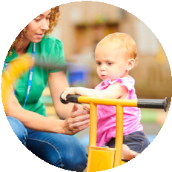




12
.
I
FEEL
SAFE
WHEN
YOU
ARE
GENTLE
AND
PREDICTABLE.

13 I CAN FEEL WHEN YOU ARE ANGRY

WITH ME.
14. IT’S OKAY TO ASK FOR HELP
. MY BRAIN THRIVES ON LOVE, RESPONSIVE ATTENTION AND CALMNESS.
25
4
.
I
AM
READY
TO
INTERACT
WITH
YOU
FROM
THE
MOMENT
I'M
BORN.
INTERACTIONS
GROW MY BRAIN.
. I LOVE TO LOOK AT YOUR FACE AND HAVE CONVERSATIONS WITH YOU.
5
6
.
I
ALSO
LOVE
IT
WHEN
YOU
JUST
LISTEN
TO
THE
NOISES
I
MAKE
AND
REFLECT
THEM
BACK TO ME.
7
. WATCH FOR MY RESPONSE TO EVERYTHING THAT YOU SAY AND DO.
19
. PLEASE DON’T LEAVE ME TO CRY FOR A LONG TIME ON MY OWN. IF I CRY LOTS, I NEED YOU
TO STAY WITH ME UNTIL I AM CALMER.
20
. I LEARN FROM YOU SOOTHING ME. AS I GET OLDER, I’LL BE ABLE TO SOOTHE MYSELF
BACK TO SLEEP.
21
. SOMETIMES I WILL SLEEP FOR A LONG TIME, SOMETIMES FOR REALLY SHORT PERIODS.

IT DEPENDS WHAT’S GOING ON INSIDE ME. MY SLEEP PATTERNS WILL CHANGE A LOT AS I
GROW!
. I DON’T YET USE WORDS, BUT I AM TRYING VERY HARD TO TELL YOU WHAT I NEED WITH MY
16
ACTIONS.
17
. GUESSING WHAT I AM NEEDING OR FEELING AND THEN SAYING IT ALOUD GENTLY CAN
SOOTHE ME.
. SOMETIMES JUST YOU BEING WITH ME, YOUR SMELL, TOUCH AND WARMTH,
18

IS ALL I NEED EVEN
IF I DON’T STOP CRYING IMMEDIATELY.

22
. WHEN YOU NEED TO LEAVE ME WITH SOMEONE, CHOOSE SOMEONE WHO WANTS TO BE WITH
ME AND IS SAFE, ATTENTIVE AND KIND.
23
. I WILL BE OKAY WHEN YOU LEAVE ME. I JUST NEED SOMEONE TO UNDERSTAND THAT
PARTING IS HARD AND WILL HELP ME TO FEEL SAFE UNTIL YOU COME BACK.
. WHEN YOU CAN LEAVE ME WITH THE RIGHT PERSON, I WILL BE FINE AND WE WILL BOTH
24
FEEL
HAPPY AND RELAXED WHEN WE SEE EACH OTHER AGAIN.
. I LOVE IT WHEN YOU PLAY WITH ME, AND ESPECIALLY WHEN YOU TAKE TIME TO NOTICE
8

WHAT I’M INTERESTED IN
. THE WORLD IS ALL NEW TO ME, HELP ME TO EXPLORE IT.
9
. I REALLY ENJOY TAKING TURNS TO INTERACT AND ALSO NEED TIME TO LOOK AWAY AND TAKE
10
A
BREAK
. RELAX AND ENJOY BEING WITH ME, THIS MAKES ME FEEL LOVED.
11
1
. I MIGHT NOT BE THE BABY YOU IMAGINED BUT I’M A UNIQUE PERSON WITH MY OWN WAY OF
BEING IN THE WORLD.
. TAKE TIME TO GET TO KNOW ME,
2

MY LIKES, MY NEEDS, MY EXPRESSIONS, MY LITTLE WAYS.
3
. IT WILL TAKE TIME FOR US TO GET TO KNOW EACH OTHER. I DON'T NEED YOU TO BE
PERFECT,
JUST TO KEEP TRYING.
BABY’S BRAIN HEALTH = INFANT MENTAL HEALTH
The Association for Infant Mental Health - celebrating 25 years
BEING ACCEPTED
BRAIN GROWTH & HEALTH
RELATING TO ME
TRANSITIONS & SEPARATIONS
FOLLOWING AND PLAYING WITH ME
COMFORTING AND UNDERSTANDING ME
FEELING SAFE
SLEEP AND ME
. 15.PLEASE LOOK AFTER YOURSELF. THIS WILL HELP YOU TO LOOK AFTER ME.
THINGS EVERY BABY WOULD WANT YOU TO KNOW
25
https://aimh.u
k
