Census

- Log into the Ehub as you would normally do.
- Click “Forms”

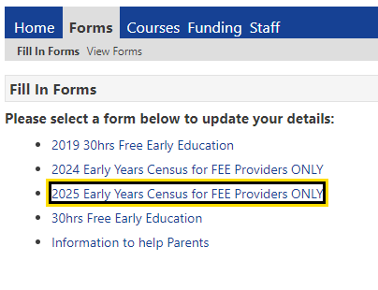
- The below will be displayed
- Click on “2025 Early Years Census for FEE providers ONLY”
- The below screen will open

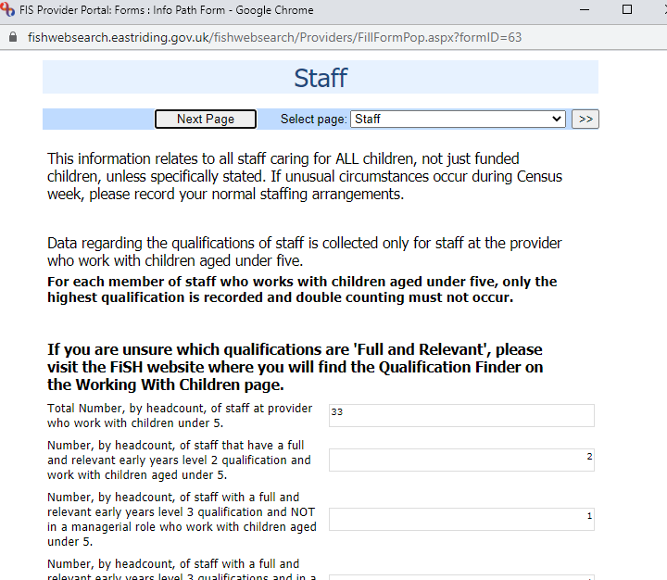
- Click “Submit” at the bottom of the screen once all the questions are answered
