**Census**

* Log into the Ehub as you would normally do.
* Click “Forms”

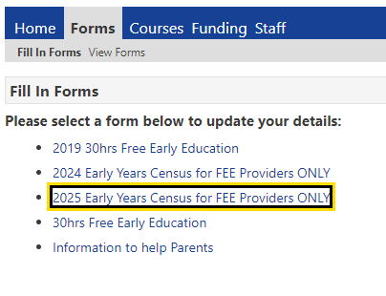

* The below will be displayed
* Click on “2025 Early Years Census for FEE providers ONLY”
* The below screen will open

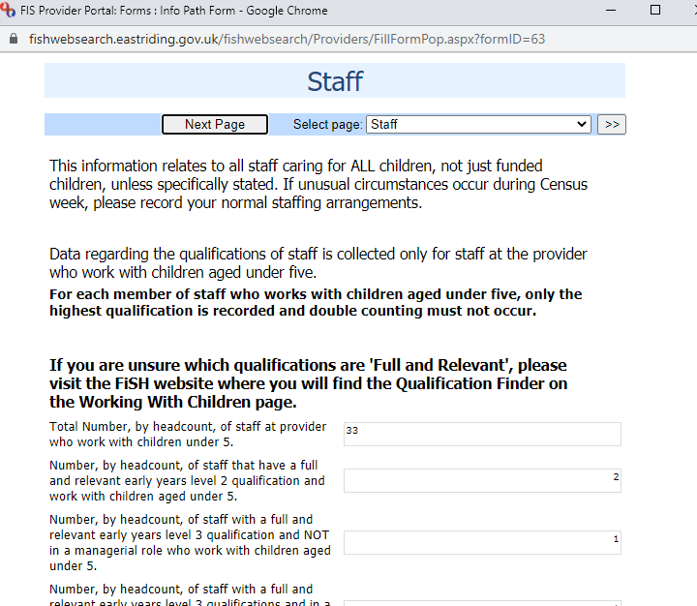

* Click “Submit” at the bottom of the screen once all the questions are answered

