* **Census information *– New addition to the Ehub requested by the DfE***

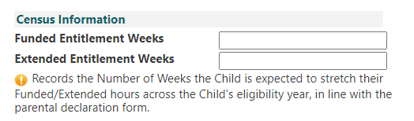

* This has been requested by the DfE to collate information – meaning that the providers now need to say how many weeks that child will attend the setting from January to December.

*DfE state: Children who are taking their funded hours term-time only, 38 funded entitlement weeks should be recorded (or the number of weeks the provider is open in term-time which could be less than 38 weeks, for independent schools for example). For children who are stretching their funded entitlement over more than 38 weeks, record the number of weeks agreed between the parent and the provider.*

**Examples:**

1. Setting/childminder is term time, the information in the box should be **38**. (However, if you are open less than this it would be reflective of how many weeks you are open i.e. nurseries of private schools)
2. Setting/childminder opens 51 weeks but only offers funding on a term time basis and the other weeks paid for privately it would be **38** weeks in the box(es).
3. Setting/childminder open 51 weeks and stretches the 38 weeks funding over 51 weeks then **51** would be put in the box(es) (or representative of how many weeks you are open if it differs from the example)
4. Setting/childminder open 51 weeks but parent choses to only take it term time then **38** weeks in the box(es).

**\*\*\*\*Both boxes must be completed with the same figure for 3&4 year funding and only one box will currently appear for 9 month – 2 year funding\*\*\*\***