

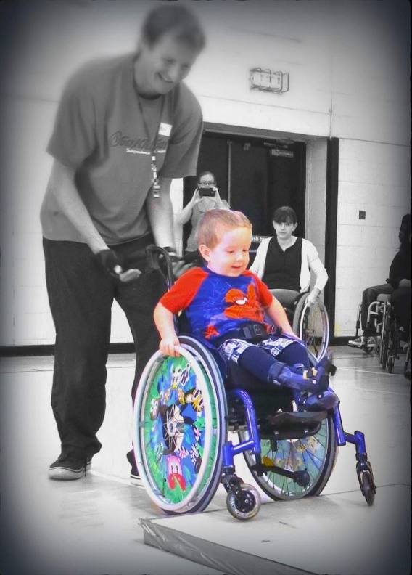

Manual or powered wheelchairs
Propulsion & manoeuvring
Slopes and rough ground,
Back wheel balancing,
Road safety
Emergency evacuation techniques
Wheelchair sports & Dance

Sunday 11th June 2023
11am – 3pm
Driffield Leisure Centre,
Bridlington Rd, Driffield,
YO25 5HZ
Please bring a packed lunch
To book a free place email:
roy@gokidsgo.org.uk
Free, fun and inclusive sessions for 2 -18 year olds. Extra wheelchairs provided so the whole family can join in!

