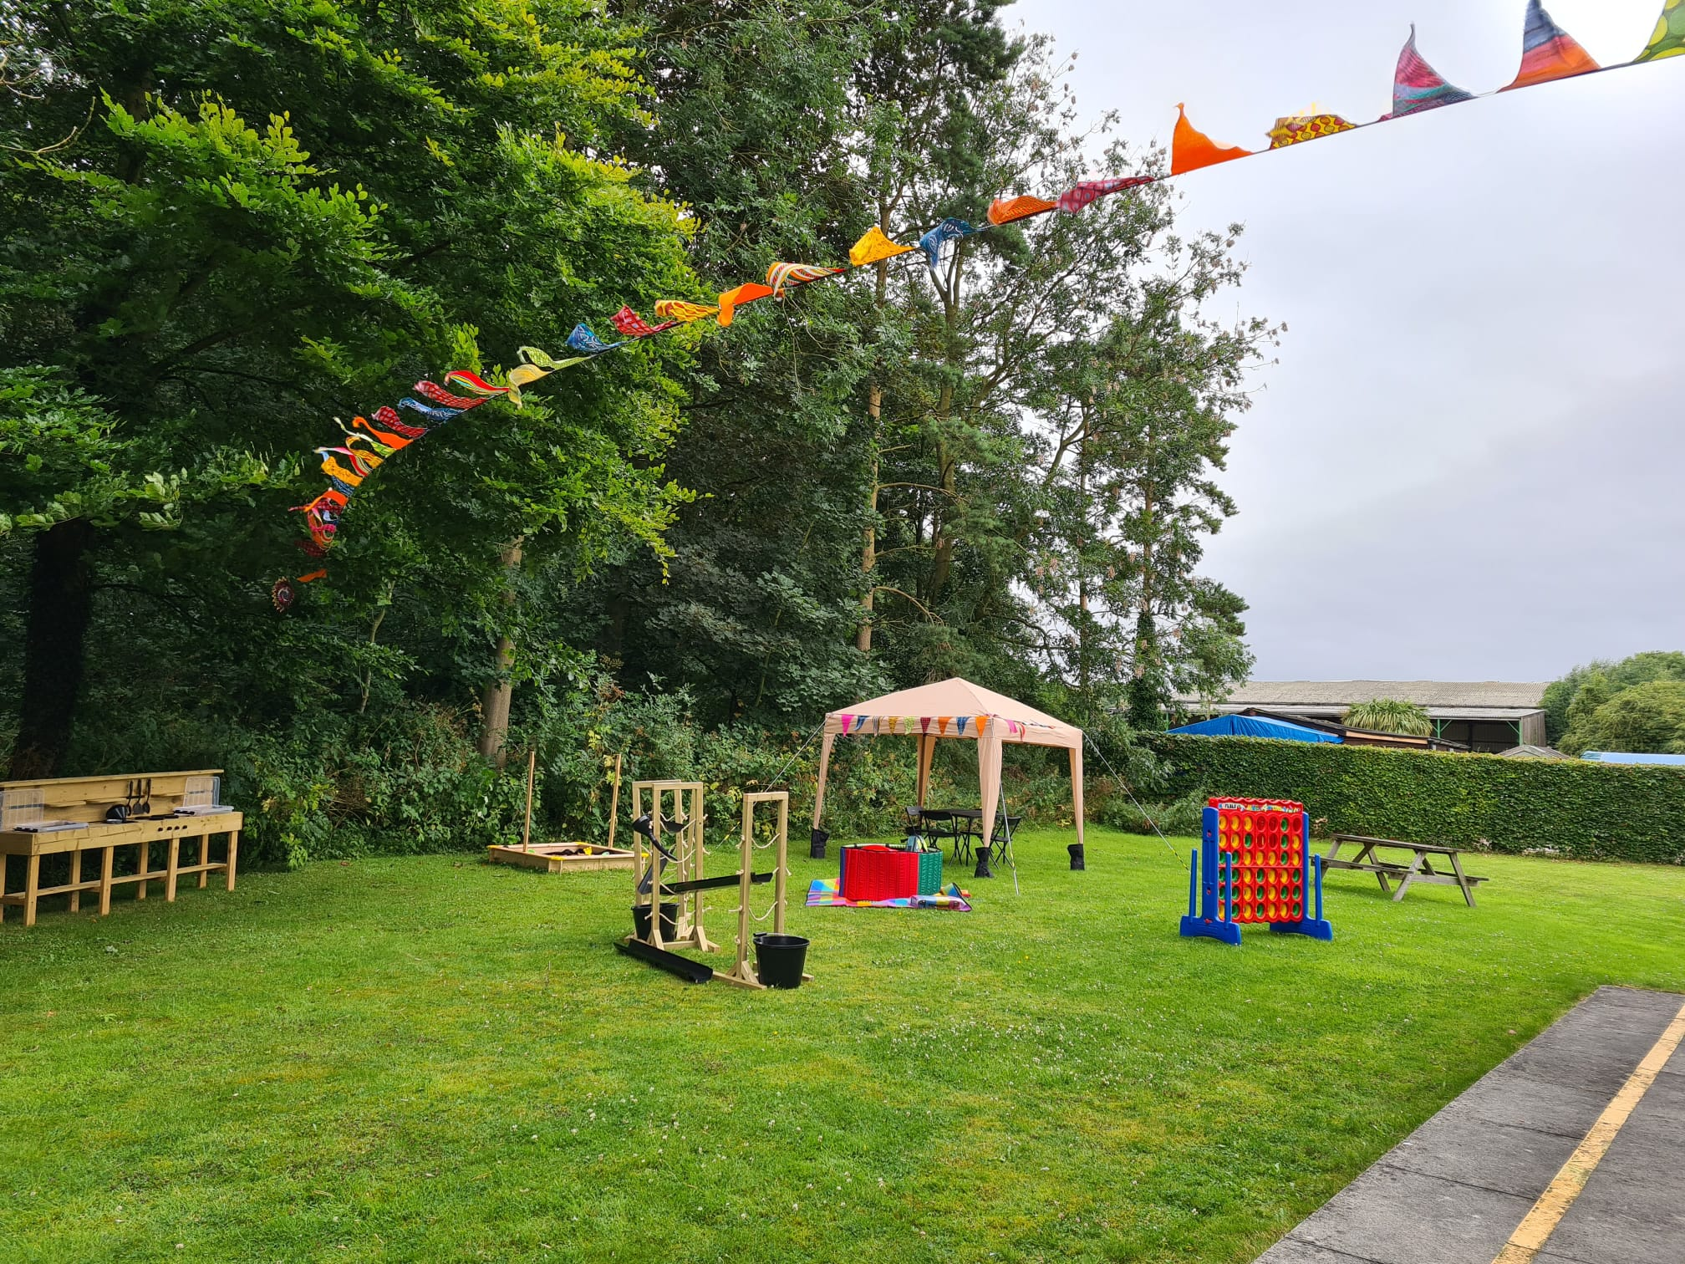  Saturday 17th June 2023  Barnardo’s dsi service summer fete  11am – 3pm  Free Entry & Free Parking    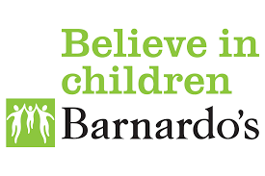  You are invited to join us at our inclusive Summer Fete, set within our wonderful grounds located at Holme on the Wolds, just a short drive from Beverley. We will be raising funds to support the continuing development of our service. Benefiting the children/young people with a disability and/or learning difficulty, who access our Short Breaks, Buzz Clubs or Hive Family Sessions. Everyone is guaranteed a warm welcome, please bring your friends and family. We look forward to seeing you!       | Fun for all the Family  ────  Food Stalls  Drink Stalls  Cake Stalls  ────  Raffle  Bottle Stall  Book Stall  ────  Games  Sports  Arts & Crafts  Face Painting  ────  The Great Barnardo’s Bake Off  BARNARDO’S DSI SERVICE  Village Farm Business Centre  East Street  Holme on the Wolds  HU17 7GA  01430 810139  dsi@barnardos.org.uk  https://www.facebook.com/groups/364989234300673

