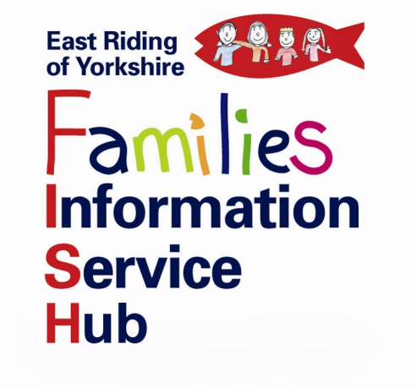

East Riding of Yorkshire Childcare Sufficiency Assessment 2023- Parent/Carer Childcare Survey

The Families Information Service Hub (FISH) would like help from parents/carers to inform the East Riding of Yorkshire Childcare Sufficiency Assessment (CSA) Survey 2023.

We are reviewing our Childcare Sufficiency Assessment, for 2023 and we need as many parents/carers to complete the East Riding of Yorkshire Council Parental Childcare Survey as possible, including those who currently access childcare and those who may wish to access childcare in the future.

We would be grateful for your assistance in answering the following questions about your childcare needs. Your submission will be anonymous. This survey is open from 12th April until 12th June.

If you require any further information please contact FISH on 01482 396469 or via e-mail fish@eastriding.gov.uk

https://consultation.eastriding.gov.uk/s/ERYCChildcareSurvey2023_Parental/

