E-Hub Free Early Education Funding Claims and Online Submission
Guidance Notes
Contents:
Logging in to the E-hub | Page 4-5
Password Rules | Page 6
Resetting Password | Page 6-8
Headcount - 3 & 4 Year funding
Accessing funding actuals | Page 9-10
Adding a child | Page 11-15
Removing/Editing a child | Page 15
Submitting Headcount Claim | Page 15
Headcount - 2 Year funding
Adding children with EY codes (without follow steps on Page 11-15) | Page 16-20
Extended Entitlement
Eligibility Checker | Page 19-23
Viewing Previous Terms
Summary | Page 24-26
Actuals | Page 27
Estimates | Page 28-30
Adjustments | Page 31-32

For further help on any of the e-Hub modules, please contact:

FISH team (01482 396469) about usernames, passwords, problems logging in, access to new modules, headcount queries, finance, submissions issues

Data Processing Role and Responsibility for Providers offering the Free Early Education (FEE)

These guidance notes set out the detailed expectations that the East Riding of Yorkshire Council have of all childcare providers who have signed the Provider Agreement to offer FEE to 2, 3 and 4 yr olds, in additional to those contained in the Provider Agreement in relation to their role as data processor.

All users of the e-Hub offering free early education (FEE), are data processors for the Local Authority, who is the Data Controller, and they MUST ensure they have regard to the following responsibilities in processing any data related to FEE.

As data processor, the provider will:
- Ensure all data collected to be inputted into the e-Hub is kept safe to ensure against unauthorised access, accidental loss or damage and is used only for the purpose as described in the Provider Agreement.

- Ensure that the data is entered into the e-Hub by the set dates and is checked against original records to ensure accuracy.

- Individual passwords should be such that they are not easily compromised.

- Childminders - will not disclose their username and password for the e-Hub to anyone else.

- Settings - only the manager or nominated representative will access the e-Hub to enter FEE data or check eligibility and they will not disclose their username and password to any other staff member. (In the near future it is intended that each individual in a setting will be given their own unique username and password, which should not be disclosed to anyone else. Managers will then need to ensure they notify FISH when individuals leave the setting.)

- Ensure that any PC’s or laptops being used to enter data into the e-Hub, is locked when unattended to prevent unauthorised use.

- Ensure that all users log out of the e-Hub after each session to maintain data confidentiality.

- The above roles and responsibilities must be followed as part of compliance with the Provider Agreement, as referred to in para 2.48

As data controller, the local authority will:
- Notify providers each term through the Mailout, of relevant dates and deadlines for submission of FEE data, as described in the Provider Agreement.

- Provide help and support with the operational use of the e-Hub, deal with any technical issues and re-issue passwords.

- Provide access to new users and issue usernames and passwords and remove inactive users from the system, (when unique individual usernames are issued)
- Provide face-to-face training when appropriate to childminders and nominated members of staff in settings.

- Notify users of updates and changes to the system through the Mailout and revised Guidance Notes as appropriate.

The e-Hub will be used to record children attending for whom claims are made and also to view payments that have been processed.
This secure website will ensure payments can be processed efficiently whilst maintaining data quality and integrity.

Logging in to the e-Hub

Enter the below address directly into your web browser address bar. This takes you to the log in page as shown below.
https://fishwebsearch.eastriding.gov.uk

Either
- Click “sign in” in the top right-hand corner
OR
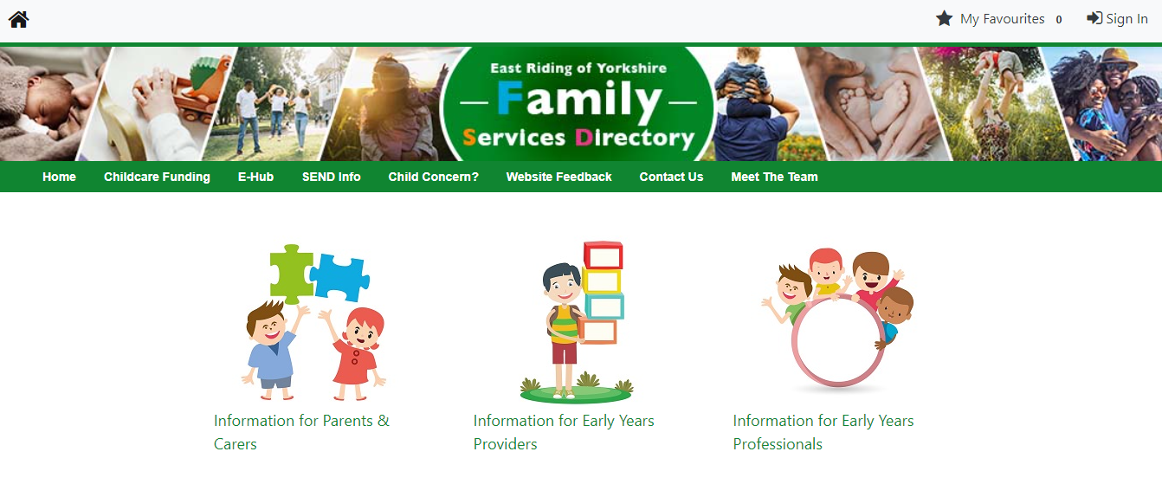

- Click “Information for Early Years Providers”
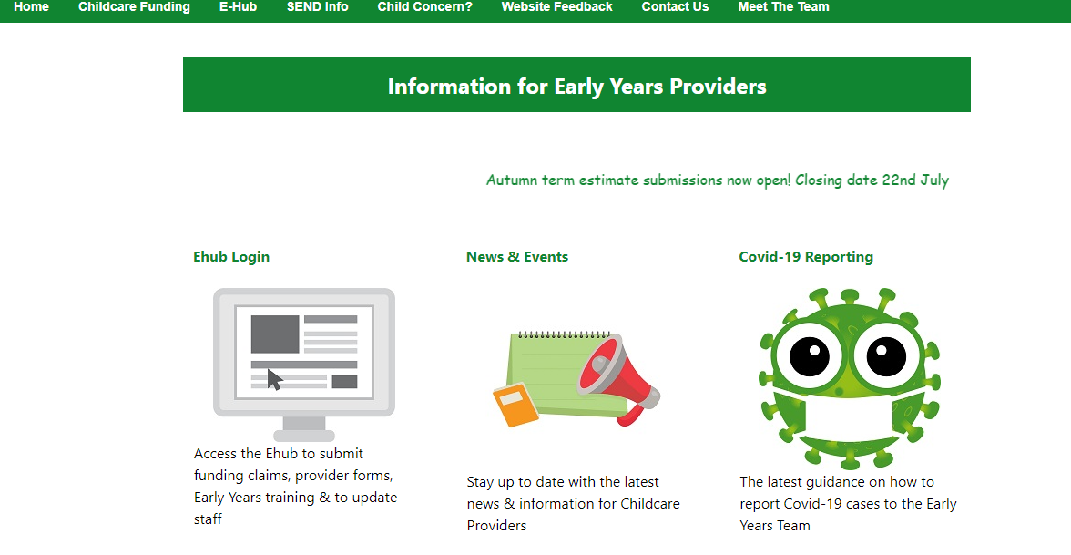
- Click here.
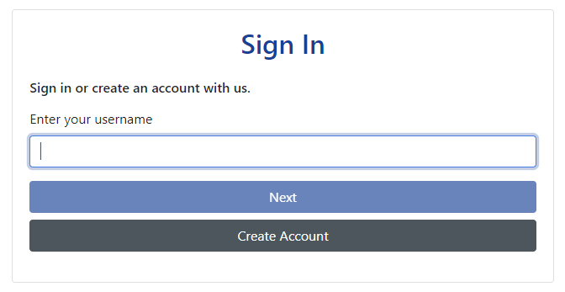
- Enter your username and click “Next”
- Enter your password and click “Sign In”
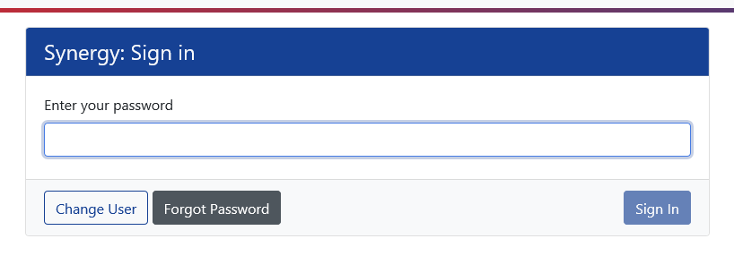
- If you forget your password or are having difficulties logging please refer to pages 6-8 of these guidance notes.
- You will the go to the screen you are used to seeing and from here you can navigate where you need to be.
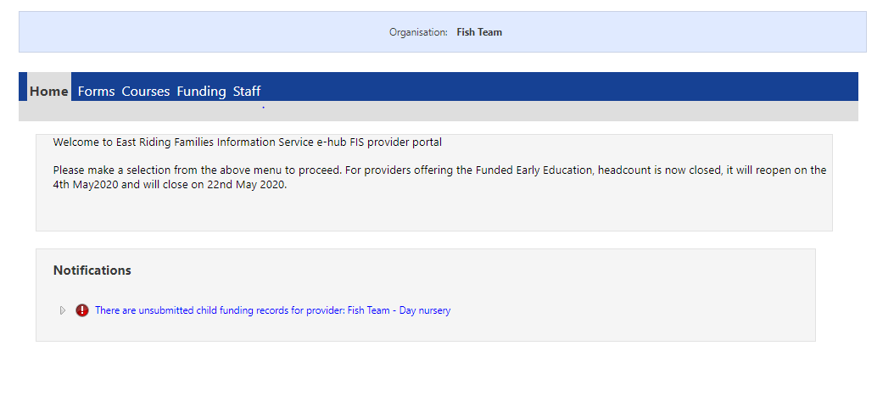
Password Rules
There is now a password policy and this means that every year you will be prompted to change your password.
Your password should include at least:
- Alpha character
- Uppercase character
- Numeric character
- Special character
- 8 characters
- Not username
- Not last 5 passwords
There isn’t a minimum or maximum length to the password.
Resetting Password
If you forget your password you will now be able to reset your password without having to contact FISH
Please that that if you have forgotten you username you will need to contact FISH on 01482 386469
- Follow the previous steps up until it asks for your password
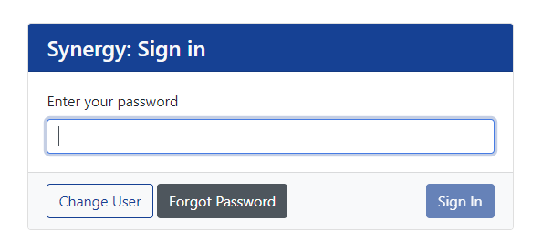
- Click on "Forgot password?"
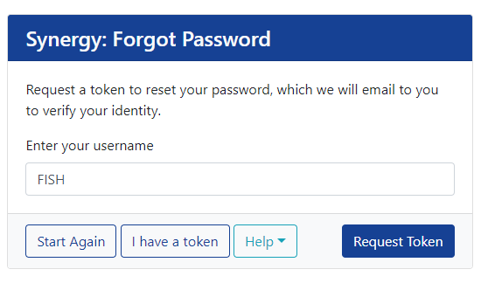
- Click “Request Token”
- You will then receive an email to the email address that you have logged against that account (if you do not receive an email you will need to contact the FISH team to update this information)
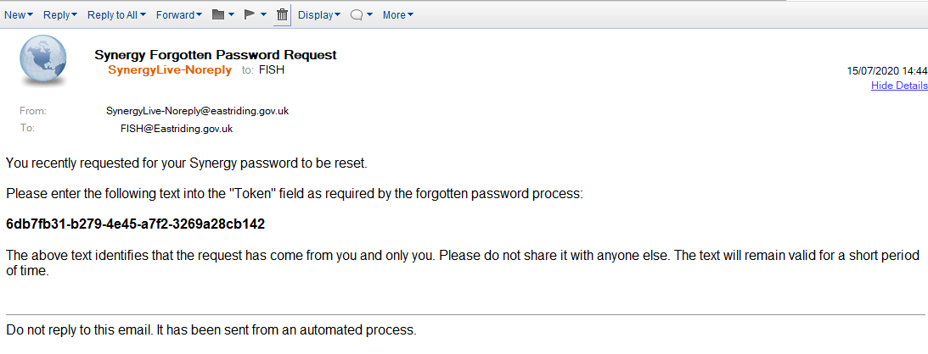
- Copy and paste this code into the below screen on the Ehub
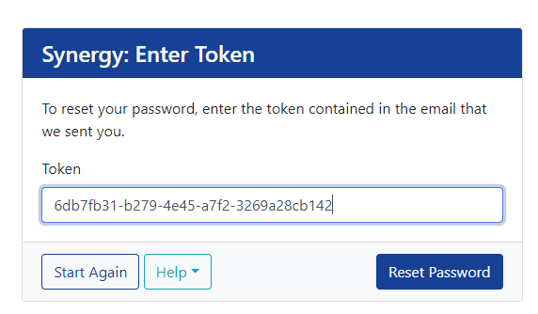
- Click “Reset Password”
- Type password following the requirements noted previously
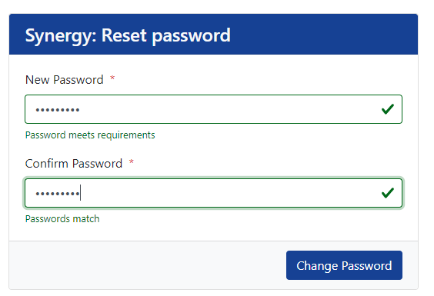
- Click “Change Password”
- It will then take you to the normal front screen that you are used to seeing and you can navigate from here.
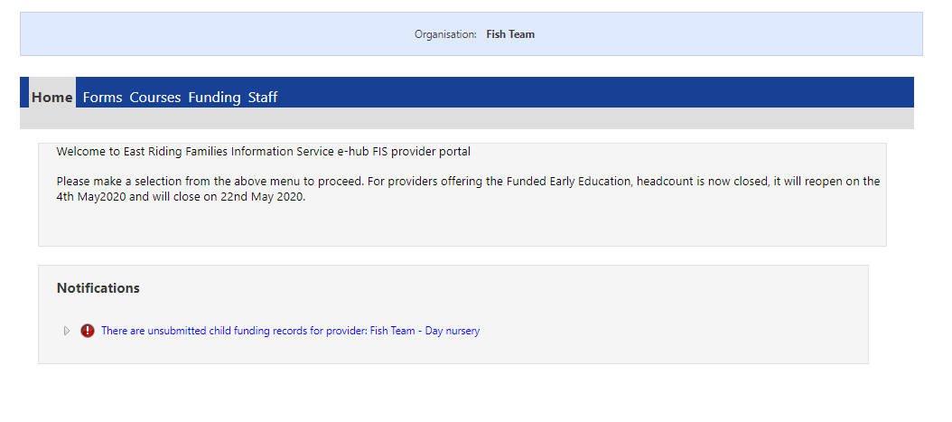
Time out
If you do not use the e-Hub for 20 minutes or more, it will “time out” and if you have not clicked the “Save” button, everything you have entered will be lost. Please remember to save regularly.

Headcount - 3 & 4 Year Funding
“Headcount” is the time in which you are able to input the funding information for individual children in order to ensure payment.
Headcount dates will be given at the beginning of each academic year for the rest of the year. FISH will also send out reminders in the FISH mailout about upcoming headcount dates and the deadline to submit information.
You will only be able to submit headcount when headcount is open- to do this you will need to go to the funding part of the EHub.

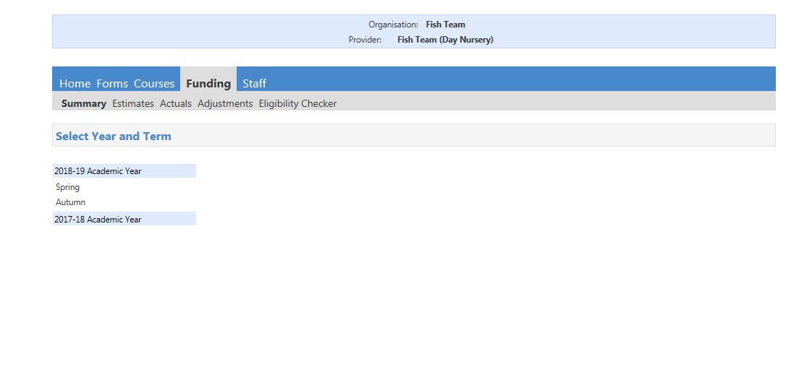
- To access the Funding information you will need to click on the “Funding” tab.
- This will then show the different Academic years.
- You will need to choose which term you would like to view before you proceed.
- Click into the appropriate funding that you want to view or amend/add to before submitting.
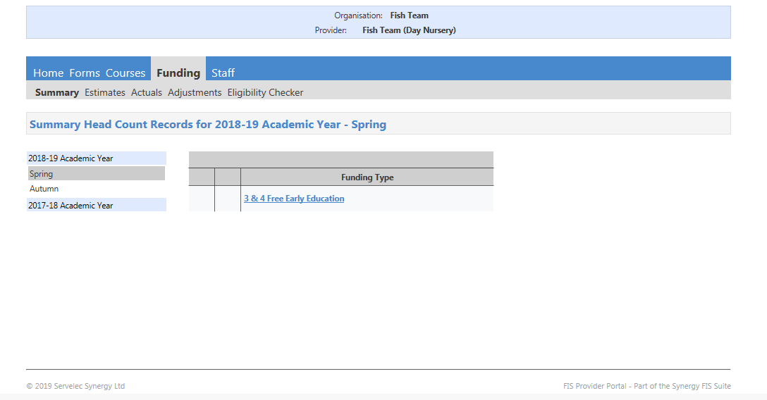
- The term you are viewing will be shown on each tab that you go into.
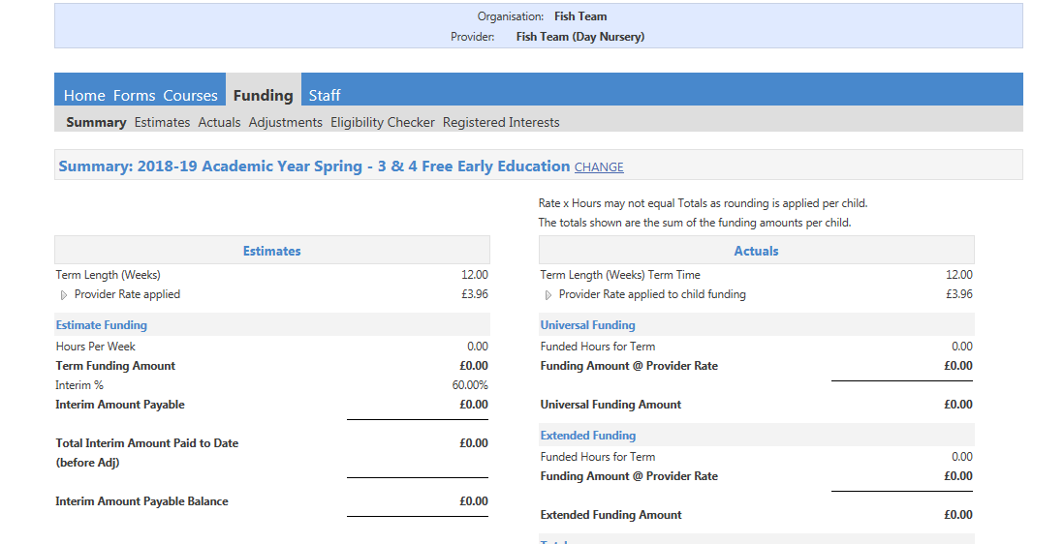
- If you want to change the term/or age group of children entering you will need to click “change” at the top of the screen and you will return to the main street where you can then select the term you wish to view.
- You will then need to select the current year and term as well as the funding group you will be inputting (2 year old funding or 3 & 4 year old funding).
- If you offer funding for 2, 3 & 4 year olds you will need to enter this information separately.
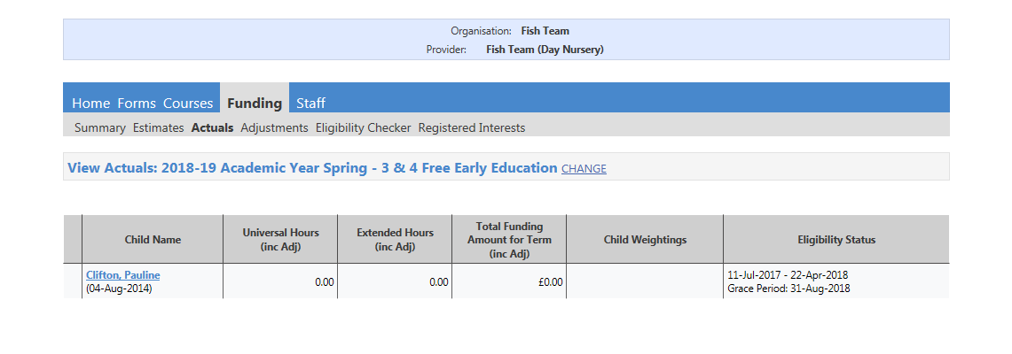
- Once you have chosen the correct term and age group you will be taken to that terms summary screen (see above)
- To input the funding amounts you will need to click on the “Actuals” tab.
- Any children that have previously attended will automatically be shown. However, you will need to input the amount of funded hours they have done as this will have been set to zero.

Adding a new child
- Click “Add Child”
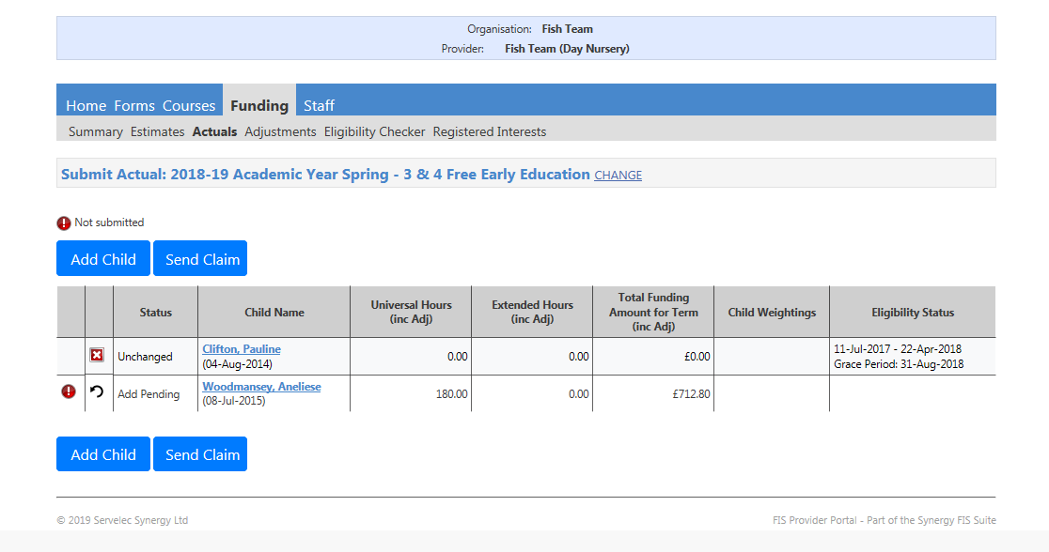
Child Details
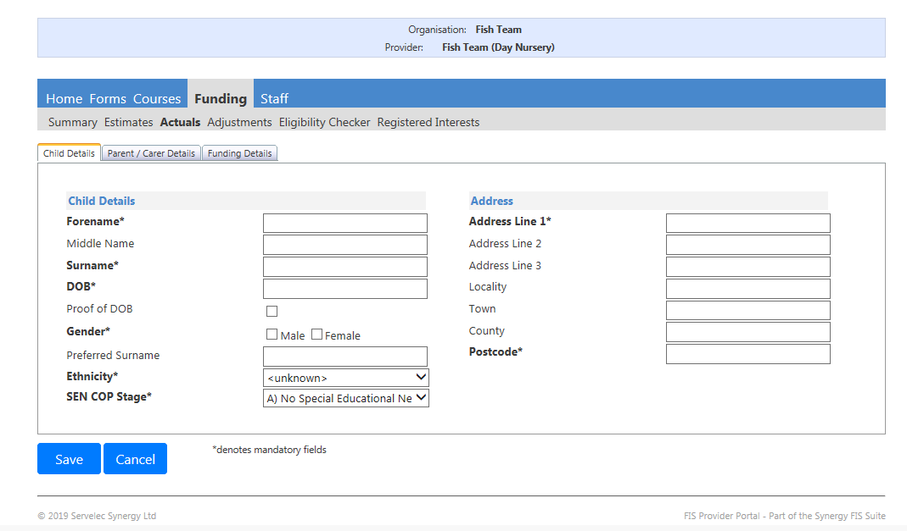
- You will need to complete all of the child’s details – Everything with a * next to it is a mandatory field.
- Complete the child’s forename and surname, and the child’s middle name if applicable.
- Complete the child’s date of birth and click the checkbox to confirm that you have seen proof of the child’s date of birth.
- Tick the relevant tick box for the child’s gender.
- You can enter a preferred surname for the child although this is not mandatory.
- You must make a selection for the child’s ethnicity, DO NOT use any of the fields which begin with “Z”
- You must complete the SEN COP stage drop down box. DO NOT use any of the fields which state ‘do not use’.
- If the child does not have a special educational need please select
- “A) No Special Educational Need”
- You will then need to complete the child’s address, including postcode, on the right.
Parent/Carer Details
- Then move onto the parent/carer details tab
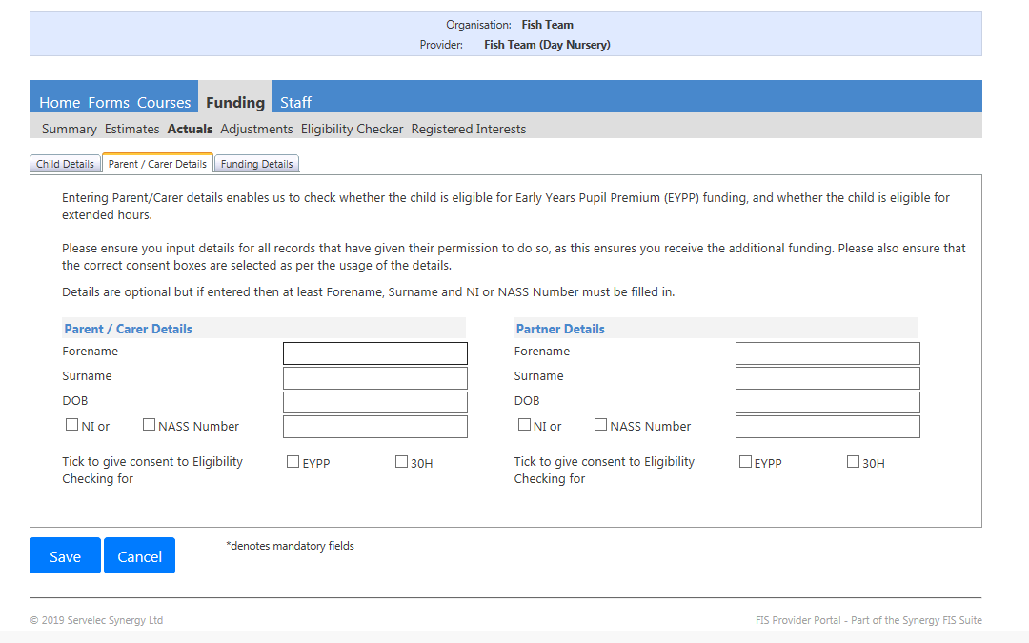
- You must complete this section if you want to apply for the Early Years Pupil Premium (EYPP) for the child or if the child is entitled to the extended entitlement.
- Please note: Children who are in foster care will automatically be identified by the local authority and the childcare setting will be paid the EYPP as long as the child is on your headcount.
- Children who have been adopted or have a Special Guardianship Order in place will also be entitled to EYPP. However in order to ensure payment for these children you will need to call FISH to give us the details of these children.

- To claim EYPP (Early Years Pupil Premium) complete:
  - Parent Forename and Surname
  - DOB
  - NI or NASS number
  - Tick EYPP eligibility consent box
- To claim 30 hours extended entitlement complete:
  - Parent Forename and Surname
  - NI or NASS number
  - Tick 30H eligibility consent box
******DO NOT PRESS SAVE YET or you will receive errors as you have not completed all of the required details******* - move straight onto the “funding details” tab.

Funding Details
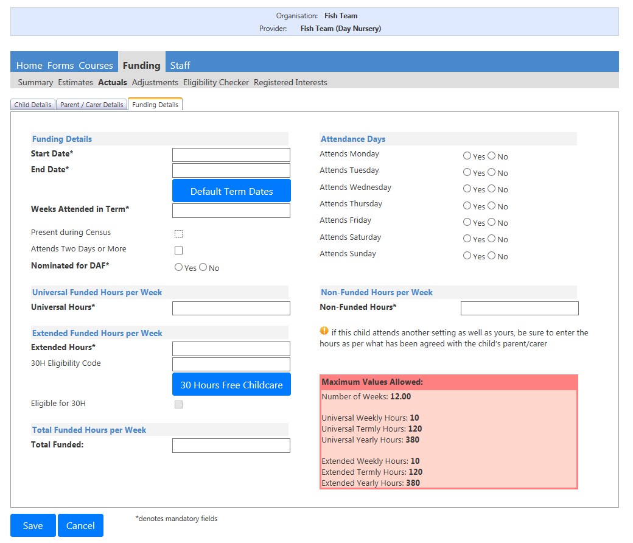
- If the child has/is attending for the entire term you can click ‘Default term dates’ to have these completed automatically for you. If not Enter the start date and end date. (This is the date that the child started in the current term and the date the child is expected to leave during the term OR the end date of the term if the child will be attending for the entire term.)
- Enter the number of weeks the child has attended within that term.
- Use the tick box to confirm whether or not that child was attending during the last annual census.
- Use the next tick box to confirm whether or not the child attends for two days or more.
- You will then need to specify whether or not the child has been nominated for DAF.
- Under the heading ‘Attendance Days’ you can specify the days in which the child attends your setting.
- Under the heading ‘Universal Funded Hours per Week’ you will need to enter the number of hours you are claiming funding for the universal hours. (These are the first 15 hours that all 3 and 4 year olds are entitled to. If the child is entitled to the 30 hours funding, the parent should have made clear on the Parental Agreement the number of universal hours they wish to use with you and the number of extended hours they wish to use with you.)
- Under the ‘Extended Funded Hours per Week’ heading enter the number of Extended Hours that the parent is using with you.
- Enter the 30H Eligibility code that the parent has given you.
- Then click the “30 Hours Free Childcare” button.
  - This will perform an eligibility check on the child. Please ensure that you have entered the correct date of birth of the child and the correct details in the Parent / Carer Details tab.
- Under the heading ‘Non-Funded Hours per week’ - Enter any additional hours that the child attends your setting which are not funded.
- Once you have completed all of this information you should see the total number of weekly funded hours that you are claiming for in the ‘Total Funded Hours per Week’ box.
- If you have input hours into the ‘Extended Funded Hours per Week’ box and you try to save without performing an eligibility check (clicking the blue “30 Hours Free Childcare” button) you will receive the below error.
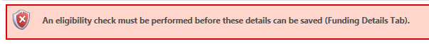
- Once you have completed all the required information click ‘Save’ and you will be taken back to the actuals tab, where you will now see the child that you have just added.
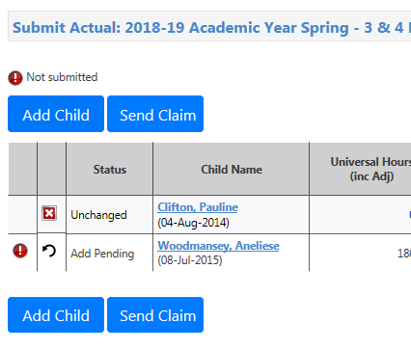
- If this symbol is next to a child’s name it means that the funding claim has not been submitted. (Please do not submit each child individually you will need to add/amend each child who are accessing a funded place and when all complete send them altogether.)

Submitting Claim
- Once all children are added and hours are correct submit your funding claim by pressing the ‘Send Claim’ button (shown above)
- You will see a message that states “Submission successful” and next to the child(s) name will be “awaiting LA download” (this will change when headcount closes and all the date in imported)

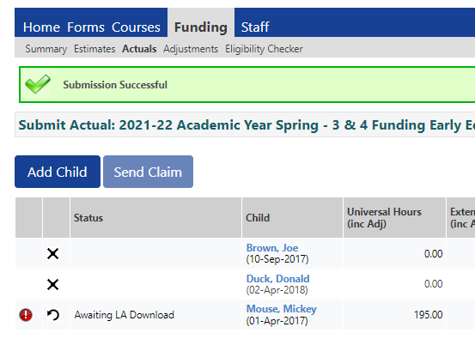

Removing/Editing a child

- To remove a child, click on the button.
- To edit the child details you have inputted click on their name of the child you wish to edit.

Headcount - 2 Year Funding
Please note for children who do not have a code but a letter from the East Riding of Yorkshire Council follow the same process as you would to add 3&4 year old for children on pages 11-15 of these guidance notes.
Those children who have an EY Voucher code follow the below:
- Click funding
- Click actuals
- Choose relevant academic year
- Choose relevant term (remember you can only make amendments/add when headcount is open)
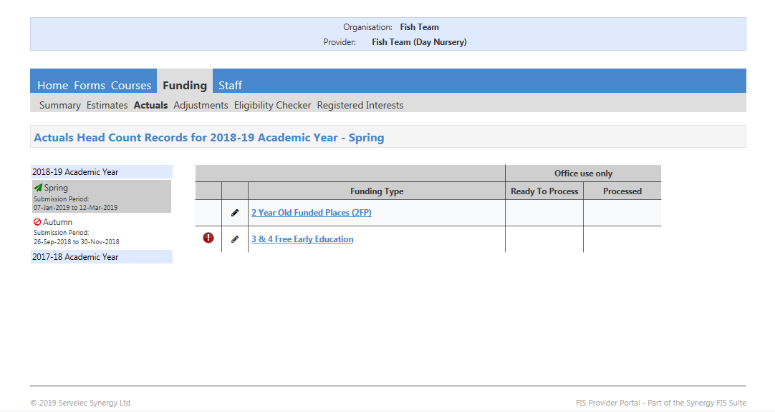
- If you click add child it will bring up usual screen for children who are already accessing 2 year funding without a voucher code
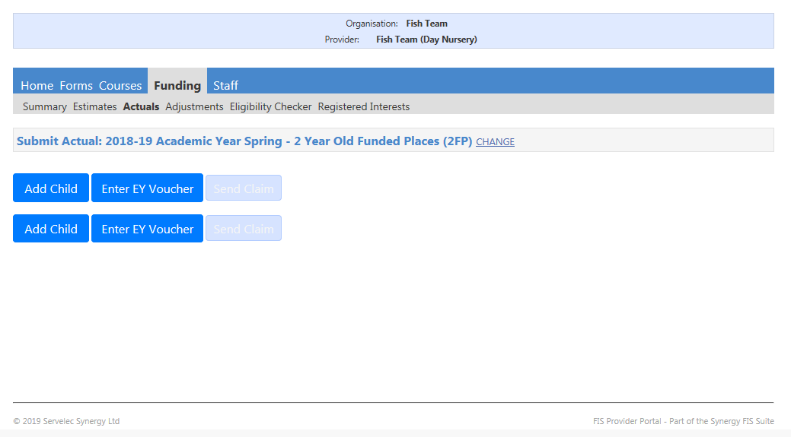
- Click "Enter EY Voucher" button
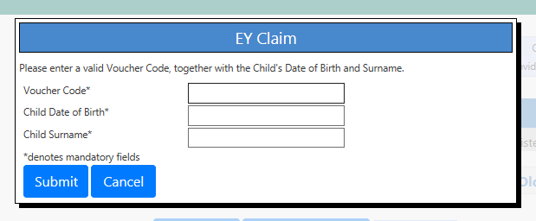
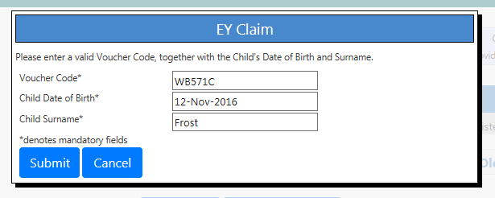
EY codes are now given from the parental portal and the parent should either show you the screen print

- This will then bring up the child's information saving you time of having to input this information.
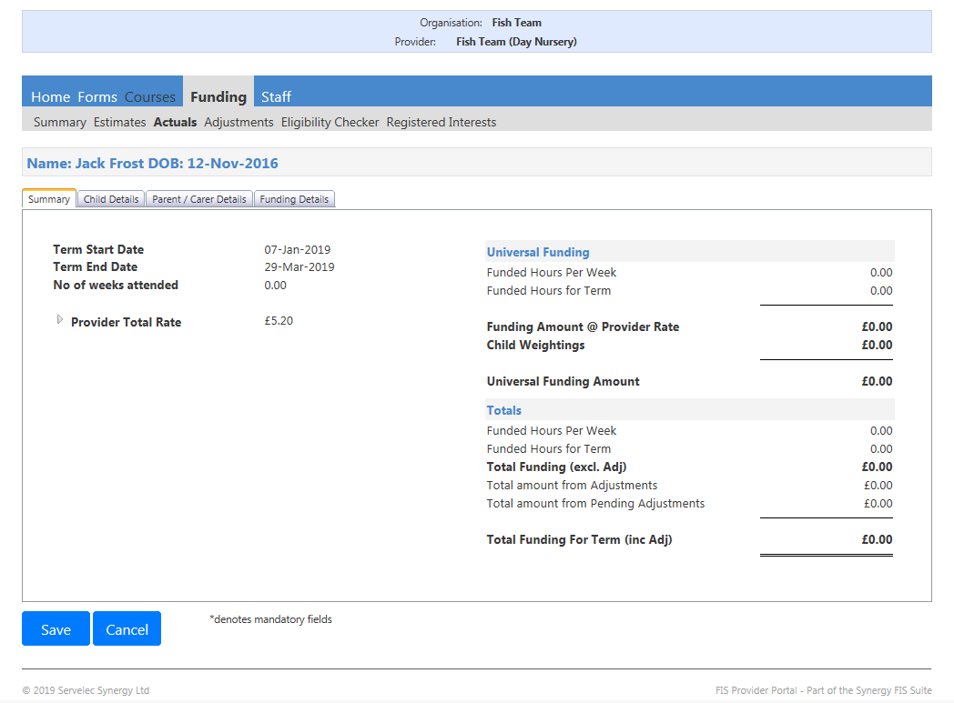
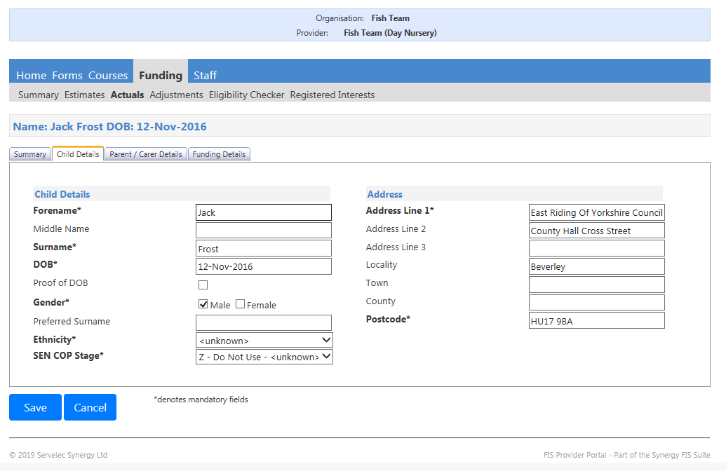
- You will still need in the child details tab to input the information regarding
  - Ethnicity and
  - SEN COP Stage (as these questions are not asked on the parental portal when they set up an account)
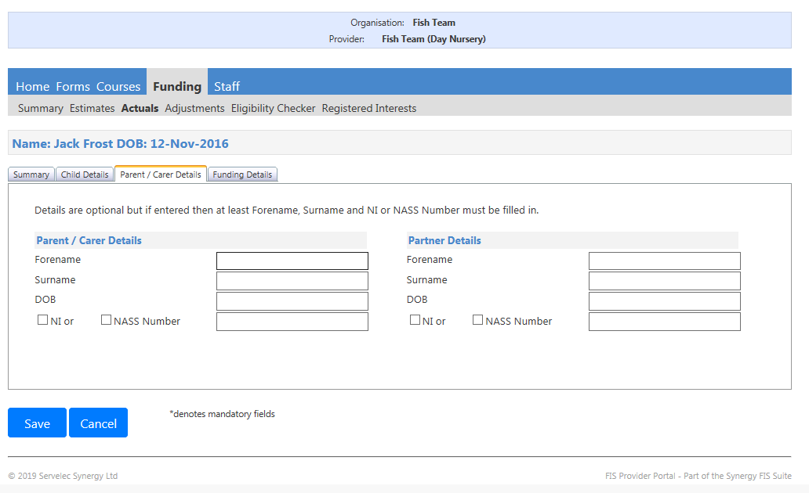
- In the parent/carer details tab the information asked for is not a mandatory field but it is good practice to get into having this information for when the children access 3&4 year funding.
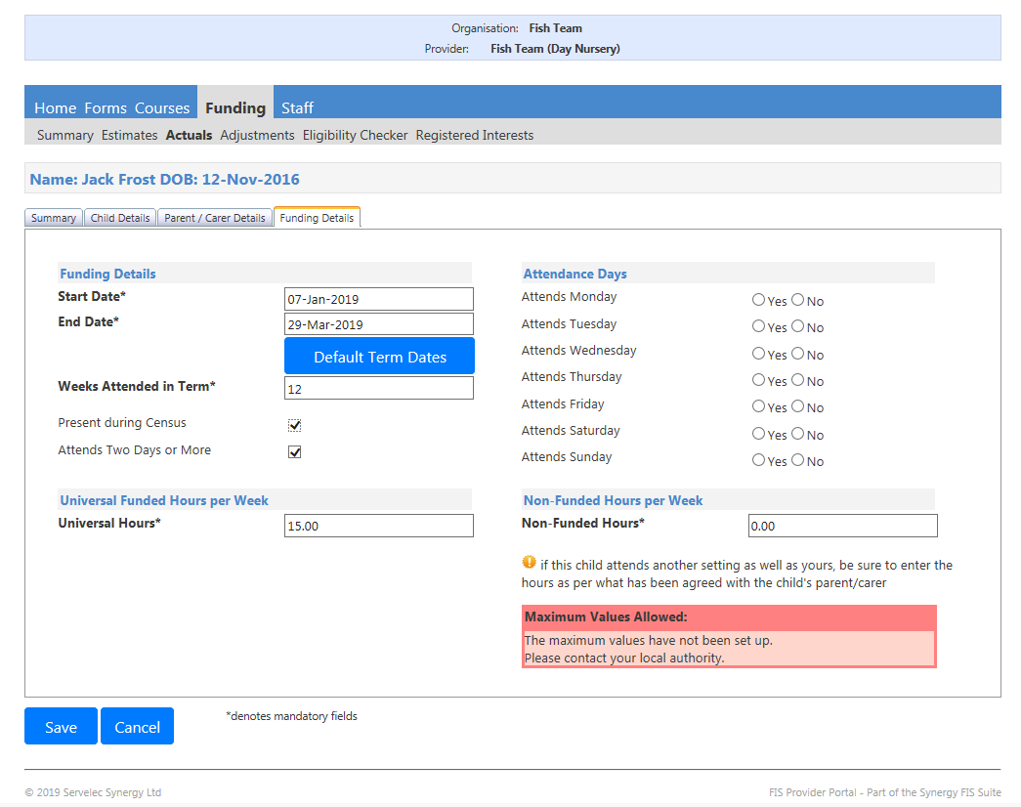
- In the Funding Details tab you will then need to input anything with an * is a mandatory field.
  - Start date
  - End Date
  - Tick whether they are present during census and whether they attend two or more days
  - Insert number of universal hours they access (maximum of 15 hours for 2 year funded places)
  - Click what days they attend
  - Insert if they do any non-funded hours at your setting.
- Click "Save"
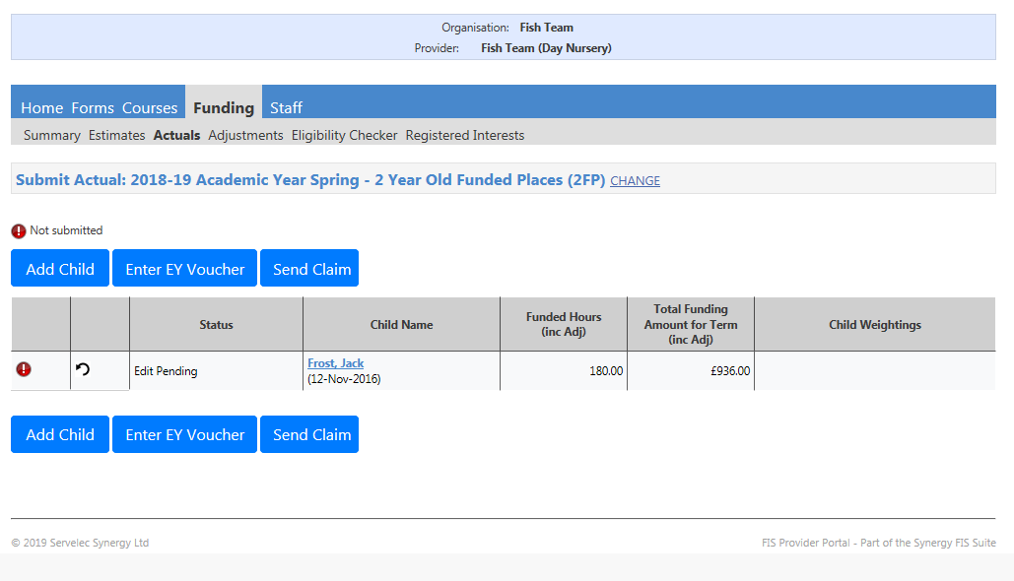
- Once you have completed all 2 year children accessing 2 year funding details you can then "Send Claim" (please do not send them one at a time)

Extended Entitlement Eligibility Checker
****Before using the eligibility checker you will need to ensure you have written consent from the parent / carer to input their details into the e-hub - You can use the Parental agreement form for this, found on the FISH website****
- You will be given the eligibility code from a parent for the extended entitlement this will need to be verified via the e-hub. Please note that you can check a child’s eligibility code at any time, even if headcount is not currently open.
To do this:
- Click “Funding”
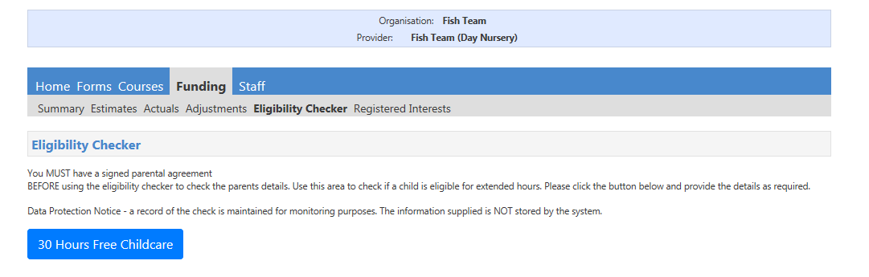
- Click on the ‘Eligibility Checker’
- Click on the “30 Hours Free Childcare” button.
- Enter the details marked with an * - you will also need to tick that you have been given consent to perform this eligibility check.
- Click “Submit”
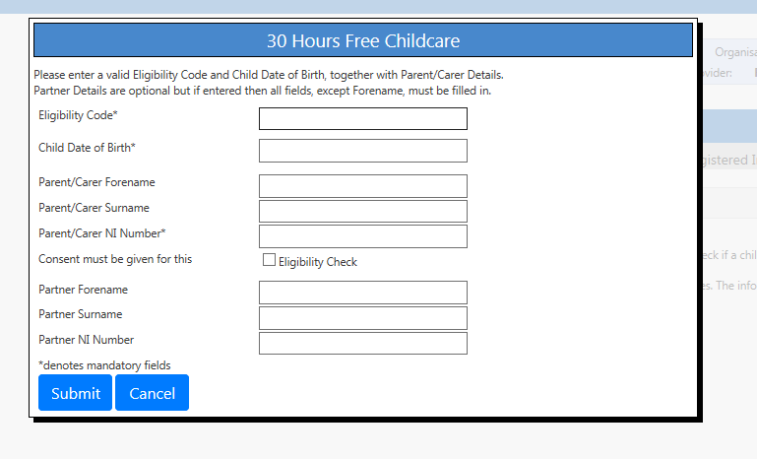
Non-eligible code
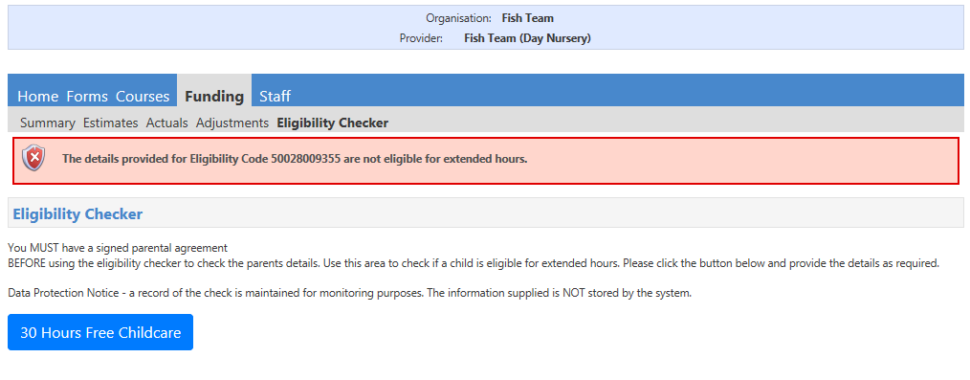
- If the code is not eligible, you will receive an error message. If you receive the above message please ensure that you have entered the correct
  - Childs date of birth,
  - Parents national insurance number
  - and eligibility code.
- We have in recent months seen this error message when the code has gone past both the end date and the grace period end date without being reconfirmed by the parent. This means the code is now not valid and therefore parent cannot access their 30 hours (but still entitled to 15 universal) unless they reconfirm before the cut off dates before the start of the term they wish to access the funding in.

- If you have checked all of these details and you are still receiving this message please advise the parent to call the childcare choices helpline on 0300 123 4097
- If you accept a child without checking they are eligible for the extended entitlement, we will not be responsible for covering this funding and responsibility will fall back on yourself and/or parent to cover costs.

Eligible Code
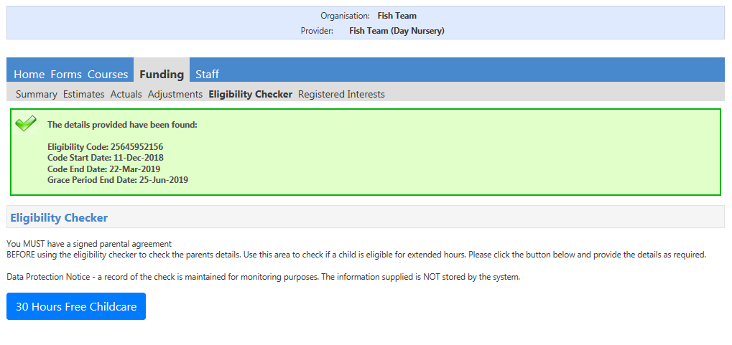
If the voucher code is eligible you will be shown the message below.

The Voucher Start Date - this shows that date in which the parents received the eligible code/applied (N/B please remember that when a parent becomes eligible they can start accessing their funding from the term after) NOT when they applied.
The Voucher End Date – this shows the date which the parent will need to reconfirm their details by in order to stay eligible. (N/B If a parent becomes ineligible on or before this date it will be the Local Authorities responsibility to inform settings that the parent is no longer eligible.) This information will be show on the ehub.
Grace Period – children cannot start their funding if they are in their grace period if they have not accessed the funding before.
***Should a parent become ineligible and have been accessing the funding they can continue to access the funding up until the Grace Period End Date***

Previous Terms - Summary
You can view information that you have submitted in previous terms or years.
This will then allow you to look back at previous funding information, including estimates and ‘child weighting’ payments. (EYPP, DAF where applicable) and adjustment payments. You will NOT be able to edit any of this information.
- Go to funding
- Click Summary
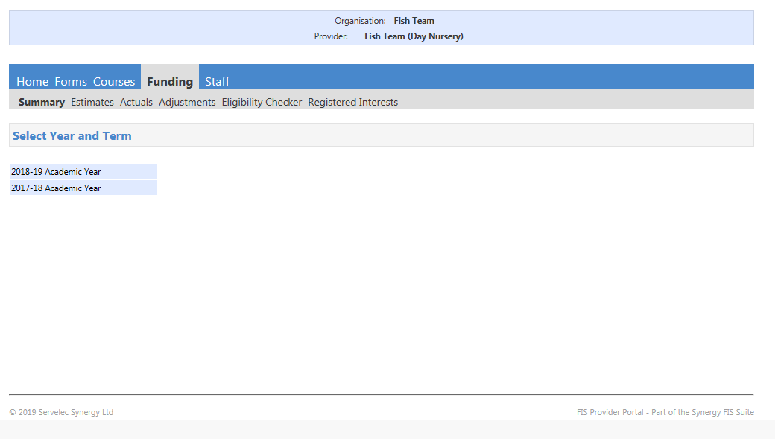
- Choose the academic year you wish to view.
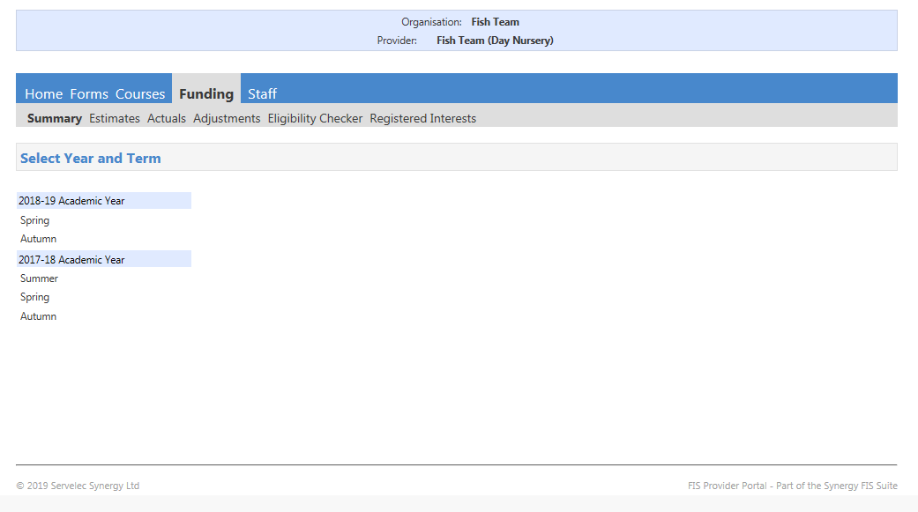
- Choose the term you wish to view.
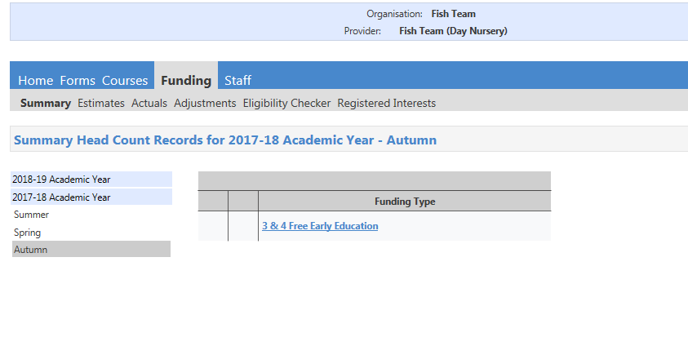
- Choose what funding type you wish to view, choose between:
  - 2 year old funded places
  - 3 & 4 old funded places
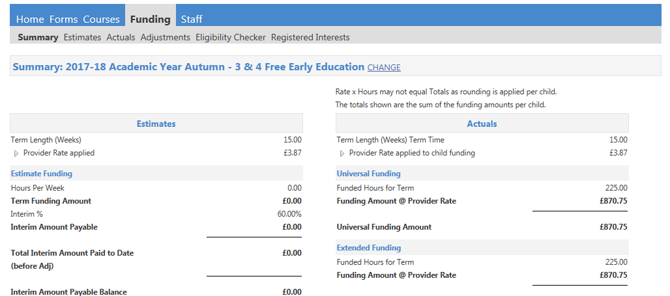
- The term you are viewing will be shown on each tab that you go into.
- If you want to change the term you will need to click the ‘CHANGE’ button and you will return back to the summary page for you to choose which one you need to view.

- After selecting the chosen term you will then be taken to that terms summary screen.
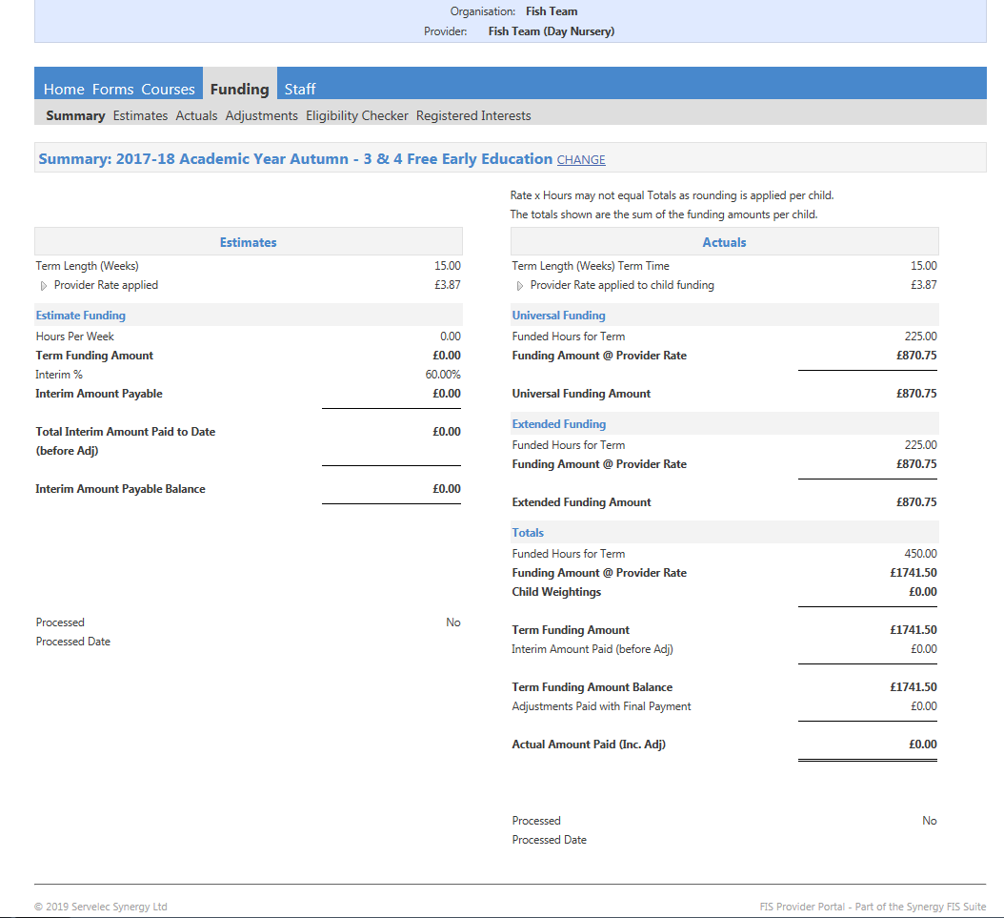

Actuals
To view these:
- Click “Funding”
- Click “Actuals”
This will then show you:
- A list of children who attended during the chosen term.
- The amount of funded hours the child attended for.
- The total amount of funding that was paid for this child.
In the child’s “Summary” tab you will be able to see any additional payments that were made for the child (this will include EYPP). You will also be able to see the 30 hours eligibility status for the child.
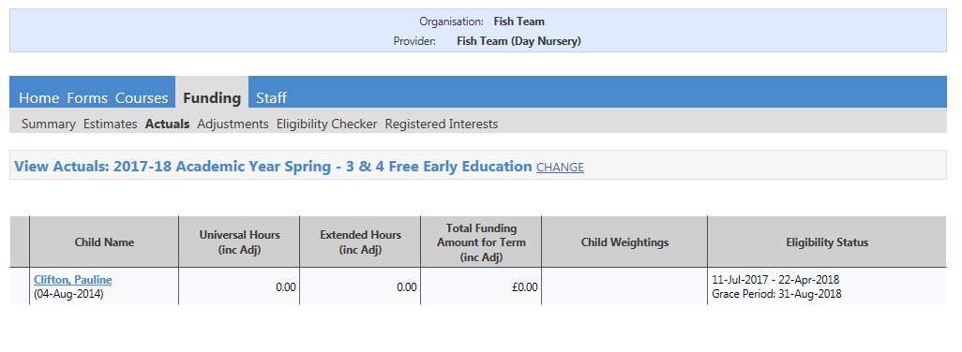
You can click on an individual child to see a summary of the funding that was paid for that child. 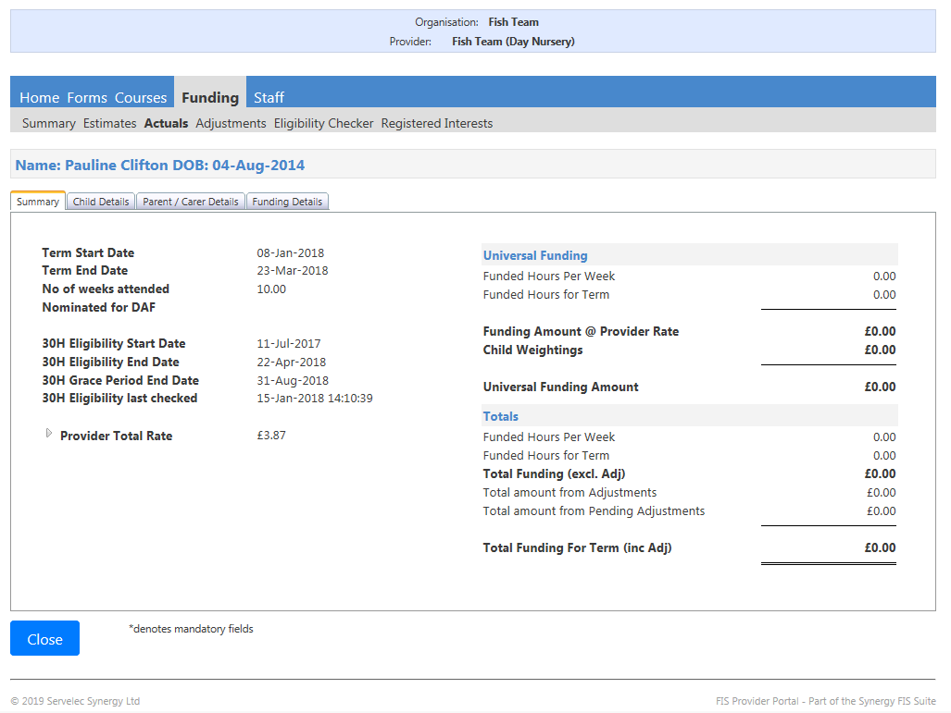
You can also go into the child details, parent / carer details and funding tabs to view the information that you submitted previously. You will not be able to edit any of this information for previous terms.
Estimates
You can now submit your estimates via the Ehub
- Click on the "Funding tab"
- Click on the "Estimates tab"
- Click in the appropriate academic year
- Click the appropriate term (Autumn, Spring or Summer)
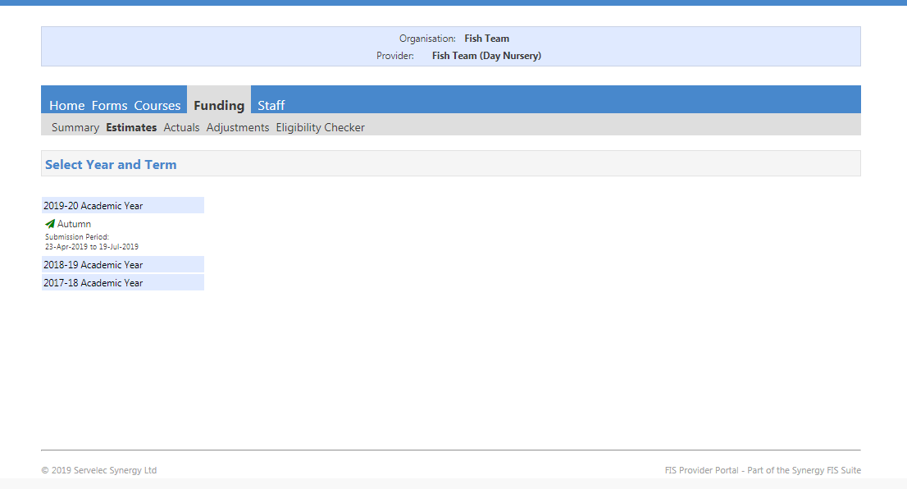
- Click the funding type you wish to submit estimates for (the process is the same for both funding)
  - 2 year funded places
  - 3 & 4 year funded places
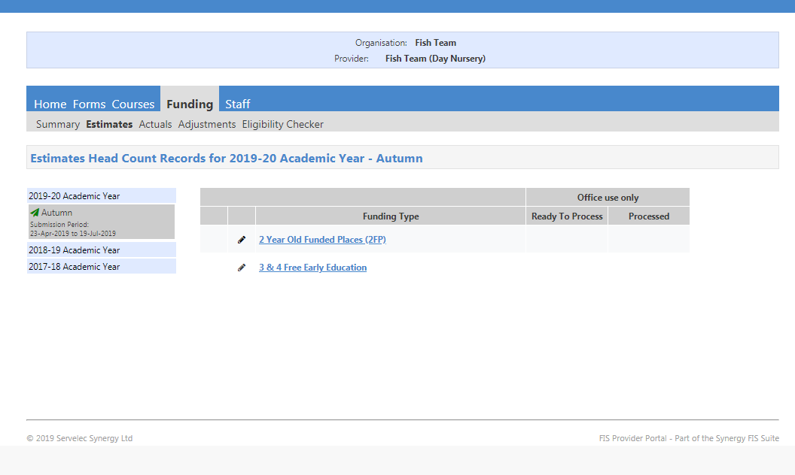
- If you have chosen the wrong funding type you can always click here and it will take you back to the screen before
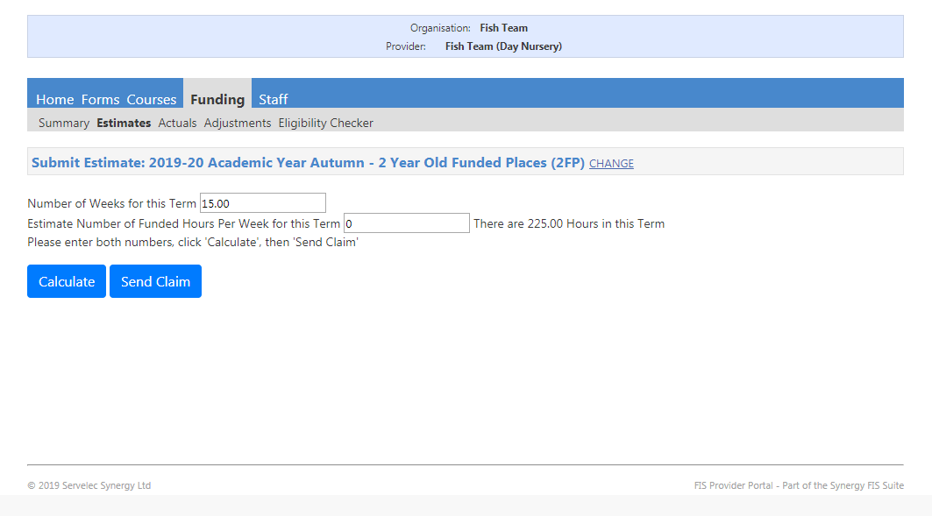
- In the screen the number of weeks for this term will be instantly populated
- You will need to populate the "Estimate number of funded hours per week for the term" you are submitting estimates for. This will be a total for all children accessing funded hours for 1 week. This figure will be automatically be multiplied by the number of weeks in the term when you click Calculate. Please see below for examples.
Example A: 3 children accessing 15 hours of 2 year funded education = you will need to insert 45 hours in this box.
Example B: 2 children accessing 5 hours, 1 child accessing 7 hours and 3 children accessing 15 hours = 62 hours in this box.
- Click "Calculate"
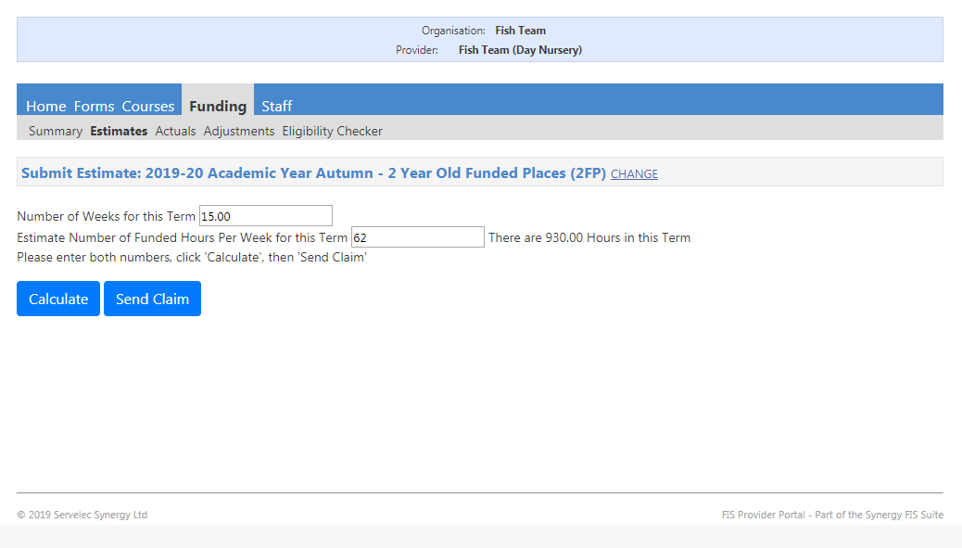
- This will then bring up the total hours you are claiming for that term
- Click "Send Claim"
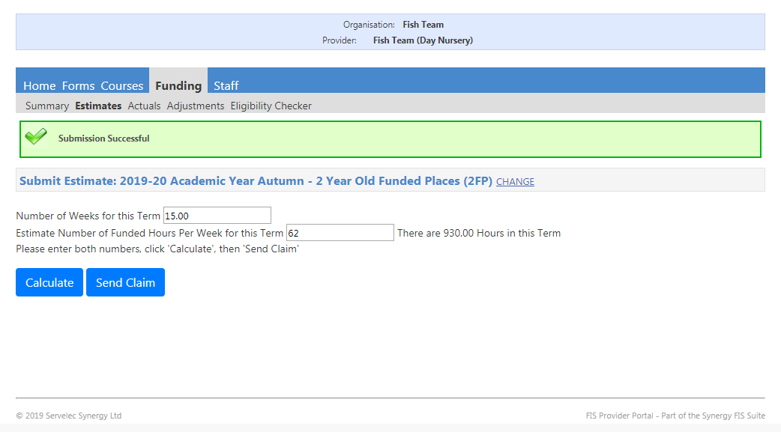
- Once claim is sent it will show at the top as "Submission Successful"
- You will need to repeat this process for 3 & 4 year funded places if necessary.
- The submission periods for estimates are noted on each term under the relevant academic years. For example for Autumn 2019 you can submit your estimates from 23/04/2019 until 19/07/2019 after 19/07/2019 it will be closed and you will no longer be able to submit.
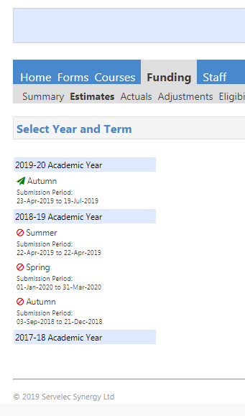
Adjustments
If you need to make any adjustments you will need complete the adjustment details on the Ehub by:
- The adjustment criteria will remain the same. Complete the adjustment email ONLY when a child begins/Ceases to access FEE during term time in the following circumstances:

  - A child starts AFTER headcount and has moved into the East Riding of Yorkshire from another Local Authority.
  - A child starts due to withdrawal of funding or closure of another provider.
  - A child starts after giving 4 weeks’ notice to a previous provider.
  - A child moves out of the East Riding of Yorkshire AFTER headcount, but before the end of term.
  - A child moves out of the East Riding of Yorkshire BEFORE headcount.

- Click “Funding” tab
- Select “Adjustments” you will then get the below screen:
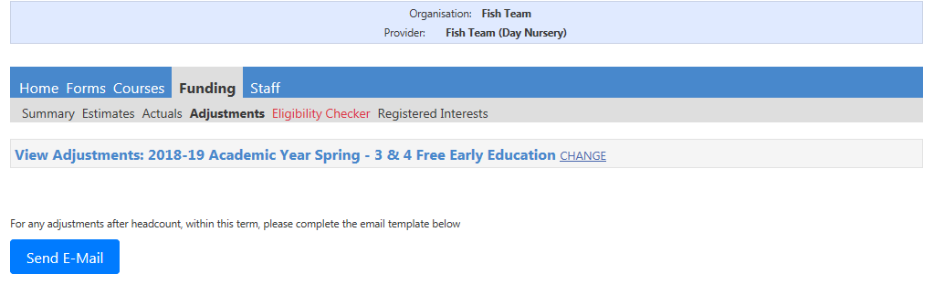
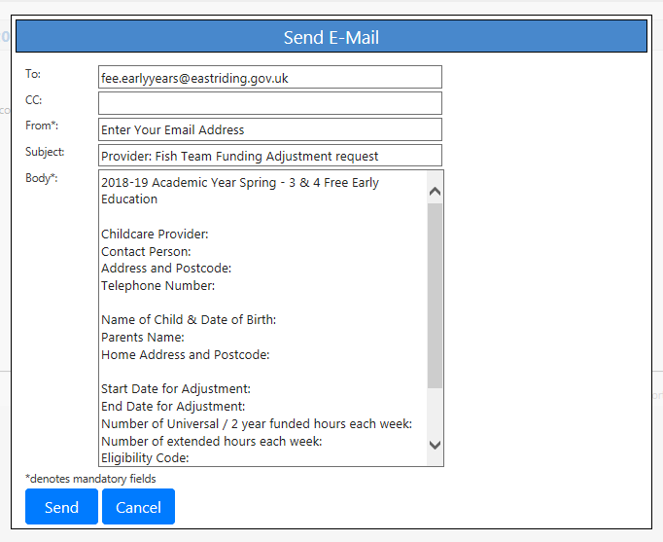
- Click “Send E-Mail”You will then need to complete the necessary information on the template email seen below:
- Once all details are completed press “Send”
- In the adjustments tab you will be able to see any adjustments that you have submitted, the amount of the adjustment and reason for the adjustment.
- Disability Access Funding (DAF) payments will also be shown here.

