

Halloween Colouring Competition

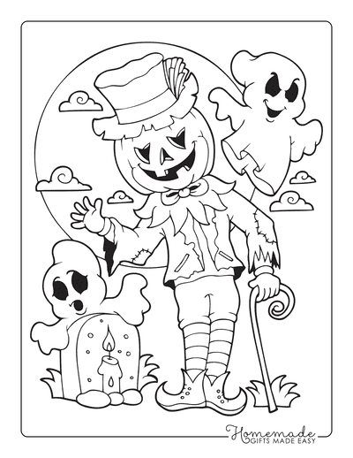

Please fill in contact details on the back.

**Name:**

**Age:**

**Van Number:**