Social Media Guide for Businesses during Scotland Loves Local Week

Scotland Loves Local Week is just around the corner, and we’re excited to celebrate the power of local businesses! This campaign, now in its second year and led by Scotland Towns Partnership, is all about keeping wealth within East Ayrshire, supporting our local businesses, and creating sustainable communities through the shop local message.
From August 26th to September 1st, we encourage you to join the campaign by posting and engaging with campaign content online.

Key Themes & Handy Social Media Straplines
1. Support Local, Shop Local: "Every purchase makes a difference!"
2. Celebrate Our Community: "Together, we thrive."
3. Local Business, Local Pride: "Proud to be part of this community."
4. Keep It Local: "Shop small, shop smart, shop local."
5. Love Where You Live: "Invest in your community."

Suggested Social Media Posts
Customise to suit your own needs or write your own!

1. Post to Encourage Local Shopping
- Text: "This #ScotlandLovesLocal Week, let's show some love to our local shops! Every purchase here supports our community. #SupportLocal #ShopLocal"
- Image/Video: A photo or video showcasing your storefront or a popular product.

2. Post to Highlight Local Collaboration
- Text: "Proud to be working with [Tag Local Business] to bring you the best local [Product/Service]. Together, we make our community stronger! #ScotlandLovesLocal #LocalPride"
- Image/Video: A behind-the-scenes look at your collaboration with another local business.

3. Post Featuring Customer Testimonials
- Text: "Hear what our amazing customers have to say! Thank you for supporting us during #ScotlandLovesLocal Week. #ShopLocal #CustomerLove"
- Image/Video: A photo of a happy customer or a graphic featuring a quote from a review.

4. Post Celebrating Community
- Text: "We're more than just a business – we're part of this community. Thanks for supporting local! #ScotlandLovesLocal #CommunityFirst"
- Image/Video: A community event or gathering you’ve been part of or supported.

5. Post to Promote Special Offers or Star Products
- Text: "Exclusive offer this #ScotlandLovesLocal Week! Get [Discount/Deal/Star Product] when you shop with us. Let’s celebrate local together! #ShopSmart #SupportLocal"
- Image/Video: A promotional graphic or a short video highlighting the offer.

Easy Content Ideas

- Join our online video messaging: Show your support by creating a short clip telling us how you embrace the Love Local message. Be sure to tag us at Love Local East Ayrshire on Facebook and use the hashtag #EALovesLocal24.

- Behind-the-Scenes Content: Share short videos or photos of your team at work, preparing for the week, or interacting with customers and let people see the friendly faces behind their favourite businesses.

- Customer Spotlights: Feature loyal customers who regularly support your business, and share why they choose to shop local.

- Local Business Partnerships: Showcase collaborations or partnerships with other local businesses. Cross-promote each other on social media. This is great opportunity to try out our Instagram/Facebook story template included in your Social Media toolkit!

- Interactive Polls/Quizzes: Create polls or quizzes on Instagram Stories about your products, local trivia, or anything related to your community. It's a fun way to engage followers.

- Thank You Posts: Post a simple and heartfelt thank you to your customers, with a special message about how their support impacts your business.

---

Hashtags to Use

- #EALovesLocal24
- #ScotlandLovesLocal
- #SLLWeek
- #ShopLocal
- #SupportLocal
- #LoveLocal

---

Make sure to tag our accounts in your posts to be shared throughout the week!
Facebook – Love Local East Ayrshire
X (formerly known as Twitter) - @LoveLocalEA
Instagram - @love_local_ea

Social Media Assets

Instagram/Facebook Stories template
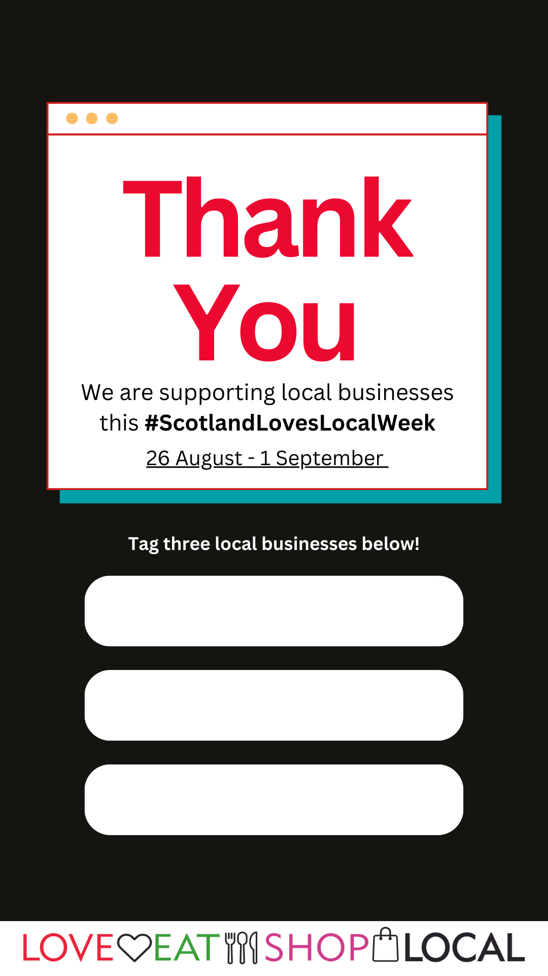

Facebook/Instagram thank you graphic.
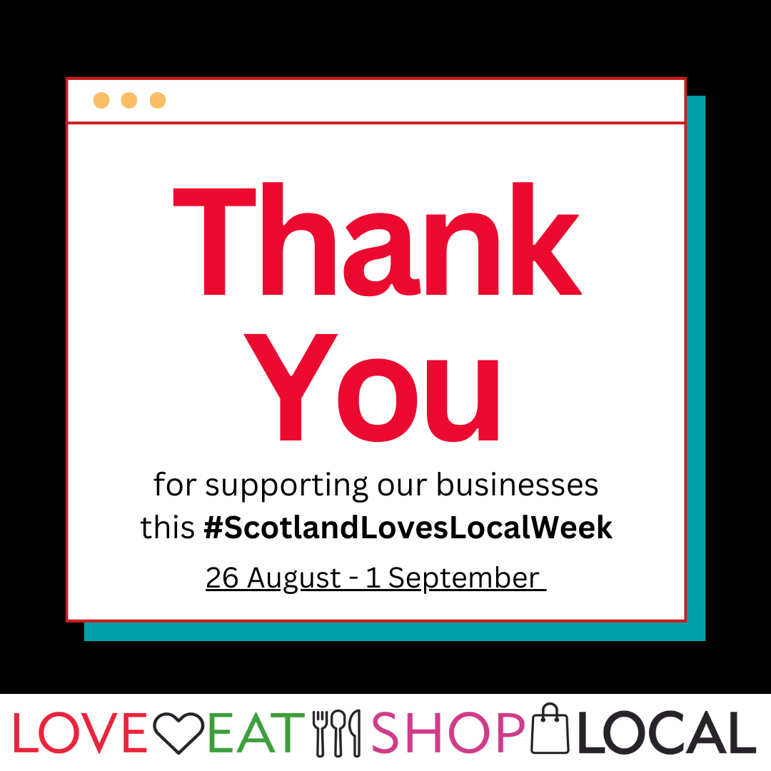

East Ayrshire Gift Card graphic
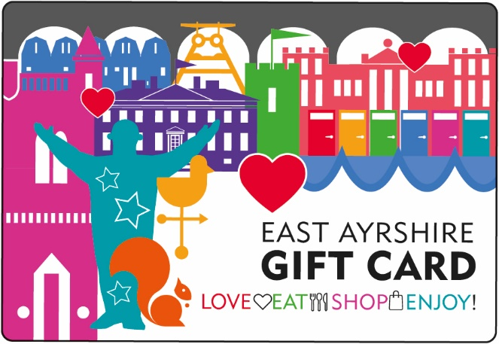

Social media badges

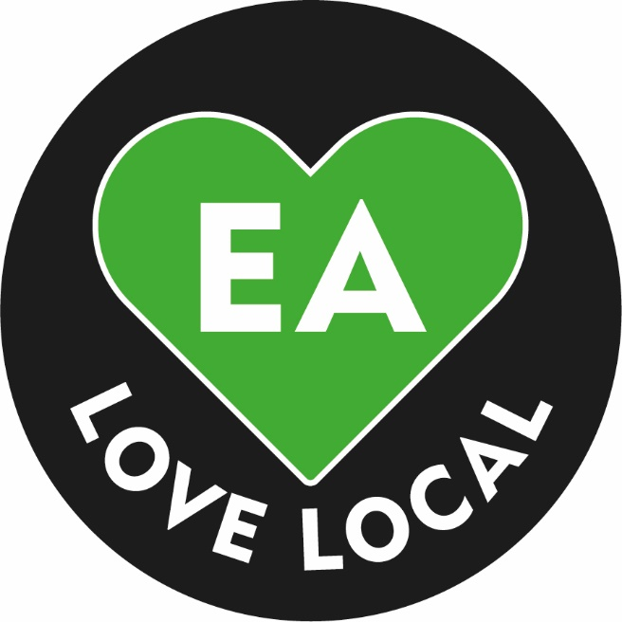
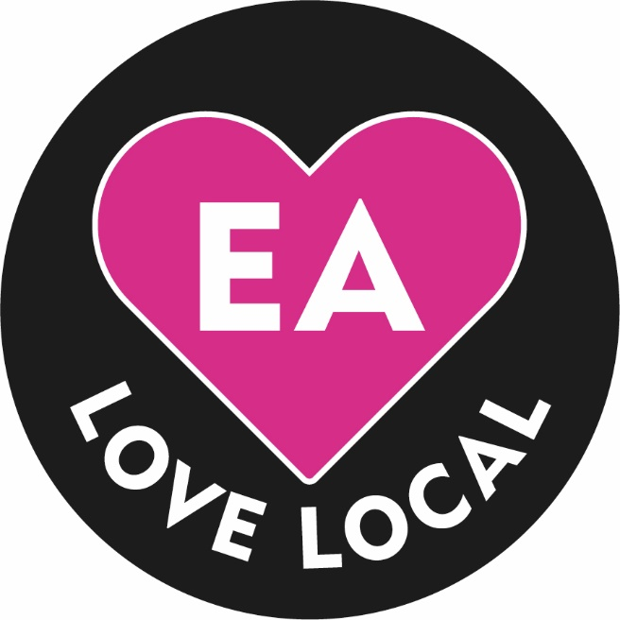
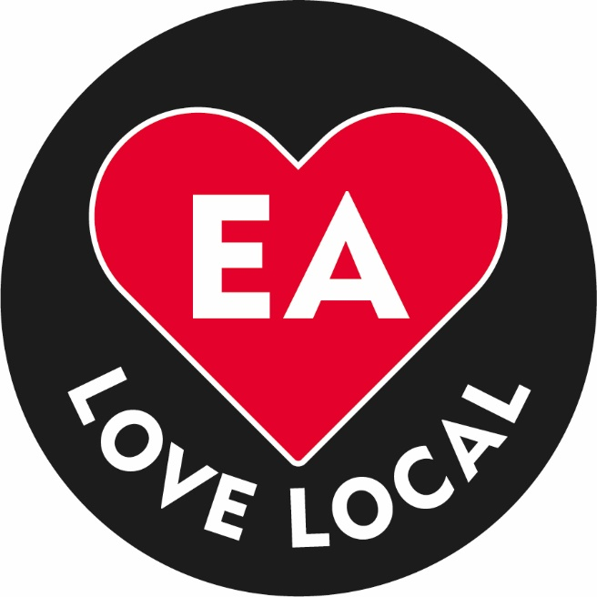

Social Media Banner
