Mentors in Violence Prevention – MVP
Violence remains at an unacceptable level in Scotland. The MVP programme offers excellent opportunities to discuss a range of issues within an educational framework and is connected to the Curriculum for Excellence.
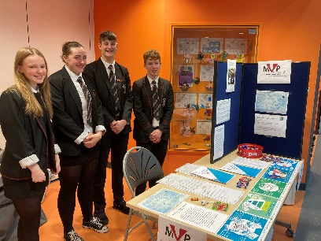
Mentors in Violence Prevention is a peer mentoring leadership programme for young people. It gives young people the chance to explore and challenge the attitudes, beliefs and cultural norms that underpin gender-based violence.
The MVP programme was developed in the 1990s by Jackson Katz in the United States. It utilises a creative bystander approach to prevent all forms of bullying and gender-based violence. Males and females are not looked on as victims or perpetrators but as empowered bystanders with the ability to support and challenge peers. Within the MVP programme a bystander is defined as a friend, classmate, teammate, colleague or relative. It is someone they know. If the bystander can show empathy to the person, then this can result in a reduced threat. “In the end, we will remember not the words of our enemies, but the silence of our friends.” Martin Luther King
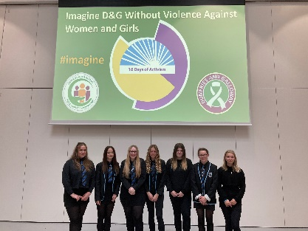
At the 16 Days of Activism Conference on 27 November 2023 at The Bridge, Dumfries, Dalbeattie High School, Sanquhar Academy and North West Community Campus highlighted what they are doing in their schools to promote MVP and encourage their peers to be bystanders. Lockerbie Academy spoke about their Boys 2 Men initiative and as early adopters of MVP they spoke of their MVP journey.
The MVP trained staff spoke to the conference delegates about their roles as MVP trainers and the impact it has in their schools.
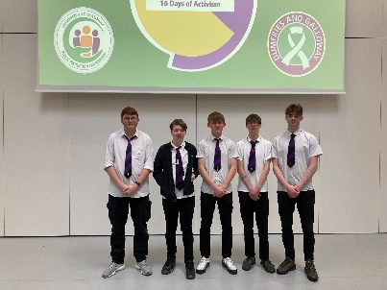
Young people from Sanquhar Academy also recited the poem ‘Imagine’ as well as delivering a powerful performance of locker room chat – what men say about women when they are not there. It was thought provoking and powerful.
The young people from our schools were excellent contributors to the event.

