16 Days of Activism for the Elimination of Violence Against Women 2023
16 Days of Activism for the Elimination of Violence Against Women/Gender Based Violence is an annual international campaign that runs from 25 November (the International Day for the Elimination of VAW) until 10 December (International Human Rights Day).

It is a campaign promoted by the United Nations and promoted by many countries, including Scotland. Dumfries and Galloway, like many places in Scotland, has a programme of events and public information to raise awareness of all the forms of violence against women, the impact of it and where there are supports available. This year, like the rest of Scotland, the message was Imagine Scotland without violence against women and children.
Throughout the 16 Days of Activism, there were many messages shared on social media –some of which were created and posted by local young people on TikTok, Instagram and others on Facebook.
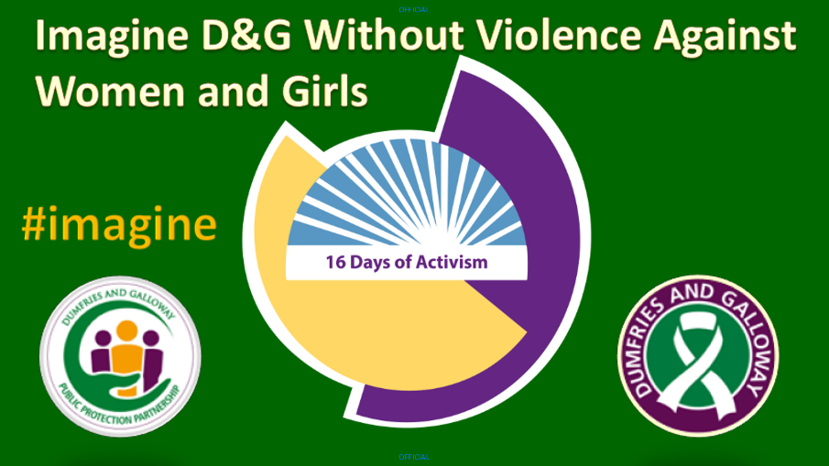
On 27 November, there was a morning conference at The Bridge in Dumfries with the theme “Imagine Dumfries and Galloway without Violence Against Women and Children”. There were 120 attendees, and it was exciting to hear about some of the activities that young people are involved in – both in schools and with other groups and organisations. Pupils and teachers spoke about the inspirational “Boys to Men” project in Lockerbie; Mentors in Violence Prevention (in Lockerbie, Dumfries Academy, North West Campus and Dalbeattie High School); and there was an excerpt from the Locker Room Diaries delivered by pupils at Sanquhar Academy who also delivered “Imagine” a poem by Myra Ross. It was inspiring to hear and see talented young people.
The Young Women’s Network also provided an input on the network’s activities and future plans. A fantastic poem was written and delivered by a young person supported by Wigtownshire Women’s Aid.

Further, there was input on the local White Ribbon Campaign and the National White Ribbon Coordinator spoke about the campaign from a woman’s perspective.

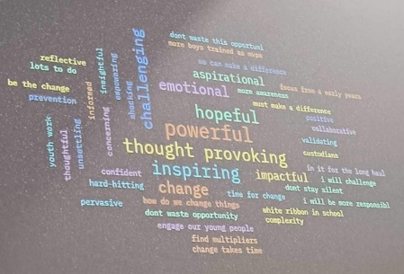
Rape Crisis’s Sexual Violence Prevention Worker also gave input on the project to raise issues such as the impact of pornography and consent in local schools.

People were asked to share their thoughts on the conference via MENTI.

In the afternoon there was a screening of The Bystander film, with an opportunity to discuss how to engage men and women to challenge violence against women. Members of the panel recognised that partnership working, and challenge is needed to prevent and eradicate violence against women.

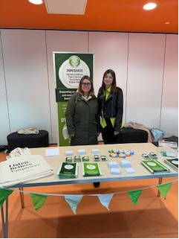
Throughout the day, various agencies had stalls at The Bridge to promote their services and work.

Other events were held online, and included:
- Incel…links to vulnerability with David Russell.
- Psychological Trauma with Rab McColm.
- Revenge Porn Webinar with Kate Worthington.
- Women through a different Lens– Stigma a shared issue-Online Workshop.
- Commercial Sexual Exploitation Workshop with Linda Thomson from the Women’s Support Project.
- Safe and Together Overview.

Dumfries & Galloway Rape Crisis (DGRC) hosted a ‘Night of Empowerment’ at The Stove, Dumfries, on Thursday 30 November. The event ran from 5.30pm to 8pm with guest speakers, winter warming snacks and refreshments and lots of networking buzz. This was the culmination of a competition launched by DGRC in early autumn that asked local creatives to submit work inspired by the word EMPOWER, to send a strong message of strength and survival out to our communities. The competition winners and other finalists spoke about how much the competition has helped them with their healing journey and how they all found writing cathartic in the context of trauma recovery.

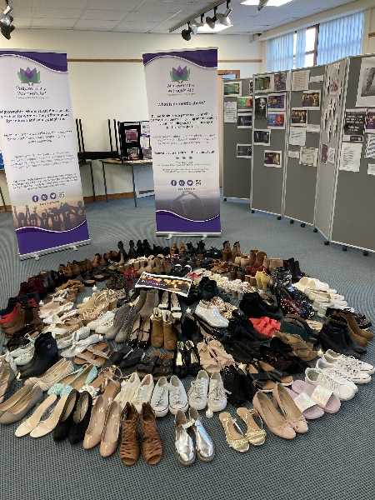
Wigtownshire Women’s Aid held three drop-in exhibition style events across the locality, one in Stranraer, one in Newton Stewart and one in Whithorn. All three events were open to professionals and the public and included videos, poetry, quotes, interactive activities, and a display of shoes to commemorate the lives of woman killed in the UK by a partner or ex-partner in one year. Feedback from the events has been positive and includes: “wow, that’s emotional,” and “it brings home what women suffer and it’s not right”.

Dumfriesshire and Stewartry Women’s Aid hosted an event to launch a local film on Adverse Childhood Experiences which was very well received.

