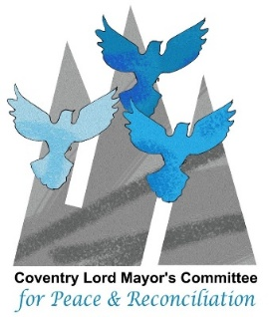
Dear Colleague
Message from the Lord Mayor’s Peace Committee
Peace education has never been a greater necessity than today, education in this area includes; empathy, conflict resolution, and communication skill. These are necessary tools for our children and young people for the 21st century.
As you know there are many ways to develop and maintain peace in a school environment. In schools we nurture a safe and supportive environment and we can discuss, promote peace in a variety of ways such as:
- building a foundation for peaceful societies
- developing conflict resolution skills
- promoting tolerance and understanding
- reducing violence and crime
- supporting sustainable development
- preparing future leasers
- fostering global citizenship
Educating our children and young people about peace is not just a noble endeavour but a necessary one. Please do take time to read the information attached about the Coventry Peace Award. This free scheme is managed by Coventry Lord Mayor’s Committee for Peace and Reconciliation (LMPC). The award is presented to individuals, groups and schools who have promoted peace and reconciliation.
The Award
Coventry Peace Award will consist of a Certificate and a Trophy. The Award is valid for a period of three years, after which you will need to submit evidence of your continued activity in promoting peace and reconciliation.
Steps to gain the award
If you are a teacher in a Coventry school that is interested in getting involved, we recommend you should read the Award Process page
Peace education has an important role in increasing awareness and creating a democratic learning environment for children and young people, paving the way for more democratic societies.
Also included in this email is the Peace Chart 2026 developed by the LMPC, we hope you will find useful. If you have queries please contact Balbir Sohal on balbirsohalconsultancy@gmail.com
In peace
Balbir

