Wellbeing Support for Carers

This wellbeing offer is available to all Coventry City Council Foster Carers and Kinship Carers, (this includes Connected Persons, Special Guardians and carers with a Child Arrangement Order). You have fed back to us and asked us to provide support for your wellbeing, and this offer is being made available to you as part of that commitment. For simplicity and consistency throughout the document, we have referred to everyone collectively as 'carers'
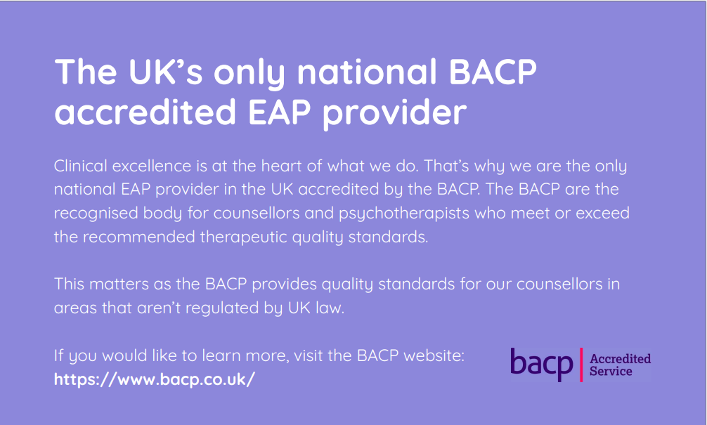
Wellbeing support tailored for you
healthassured.org | your trusted wellbeing partner
The UK’s exclusive national BACP-accredited EAP provider
At the core of our service is clinical excellence. We proudly stand as the only national EAP provider in the UK accredited by the BACP, the recognised authority for counsellors and psychotherapists who meet or exceed recommended therapeutic quality standards.
To learn more, visit the BACP website: https://www.bacp.co.uk/
Carers Support
Structured Counselling
Using the solution focused model, carers can use our confidential helpline to access our best-in-class, BACP accredited counselling service with one of our qualified 2,000+ counsellors. Individuals can access the service via telephone, live chat, video call for face to face.
- Carers will be assessed (triaged) by qualified counsellors to ensure they receive the right care
- 24/7 helpline for counselling, legal and financial advice
- Up to 12 sessions of structured counselling per person, per issue, per year

Support for your immediate family
Carers can also extend confidential counselling support and life coaching to their immediate family. This includes:
- Partners
- Dependent children (aged 16 to 24 in full-time education and living in the same household)

Life and leadership coaching
Using the GROW model (Goal, Reality, Options, Will) our life and leadership coaching can help individuals focus on development within a life and/or professional skill. Carers will get 4 sessions which can focus on:
- Wellbeing
- Career progression
- Personal/professional relationships
- Work/life balance
- Stress management
- Coping with change and much more

Financial coaching (powered by Munny)
With the 1:1 coaching service, carers can access personalized financial guidance to help unlock their financial potential and improve the mental health concerns surrounding finances. The service can support with:
- Household budgeting
- Credit, borrowing and debt
- Insurance and protection
- Financial future
- Cybersecurity
- Cost of Living
- Pension advice
Up to 3 sessions of financial coaching per person, per issue, per year.

Legal & Financial
Available 24/7, our in-house legal team can provide you with legal consultations on a variety of issues ranging from personal and financial, through to probate and will. We also address:
- Consumer rights
- Family and matrimonial law
- Civil litigation
- Landlord, tenant, housing and property law
- Debt support
- Immigration and much more

Medical
Whether you’re still awaiting support from a GP or need general advice, you can get support from one of our qualified nurses who can support you with musculoskeletal conditions, bugs, viruses and everything in between. While we can’t diagnose or prescribe treatment, we can signpost the right place for support.

Wisdom
As a member of HA | Wisdom Wellbeing, carers gain exclusive access to our unique wellbeing app designed to track wellness, improve mental health, and stay resilient during tough times.

Interactive mood tracker
You will receive regular prompts to track your mood. By tracking mood trends. Wisdom can help you identify patterns and areas for improvement in your wellbeing.

Four-week health plans
Wisdom will support you in your health goals, whether that be eating healthier, quitting smoking, sleeping better, or coping with pressure. Get started on your health plan and track your daily progress.

Mini health checks
How are you feeling today? Take a minute to check in with yourself by using the health checks to assess and support your health and mental wellbeing.

Breathing techniques
Our guided breathing exercises help you feel a sense of calm and relaxation to carry into the rest of your day.

Counselling, HR & legal advice
Contact HA | Wisdom Wellbeing directly on the Wisdom app to access quick counselling support, HR and Legal advice. Our helplines are open 24/7, 365 days a year.

Exclusive content
Carers gain access to insightful articles, podcasts, audio and video content surrounding mental and physical wellbeing.

Perks & discounts
You can also gain access to 1000’s of perks and discounts from our marketplace hosted by BrightHR. Save on hotels, travel, shopping, spas and much more.

Digital support

Combining AI and real answers, Wisdom AI is our revolutionary platform powered by answers from our clinical experts. If carers need and answer about mental health and wellbeing quickly, Wisdom AI can help.

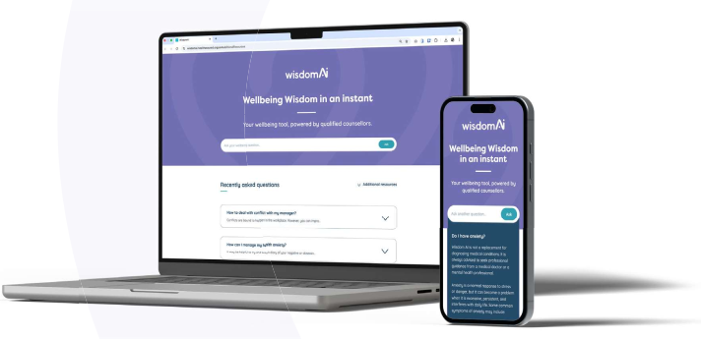

SilverCloud: Digital CBT

As part of HA Wisdom Wellbeing’s clinical interventions, carers can receive online CBT (cognitive behavioural therapy) programmes (if appropriate). Available on desktop, mobile, and tablet, the SilverCloud platfrom is user friendly, engaging and hosts over 30 support programmes, including (but not limited to):

- Space for Resilience
- Space from Money Worries
- Space from Stress
- Supporting teens and children with low moods and anxiety
- Space from Anxiety
- Space from Depression
- Space for Sleep
- Space in Diabetes
- Space in Lung Conditions
- Space in Chronic Pain
- Space in Chronic Heart Disease
- Space from drug use and alcohol
- Space from Phobia
- Space from OCD (Obsessive Compulsive Disorder)
- Trauma programmes

Rightsteps: Menopause Cognitive Behavioural Therapy (CBT)

Developed by Professor Myra Hunter at Kings College London, Rightsteps is tailoured CBT focused on those experiencing the effects of the menopause. It can help:

- Manage problematic symptoms such as hot flushes and night sweats
- Provide strategies for managing anxiety and depression
- Reduce stress and negative thoughts
- Give you the skills to build your support network

