Find out more about supporting your child with primary school maths
Join our free 10-week course ‘Maths in the Primary School’
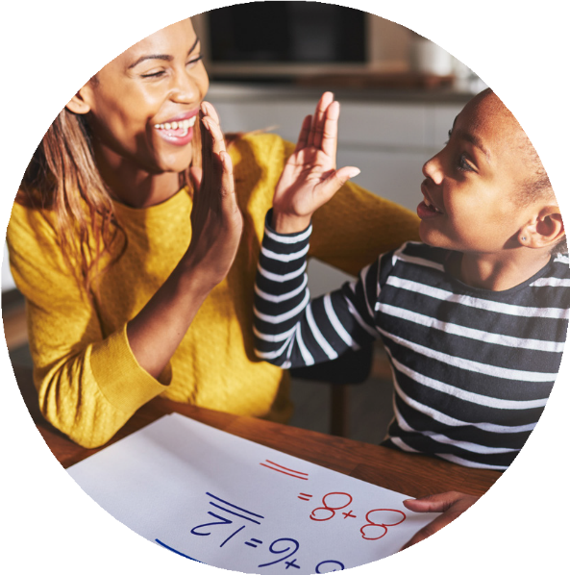

This course is for
Parents and carers with children at school in Coventry

What we do
- give you more maths confidence
- explain the maths methods used
- learn and understand maths words used in school
- give you fun games to take home and play with
your children

Where it is
‘I felt really comfortable – they made the maths easy to understand. The great games didn’t feel like homework at all’

Coffee Tots @The Wave Waterpark, New Union St,
Coventry CV1 2PS

When it is

12.30-2.30pm every Thursday from 15th January

How to join

To enrol click the QR code or go to https://www.coventry.gov.uk/adulted

For further information email aeslifeskills@coventry.gov.uk


*Assume you have a place unless you hear from us *
