Find out more about supporting your
free
online
course
child with primary school maths
Join our free 10-week online course -
‘Maths in the Primary School’

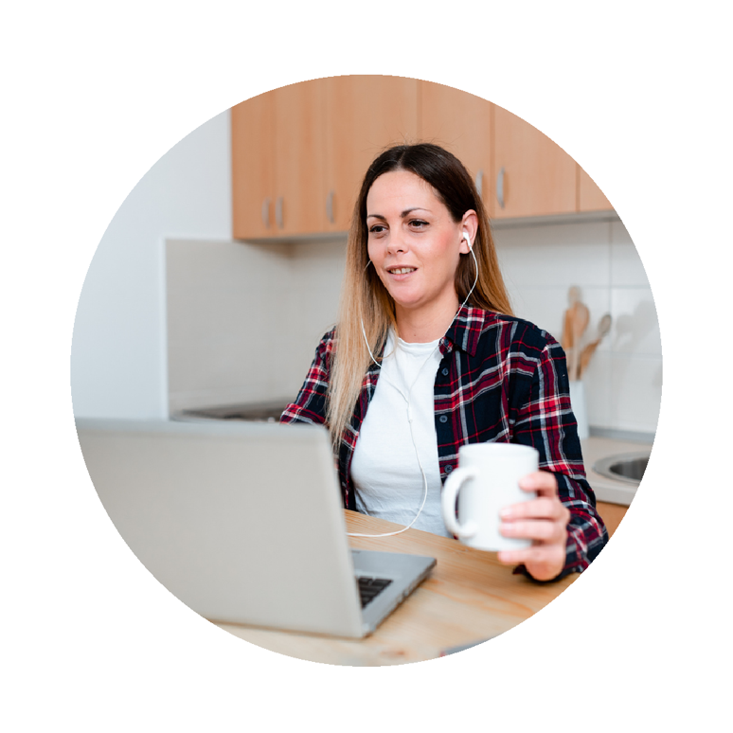
This course is for
All parents and carers with children
in Coventry

What you’ll learn
The maths words and methods used in primary
schools and how you can help at home

What we do
- email you a new 30-minute course video
each week
- give you digital resources to help your learning
- answer any questions you’ve got by email
‘I learnt a lot – now it’s much easier to help my son with his maths’

Where it is
A pre-recorded online course to watch where and
when you like

When it is
Emails sent on Mondays, containing all the information for that week
From Monday 12th January for 10 weeks
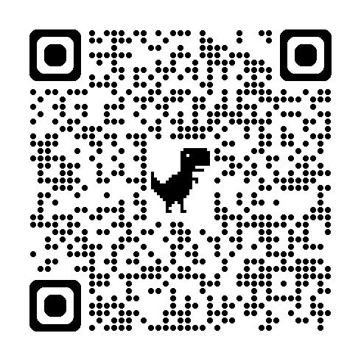

How to join
Svca the QR code
View all Family Learning courses and enrol online at www.coventry.gov.uk/adulted
To find out more email aeslifeskills@coventry.gov.uk
*Assume you have a place unless you hear from us*

