Find out more about supporting your
free
online
course
child with reading and writing


Join our free 10-week online course-
‘English in the Primary School’

This course is for
All parents and carers with children aged 2-10
in Coventry

What you’ll learn
The phonics, reading, grammar and spelling used in primary schools and how you can help at home

What we do
‘This was great as I work full-time and couldn’t go to the daytime classes.’
- email you a new 30-minute course video
each week
- give you digital resources to help your learning
- answer any questions you’ve got by email

Where it is
A pre-recorded online course to watch where and
when you like

When it is
Emails sent on Mondays, containing all the information for that week
From Monday 12th January for 10 weeks

How to join
Scan the QR code to enrol
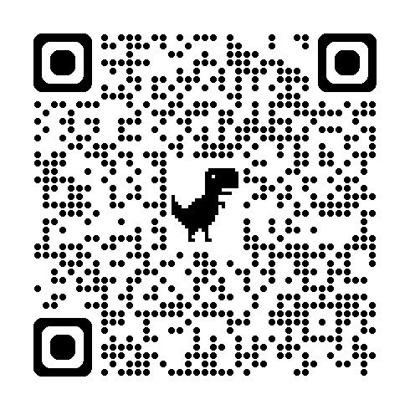
View all Family Learning courses and enrol online at www.coventry.gov.uk/adulted
To find out more email aesloifeskills@coventry.gov.uk
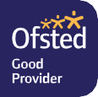
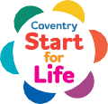
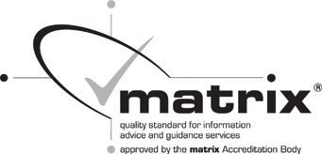

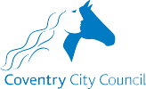
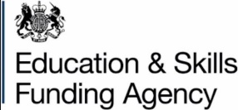
*Assume you have a place unless you hear from us*

