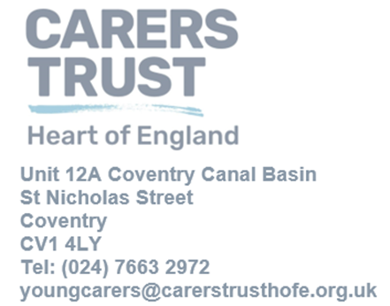
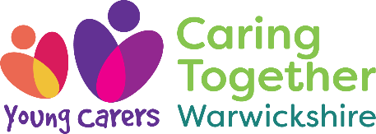

Dear colleagues, families and partners,
We are writing to clarify who we are, what we do, and, most importantly, how to make sure young carers across Warwickshire get the right support, first time.
Following feedback with families and external professionals, we understand there has been some confusion about various offers to support for young carers, and where referrals should go, with a few being sent to a different organisation. We want to prevent delays so that young carers receive timely support. Please use the referral routes below to reach our commissioned service directly.
Who we are
Carers Trust Heart of England delivers the Caring Together – Young Carers Warwickshire, the county’s commissioned young carers service for statutory young carer assessments and wellbeing/respite groups. Learn more: Young Carers - Caring Together Warwickshire
What we do
Through Caring Together – Young Carers Warwickshire we offer:
- Young Carer assessments (statutory) and tailored support planning. Link to our referral page Referrals - Caring Together Warwickshire Young carers assessment - Caring Together Warwickshire
- One-to-one emotional support, information and advice. Young Carers Wellbeing - Caring Together Warwickshire
- Group activities and social opportunities that provide respite and peer connection. Activities - Caring Together Warwickshire
- Health and wellbeing support and resources for families and schools. Young Carers Wellbeing - Caring Together Warwickshire
- Young Carers Voice Young carers voice - Caring Together Warwickshire
- School support Resources For School's - Caring Together Warwickshire

How to refer to us (assessments and our groups)
- Online referral (Young Carers): https://www.caringtogetherwarwickshire.org.uk/young-carers-referrals/ Caring Together Warwickshire
- Helpline: 0800 197 5544 (Mon/Wed/Fri 9am–5pm; Tue/Thu 9am–8pm; Sat 9am–2pm)
- Email:youngcarers@carerstrusthofe.org.uk or hello@caringtogetherwarwickshire.org.uk
- Website: Home - Caring Together Warwickshire or Home - Carers Trust Heart of England
If you’re unsure where a previous referral went, or you haven’t had an acknowledgement within 5 working days, please contact us and we’ll check immediately. We’ll confirm whether we have it and, if not, help you redirect it quickly.
About our groups
We run wellbeing & respite groups countywide. We know other providers also run groups, sometimes in similar locations which can add to the confusion. If you’re not sure whether a group is ours, just contact us we’ll happily confirm and advise on how to join. Or you can find our monthly activities here: Activities - Caring Together Warwickshire
Working respectfully across the system
We value the wider network of organisations supporting young carers, including Warwickshire Young Carers (WYC) and similar young carers support groups across Warwickshire . We also believe that families and young carers should be able to benefit from all appropriate services. To avoid any misinterpretation of service roles, please send statutory young carer assessment referrals and enquiries for our commissioned wellbeing/respite groups to Caring Together Warwickshire (Carers Trust Heart of England)
Thank you for everything you do to identify and champion young carers. If you’d like further information regarding our service and support for unpaid carers we can provide posters with QR codes for corridors, bathrooms or staff rooms, email us, we’ll send print-ready copies. You can also keep up with updates on our Social media pages:
Instagram caringtogetheryoungcarerswarks
Twitter @CarersTrustHofE
Referrals - Carers Trust Heart of England (carerstrusthofe.org.uk)

Warm regards,
Young Carers Service Manager
Carers Trust Heart of England

