For families with children under 5
Collect your free fun Bookstart pack from your local
Coventry Council-run library

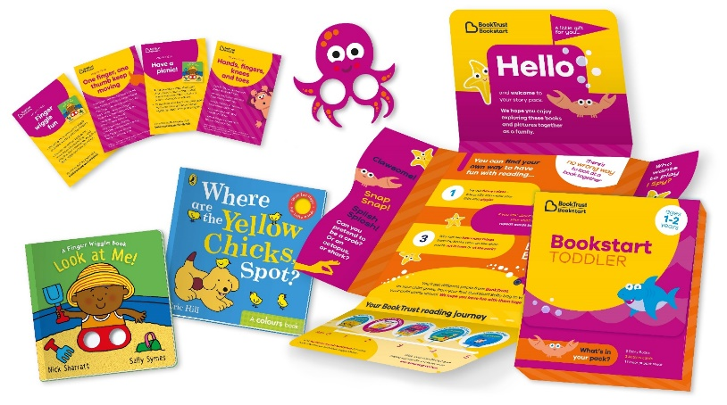
Bookstart Toddler packs for 1–2-year-olds

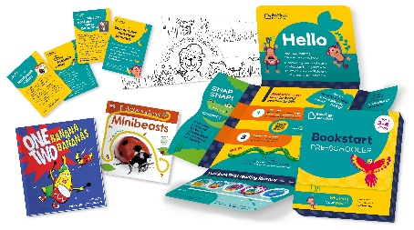

Bookstart Pre-schooler packs for 3 - 4-year-olds

These packs are offered free to low-income families You don’t need to bring any id or proof of income, just call in and ask for a pack
Sharing books and rhymes with young children can be a lovely experience, and can improve your child’s social, communication and educational skills

www.coventry.gov.uk/libraries

