


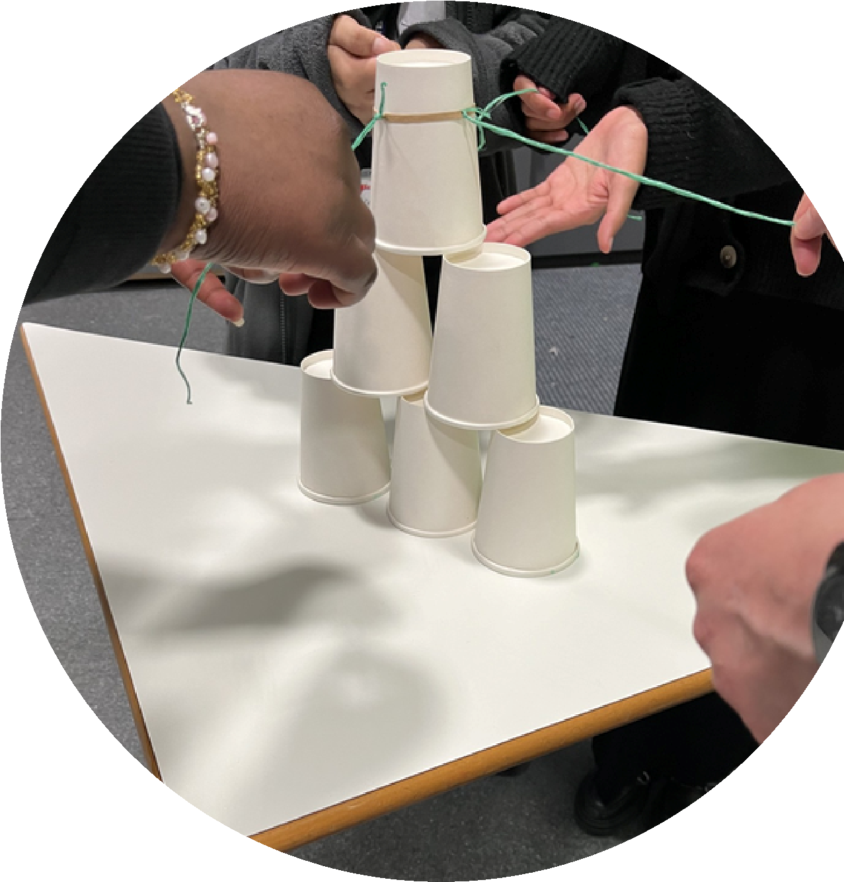


Fully funded
Peace Education Training

On Friday 11th July,

9.00-3.30
Venue
:
Conference Block,

Lyng Hall Secondary School,

Blackberry Lane,

CV2 3JS
Coventry Secondary Teachers
for
For bookings and further information contact Balbir:

balbirsohalconsultancy@gmail.com

This free whole day training will support you to:
understand the what and how of peace education
explore the relevance of peace education
for young people today
learn how to build peace in
schools
practise running peace based
activities in a circle format
plan how to incorporate
peace education in your work

