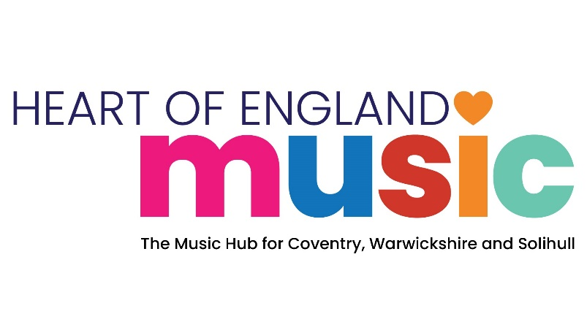

www.heartofenglandmusic.com


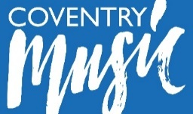


Digital Music Festival School Consent Form

FILMING AND PHOTOGRAPH PERMISSIONS FOR HEART OF ENGLAND MUSIC DIGITAL FESTIVAL
The school’s head teacher must complete this form to notify HEART OF ENGLAND MUSIC of your consent for pupils and staff to participate in the recordings detailed below. In signing this form, you are confirming that you have obtained permissions from all parents/guardians (apart from any exceptions) for images to be used in printed/digital marketing and celebration of the event by HEART OF ENGLAND MUSIC.

Programme | Digital Music Festival – “One Minute of Music”
HEART OF ENGLAND MUSIC HUB | The legal entity for HEART OF ENGLAND MUSIC HUB for these purposes is Coventry City Council
Organiser | Coventry Music, Warwickshire Music and Solihull Music
Local Contact | Mark Steele (Coventry), Richard Hart (Warwickshire), Claire Batty (Solihull)
Your Contribution | Providing permissions for photo and video consent for the big singing event.

Thank you for contributing to the above programme. By signing this form, you agree to the following terms:

- You agree to the recording, filming and broadcasting of Your contribution and assign all rights in Your Contribution for Heart of England Music to use it worldwide in perpetuity in all media known now or in the future.
- To the best of Your knowledge and belief, your contribution will not infringe the copyright or any other rights of any third party or be defamatory.
- Heart of England may edit, copy, adapt or translate your contribution at Coventry Music’s discretion and You waive any “moral rights” that may exist in your contribution.
- There is no guarantee that Your Contribution will feature on social media channels/printed media.
- In consideration of mutual exchange of obligations, you and Coventry Music agree to these terms.
- This Agreement is governed by the laws of England and Wales and the jurisdiction of the English and Welsh courts applies.

If you agree with these terms please sign on the next page and return it to info@heartofenglandmusic.com

For any queries please contact Claire Tyler on 02476788575, or by email claire.tyler@coventry.gov.uk

Please complete all sections below

SECTION 1: About the Project
Digital Music Festival “One Minute of Music” – sharing videos and audio recordings from schools around the music hub area to celebrate the achievements of pupils in schools. |  | Watch party sharing event will be on Thursday 13th March 2025. All uploaded content will be shared that day on the Heart of England Music Hub YouTube channel.
SECTION 2: About you:
Name:
Job title:
School name:
Address:
Tel No: |  | Email:
SECTION 3: Level of Media Permission:
FOR ALL SCHOOLS: Heart of England Music will not publish the names of any children in any press release/media broadcast/online publication without obtaining specific consent. |  |  |  | Please indicate
The video/photos show children singing and/or playing instruments together with no identified exceptions.
As above but with identified exceptions. These children are to be placed carefully (under the direction of school staff) to ensure that none of these children can be identified on the film/photos.
No videos or photos of any of the pupils from the school for the whole event – only audio recordings. (With a school logo or other hold screen)

I agree to these terms:

Signed: ___________________________________________________ Date: ____________________

Position in school: ________________________________________________

1.This means specifically the rights set out in sections 77 to 89 of The Copyright Designs and Patents Act 1988.

