Email for ABRSM partners

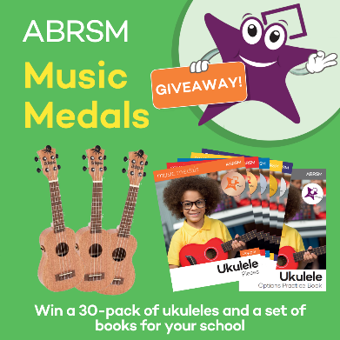
ABRSM‘s big ukulele giveaway – 30 ukuleles for your class!

Are you looking to transform your music lessons? Perhaps you want to introduce your class to new instruments and repertoire, or provide opportunities to your local school? Maybe you’re looking to reward progress whilst fitting musical milestones into lessons but aren't sure where to start?

You’re in luck – to celebrate the new Ukulele Music Medal, ABRSM have a fantastic giveaway up for grabs for schools in the UK!

THE PRIZE
Three schools in the UK will each win a pack of 30 ukuleles and a set of ABRSM’s new ukulele books.
- Student ukuleles in a natural finish
- Pre-fitted with Aquila quality strings and supplied with individual bags
- One teacher's resource book and CD
- One set of the new ‘Ukulele Pieces’ books for Music Medals from Copper to Platinum level and the Options Practice Book

TO ENTER
- Head over to ABRSM’s Facebook account and like the post from 3 October
- https://www.facebook.com/abrsmmusic
- Follow ABRSM on Facebook
- Complete this form: https://forms.gle/HE7d6381C6BgqYmy5
- Enter by midnight on 31 October 2024

The winner will be chosen after the closing deadline. Ts&Cs apply.

