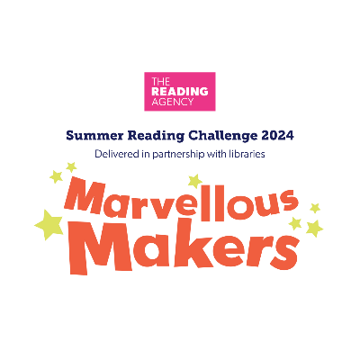
Information for parents
Children’s reading skills tend to dip over the summer holidays and research shows that the Summer Reading Challenge can help to prevent this trend
Why is reading for pleasure important?
Reading for fun improves literacy
Reading for pleasure is more important to children’s academic success than their parents’ level of education or socio-economic status
Studies have found that those who read for pleasure have higher levels of empathy, greater self-esteem and are better able to cope with difficult situations

Information for parents
Children’s reading skills tend to dip over the summer holidays and research shows that the Summer Reading Challenge can help to prevent this trend
Why is reading for pleasure important?
Reading for fun improves literacy
Reading for pleasure is more important to children’s academic success than their parents’ level of education or socio-economic status
Studies have found that those who read for pleasure have higher levels of empathy, greater self-esteem and are better able to cope with difficult situations

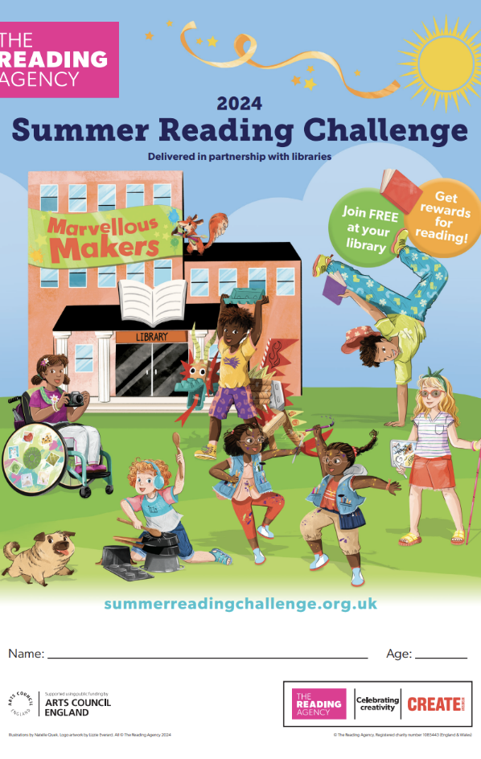
This year’s Summer Reading Challenge is Marvellous Makers. Be inspired to explore great stories with a creative theme – and have tons of fun along the way!

- Sign your child up for the Challenge at your local library
- It’s fun and totally free!
- Your child will be given a special collector folder to keep a record of their reading
- They visit the library three times, read six library books and collect stickers and rewards along the way
- Children can read whatever they want; stories, books on hobbies like sports/crafts/cookery, graphic novels etc.
- They receive a certificate, medal and reward when they finish

www.x.com/covlibraries
www.facebook.com/covlibraries
www.instagram.com/covlibraries

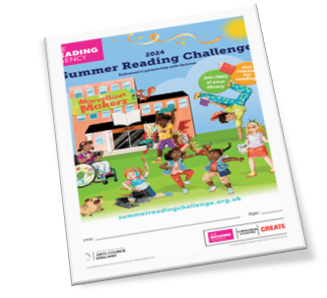
This year’s Summer Reading Challenge is Marvellous Makers. Be inspired to explore great stories with a creative theme – and have tons of fun along the way!

- Sign your child up for the Challenge at your local library
- It’s fun and totally free!
- Your child will be given a special collector folder to keep a record of their reading
- They visit the library three times, read six library books and collect stickers and rewards along the way
- Children can read whatever they want; stories, books on hobbies like sports/crafts/cookery, graphic novels etc.
- They receive a certificate, medal and reward when they finish

www.x.com/covlibraries
www.facebook.com/covlibraries
www.instagram.com/covlibraries

