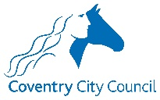
Coventry City Council Positive Parenting Offers
Coventry’s Parenting Team co-ordinates and deliver a variety of programmes and courses for parents both face to face, virtually via Microsoft Teams and online. This may be for families planning ahead who are experiencing no difficulties at all, to families who are experiencing day to day difficulties with relationships, behaviours, feelings, or confidence. The programmes cover everyone parenting children from pregnancy to 19 years or age.
Courses are available during daytime at various times as well as evenings and some weekends.
We have workshops, pre-recorded webinars, and online courses you can complete at a pace that’s right for you as well as longer programmes that you attend each week with other parents. All programmes are Free. Below are some of our popular programmes and courses.
- Five to Thrive
- Triple P programmes
- The Nurturing Programme
- Sleep Tight Workshop
- Information and advice for Dads
- Programmes for when you are expecting a baby, and many more.
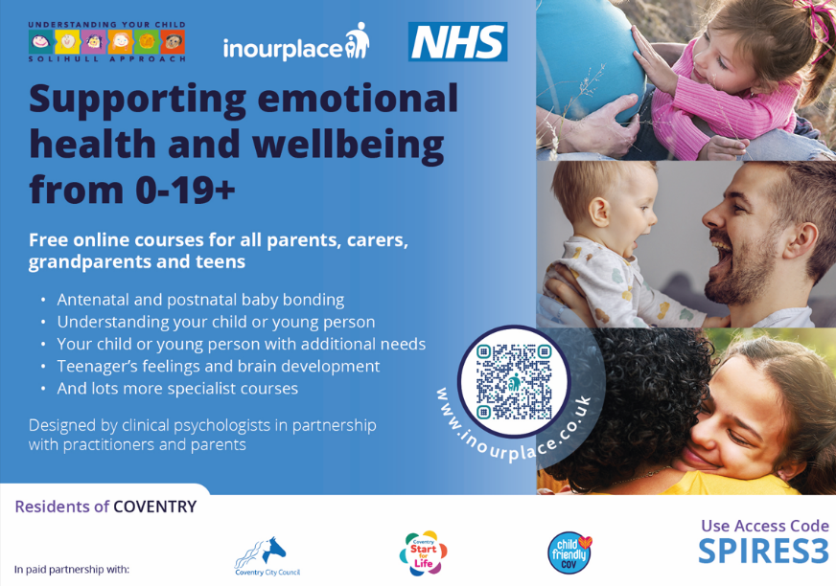
- www.inourplace.co.uk (Online courses in 104 different languages – Free access code on picture below)

To find out more contact: parenting@coventry.gov.uk or 024 76 786949. To book or register for courses visit https://www.coventry.gov.uk/parenting
Or you can also use the QR code.

