REGIONAL ENGAGEMENT TEAM TASK DESCRIPTION TABLE
Practical Problem Solving
TASK | DESCRIPTION | TIME ALLOCATIONS | AREA REQUIRED | RATIOS | REMARKS
Enigma Code | A team-based activity that involves working in small groups using logic to decode a message. | 1.5 Hours | Classroom with tables made into groups | 5 groups of 4 students with 2 Instructors | Students require basic numeracy and English skills. School to provide scrap paper
Lock Boxes | A team-based activity that involves working in small groups using logic to decode and unlock five boxes. | 25 mins | Open area which can be indoors or outdoors | 8 students to 1 instructor. | Nil

Presentations
TASK | DESCRIPTION | TIME ALLOCATIONS | AREA REQUIRED | RATIOS | REMARKS
Meet a Soldier | A presentation that shows a look at life into the army and the careers of the team | 20 – 30 mins  Per presentation | Classroom or open area. | From small group to assembly size group | IT required for PowerPoint presentation
Army Careers Brief | A presentation that shows a look into the army and the careers available | 30 -45 mins  Per presentation | Assemble or Classroom | From Classroom to assembly size group | IT required for PowerPoint presentation
SCR (Soldier Conditioning Review) | An introduction to the army fitness testing. | 30-40 mins | Sports hall/outdoor courts. Not a grass field. | Maximum 15 per group | NIL

Academic Based Presentations
TASK | DESCRIPTION | TIME ALLOCATIONS | AREA REQUIRED | RATIOS | REMARKS
WW1/WW2  Army Equipment  (History) | A presentation that shows a look into the army WW1/WW2 – Modern Equipment | 30 -45 mins  Per presentation | Assemble or Classroom | From Classroom to assembly size group | WW1/WW2 & Modern Military Equipment
Army Forensic Science Challenge | A team-based activity that involves working in small groups using Forensics to solve a crime. | 1.5 Hours | Classroom with tables made into groups | 5 groups of 4 students with 2 Instructors | Students require basic numeracy and English skills. School to provide scrap paper
Academic Based Presentations
TASK | DESCRIPTION | TIME ALLOCATIONS | AREA REQUIRED | RATIOS | REMARKS
Build a Barracks | A team-based activity that involves the designing of a military barracks | 1.5 – 2 hours | Classroom with tables made into groups | 5 groups of 5 students with 2 Instructors | Students require basic numeracy and English skills. School to provide scissors, blue tac, whiteboard pens and calculators
Frontline Biology  Army Rations  (food) | classroom-based activity that focuses on academic work in a real-life scenario | 30 -45 mins | Classroom | Classroom into small working groups | IT required for PowerPoint presentation
Frontline Chemistry  Lightweight Helmet | classroom-based activity that focuses on academic work in a real-life scenario | 30 -45 mins | Classroom | Classroom into small working groups | IT required for PowerPoint presentation
Maths | classroom-based activity that focuses on academic work in a real-life scenario | 30 -45 mins | Classroom | Classroom into small working groups | Coming Soon  IT required for PowerPoint presentation

Leadership Communication Teamwork Command Tasks
TASK | DESCRIPTION | TIME ALLOCATIONS | AREA REQUIRED | RATIOS | REMARKS
Blaze  Pods | A team-based task that involves short sprints with communication and numeracy skills | 25 Mins | Open area which can be indoors or outdoors  15-20M running distance | 8 students to 1 instructor. | Students should be able to run and have water, especially when warm
Stepping  stones | A team-based problem-solving activity that involves traversing across an area whilst carrying equipment | 25 Mins | Open area which can be indoors or outdoors  10x10M | 8 students to 1 instructor. | Involves standing on blocks and walking across planks
Barrel  Retrieval | A team-based problem-solving activity that involves removing a barrel from a designated area | 25 Mins | Open area which can be indoors or outdoors  5x5M | 8 students to 1 instructor. | Nil
Minefield | A team-based activity that involves traversing a simulated minefield whilst blindfolded | 25 mins | Open area which can be indoors or outdoors | 8 students to 1 instructor. | A team-based activity that involves traversing a simulated minefield whilst blindfolded
Leadership Communication Teamwork Command Tasks
TASK | DESCRIPTION | TIME ALLOCATIONS | AREA REQUIRED | RATIOS | REMARKS
Tire  Tower | A team-based puzzle solving activity involving tires and cones | 25 Mins | Open area which can be indoors or outdoors | 8 students to 1 instructor. | A team-based puzzle solving activity involving tires and cones
Tap Disk | A team-based task that involves short sprints with communication and numeracy skills | 25 Mins | Open area which can be indoors or outdoors  15-20M running distance | 8 students to 1 instructor. | Students should be able to run and have water, especially when warm
Giant Meccano | A team-based activity that involves the use of MTA STEM kits | 1 – 2 hours  Dependant on STEM task | Open area which can be indoors or outdoors | 5 groups of 5 students with 2 Instructors | MTA kits will be provided by us  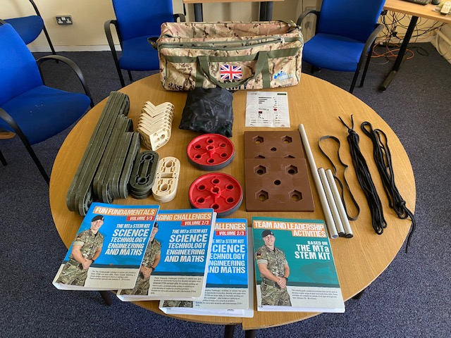
Wet Feet | A team-based activity that involves constructing a method of staying off the ground | 25 mins | Open area which can be indoors or outdoors  5x5M | 8 students to 1 instructor | Nil
Leadership Communication Teamwork Command Tasks
TASK | DESCRIPTION | TIME ALLOCATIONS | AREA REQUIRED | RATIOS | REMARKS
Jungle Maps / Circuit Breaker | A team-based puzzle solving activity that involves piecing a map together | 25 mins | Open area which can be indoors or outdoors  5x5M | 8 students to 1 instructor. | Nil
Top  Trumps | A team base puzzle solving activity that involves matching military vehicles to their statistics. | 25 Mins | Open area which can be indoors or outdoors  5x5M | 8 students to 1 instructor. | Nil
Archery Tag | The task provided are designed to focus on aspects of leadership and teamwork in a fun team’s sport environment | 60 -90 mins | Open area 100 x 50m ideal football or hockey pitch | 16/20 students to 1 instructor | Safety brief, Risk Assessment and safety equipment provided by instructor.
Field Gun Run | The task provided are designed to focus on aspects of leadership and teamwork in a fun team’s sport environment | 60 -90 mins | Open area 100 x 50m ideal football or hockey pitch | 16/20 students to 1 instructor | Safety brief, Risk Assessment and safety equipment provided by instructor.

GENERIC:
- Please make sure there is suitable parking for at least 1 van and 1 car
- If outdoor activities are booked, please make sure there is a wet weather plan
- Please note that the team will need to carry large amounts of heavy equipment to the allocated area.

HOW TO BOOK?
Email: richard.pugh783@mod.gov.uk
or
CentreHQ-Engt-Mailbox@mod.gov.uk

