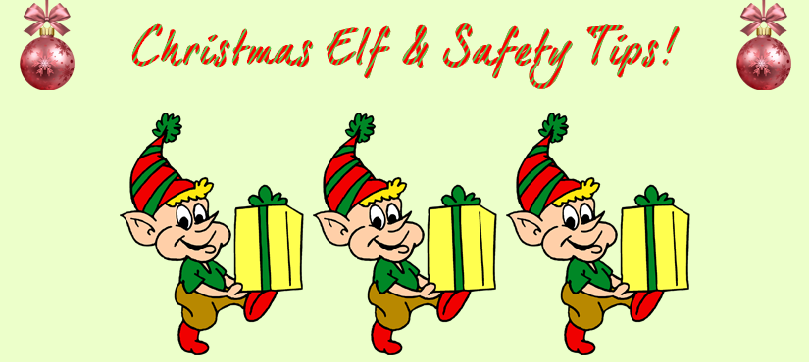

Talking Health, Safety and Wellbeing. The article to help you keep fit and stay healthy and safe in your place of work over the festive period.

With Christmas fast approaching we are exposed to an increased number of hazards in the workplace at a time of year when it is easy to get distracted by everything going on. Fortunately, most of these hazards can be controlled easily and just require a little planning to make sure we all stay safe. This article talks about asbestos safety when putting up Christmas decorations; taking care when working at height, electricity and Christmas lights, using candles and mental wellbeing over Christmas.
Asbestos

Once again Christmas is fast approaching and the time for Christmas decorations is upon us. Staff take pride in putting up decorations and a Christmas tree in offices, family hubs and schools and consideration should be given to the potential for asbestos containing materials within these buildings. | Where can asbestos containing materials be found?  Examples of where asbestos containing materials can sometimes be found include:  - Asbestos insulating board (AIB), which looks like plasterboard. This can be anywhere as it was used as general building board in previous years. It can be in the walls, ceilings, ceiling tiles, window and door surrounds and columns of any room including classrooms, corridors, toilets, halls and above suspended ceilings, etc.  - Ceiling voids of schools can potentially contain asbestos debris which may be released if the ceiling tiles are disturbed.  - Sprayed asbestos coating can be on ceilings or around structural beams.  - Asbestos lagging can be around heating pipes, in the walls, loft and in floor ducting.  - Further guidance on the management of Asbestos is available from the City Council’s Asbestos Officer.
If your building was built prior to the year 2000 it may contain asbestos. Please remind staff before they start pinning Christmas decorations to walls or hanging them from ceiling tiles, etc. to check they are not unwittingly disturbing any potential asbestos containing materials as this can result in the release of asbestos fibers into the air.
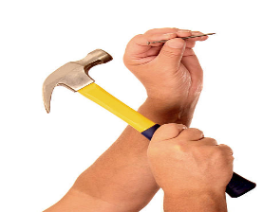
All buildings, except for new builds since 2000, will have an asbestos survey and a local asbestos management plan in place where there is known to be asbestos containing material or 'unknown' material on site that may contain asbestos. The location of these materials must be highlighted on the buildings floor plans. Staff working in areas that may contain asbestos must be advised of the risk and how it is managed. If you are unsure whether an area contains asbestos, do not put decorations up there.

How do I stay safe when working at height?

It is really important that staff use the correct equipment for the job e.g. step-stools and step-ladders. Do not be tempted to stand on chairs or desks for a 'quick fix'! It is very easy to fall from these and this can lead to quite significant injuries such as fractures.

Ensure only those staff trained to use ladders are allowed to do so. Staff using ladders and steps must wear sensible shoes and clothing and working alone should be avoided wherever possible when working at height.

Candles

Candles are used in many schools across the UK during special festivities such as Christmas. Unfortunately, every year there are a number of tragic accidents involving young people which result in life changing injuries. These accidents are easily preventable with a risk assessment looking at the risk involved and putting in place simple measures.  What measures to include?  - Use of LED candles where appropriate  - Keep flames away from flammable materials including fancy dress and costumes.  - Appropriate levels of supervision for young people  - Hair is tied back, (without ribbons, large hair bows etc.)  - There is no loose clothing such as scarves and ties that are likely to come into contact with the naked flame.  - Sufficient space is maintained between pupils holding candles.  - There is a sufficient gap between pupils that are wearing fancy dress from those pupils holding candles.  - The candle should be held in a suitable holder. | “A young boy from St Thomas Becket Catholic Primary School was seriously injured yesterday after his costume caught alight when it came into contact with a candle. He remains in hospital.  London Fire Brigade’s Fire Investigation team and fire safety officers attended Our Lady of the Annunciation Church in Croydon following a call from the Metropolitan Police Service.  The Brigade’s Assistant Commissioner for Fire Safety, Dan Daly, said: “This horrific accident is a stark reminder of the risk real candles can pose. They are a completely unnecessary hazard when it comes to children and school plays” – London Fire Brigade December 2019

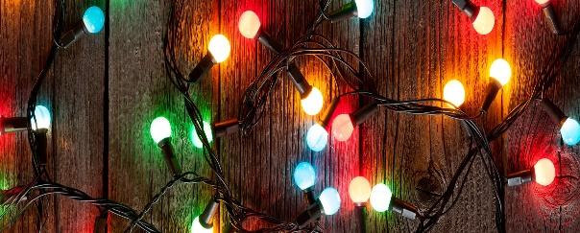
Electrical safety and Christmas lights

Christmas lights around the workplace may made the place feel more festive, however after spending 11 months packed way they can easily become unsafe. With the risk of electrocution or starting a fire, it is important make sure that lights are working properly before use and assessed to reduce the likelihood of them causing any harm.

Always  - Check the PAT test sticker to ensure its up to date.  - Check the lights are not damaged or broken before use and look out for loose wires.  - Keep lights away from flammable materials such as decorations or paperwork.  - Switch the lights off if you’re the last person to leave | Never  - Use lights outdoors unless they are specially designed for such use.  - Connect different lighting sets together.  - Connect lights to the power supply while they are still in the packaging.  - Remove or insert lamps while chain is connected to the power supply.  - Overload sockets – always avoid using extension leads or adaptors.  - Attempt to repair faulty lights.  - Use lights that are damaged.

Christmas Wellbeing
Christmas can be difficult for anyone, at any point in their life. You might be struggling this year for the first time. Or you may have found Christmas difficult in the past, and you are dreading it again this year. You may also enjoy Christmas, but not be able to celebrate it how you would like to. Or you might find some parts enjoyable, but other parts stressful.
If you or anyone you know are struggling, you can access free help and support 24/7:
- Confidential emotional support for residents across Coventry and Warwickshire: call 0800 616171
- Urgent crisis advice: call 111 or the NHS Mental Health Access Hubs on 08081 966 798
Specific Information for Children and Young People, Rise Crisis & Home Treatment Team 08081 966798 (select Option 2)"For more information on all health and safety matters please go to the Occupational Health, Safety and Wellbeing pages
Or if you have any questions or concerns, please contact the Health and Safety Team

So finally let’s stay safe in the lead up to Christmas. These simple steps may prevent an accident or incident from happening and will help to ensure we all enjoy this time of year.

