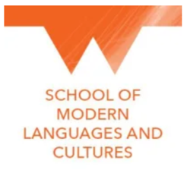
Modern Languages CPD for Primary and Secondary Teachers

Date: Friday 1st December 9am-12.30pm
Location: Friargate, Coventry, CV1 2GT
Cost: FREE

On Friday 1st December The School of Modern Languages and Culture at the University of Warwick, together with Coventry City of Languages, is running Languages CPD for both Primary and Secondary languages teachers, leaders and co-ordinators across Coventry.

Programme and Trainers:

9-9.30 - Zhiqiong Chen/ Cathy Hampton – Welcome and opportunities for students and teachers through the SMLC at the University of Warwick.

9.30-10.00 - Pierce Kiembi and Mark Muddyman, Futbol Lingo – Engaging students in languages through football and sport.

10-10:30 - Helen Masefield and Martin Ledgard, Coventry City Council Education – Ofsted and MFL

10.30-10.45 - Coffee break. Refreshments courtesy of SMLC, University of Warwick

10.45-11.30 - David Moss, English and Modern Languages Adviser and NALA Executive Committee Member – NALA Grammar Resources
The NALA Grammar resources link the Grammar from the KS1 and KS2 Primary Curriculum with French ,German and Spanish grammar. They build on the terminology that pupils have learnt for English and help them make links with the Modern Language they are learning.
The resources can be used by teachers, trainees, teaching assistants and pupils in both Primary and Secondary schools.

11.30-12.15 - John Rolfe MBE, Global Schools Alliance – Opportunities for Coventry schools to work with schools across the world.

To book your place please complete the Google form
https://forms.gle/FrnwzXKMbxpZiNff8

We look forward to seeing you there.

