**Please forward this information to your team members to share with parents and carers**



**Spotlight on Family Links Nurturing Programme for parents/carers of children age 0-12 years**

The Family Links Nurture Programme is a 10 week face to face programme that is delivered by Coventry’s Positive Parenting Team every term.

**Family Links Nurture Programme-** This programme is 10 sessions delivered face to face weekly. The emotional health of the whole family underpins this programme and parents are supported to reflect and understand their child’s behaviour as communication of needs and feelings- Parents are given lots of guidance and strategies to support their responses to their child’s behaviour and to build positive relationships.

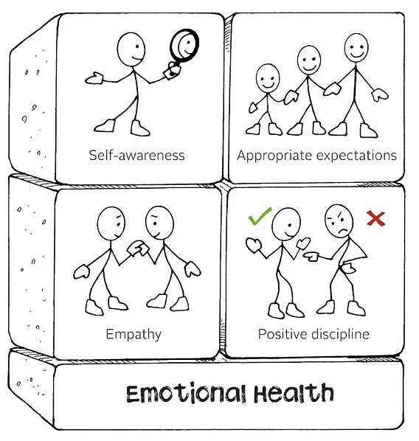

Parents who attend will receive a copy of The Parenting Puzzle book for free which enables them to refer back to useful guidance long after the programme is finished. Below is an outline of what is covered in each session:

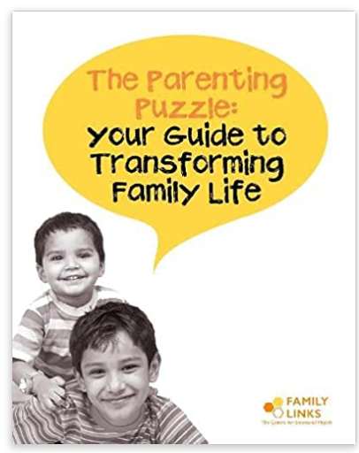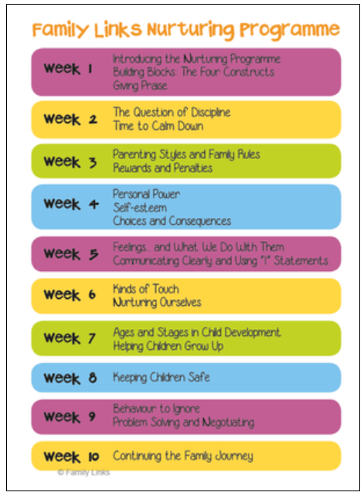

Parents and carers can make a request to attend this programme by completing a request form on our parenting website: <https://www.coventry.gov.uk/parenting> or professionals can complete the request on their behalf with their consent. These courses are run termly and parents receive a letter which tells them venues and times and they then contact the parenting team to secure their place on their chosen course. Requests received now will receive letters in December to book onto programmes beginning in January 2024.

On our website you will also find information about the new online courses for parents from the Solihull Approach as well as further information about face to face and virtual termly programmes. There are also links to other useful guidance and support for parents/carers.