Primary Library Quiz 2024

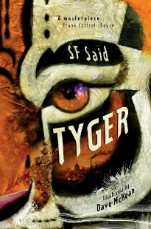
Coventry Schools Library Service in partnership with Coventry Libraries have for many years run a library quiz aimed at Year 5 and 6 pupils from Primary schools all around the city. The aim of the quiz is to challenge able readers to expand their reading, read in greater depth and understanding, and boost their literacy skills. The children read 3 books which have been selected by the specialist children’s librarians to be modern, inclusive, from different genres and writing styles and represent the highest quality of writing. This year’s books are shown below.
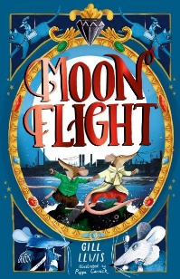
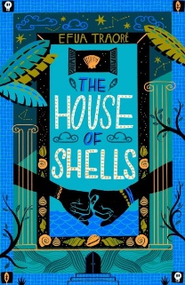

The quiz heats are held in libraries around the City and have questions on the 3 selected books as well as general book knowledge. Winners from the heats are then invited to the final where they can win not only a cup to display for the next year but also new fiction books for the school.
If your school would be interested in taking part or would like to know more about how this competition works, then please either contact SLS or Isobel Powell through the details below.
sls@coventry.gov.uk
Isobel.powell@coventry.gov.uk
Tel: 024 76975485

