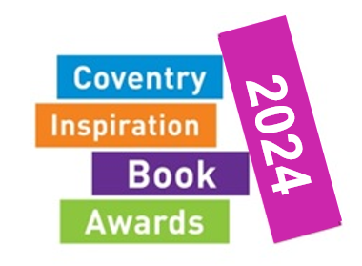

The Coventry Inspiration Book Awards
The Coventry Inspiration Book Awards have run for the last 18 years across schools in the City and support reading for enjoyment for all Coventry children and young people from age 4 to 18.
Research shows that reading for enjoyment not only improves all-round attainment in school including in maths but also increases empathy skills and improves mental wellbeing.
Multiple studies suggest that enjoyment is associated with higher reading performance. The recent 2021 PIRLS data for England showed that the pupils who said they liked reading the most scored, on average, 34 points more than those who said they did not like reading. In effect, pupils who are reading regularly for enjoyment give themselves unofficial reading lessons, supporting their reading comprehension. From the new Reading Framework (DFE, July 2023)
The Coventry Inspiration Book Awards are the ideal way to get more of your students to read for enjoyment and here are some of the comments made by students who have taken part in previous years.
“Book Awards has drawn me more into reading”
“The Book Awards have encouraged me to read more...”
“The Book Awards are a great way to find new books to read”
“Every book was amazing and has inspired me to read”
“I loved the quiz because of the excitement and the books were amazing!”
There are five categories of books to choose from covering ages 4 to 18 tailored to the specific needs of each of the targeted age groups. Each category has 8 books to read and enjoy. You can comment on the books you have read and vote for your favourite one. Taking part in the Coventry Inspiration Book Awards is about more than just reading and voting for the books. It’s about being part of a wider reading community across the city.
For more information then please visit our website www.coventry.gov.uk/bookawards where you can also download the shortlists, order forms and see pictures from last year’s fantastic celebration event with two of the winning authors.

