**CSW Resilience Team Termly School Newsletter**

The CSW Resilience Team comprises of Emergency Planning Officers that represent the local authorities of Coventry, Solihull and Warwickshire. We enable compliance with the Civil Contingencies Act through risk assessments, business continuity, training and exercising, recovery and supporting the planning and response to incidents.

The theme of this term’s newsletter is Risk Assessing and Managing Risk

I wish you all a happy summer break and hope you have a safe return next academic. Please do not hesitate to contact me regarding your school’s emergency planning arrangements.

As we commence a new academic year, we are encouraging you to forward think about what you could do this year to ensure your emergency planning arrangements make you prepared to respond to any incident that might occur in your school. Below is a suggested timetable which makes emergency planning manageable.

|  |  |  |  |
| --- | --- | --- | --- |
| **Activity** | **Autumn term** | **Spring term** | **Summer term** |
| Develop / review emergency plan | **\*** |  |  |
| Prepare / review grab bag | **\*** |  |  |
| Review contact details | **\*** |  |  |
| General awareness training |  | **\*** |  |
| SERT training |  | **\*** |  |
| Discussion-based / tabletop exercise |  | **\*** |  |
| Live exercise |  |  | **\*** |

The suggested activity listed for this term is:

1. Develop / review your schools emergency management plan
2. Prepare / review your schools grab bag. If you need guidance on what should be included in your grab bag, refer to the Spring CSW Resilience Team Termly Newsletter
3. Review your contact details. In the case of power outage or cyber-attack, it might not be possible to rely to electronic storage of contact numbers. Therefore, we recommend keeping a physical contact list. This could be stored in your physical emergency management plan. Ensure everyone who might be required during a emergency is listed with their contact number

You might wonder what sort of incidents might you need to prepare for? Here are some examples of emergencies that have previous affected schools –

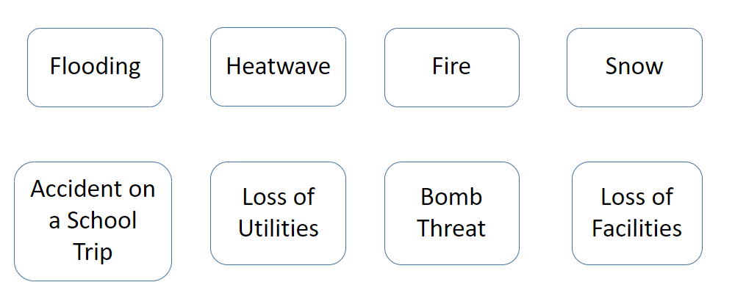

I wish you all a great start to the new academic year. Please do not hesitate to contact me regarding your school’s emergency planning arrangements.

Kind Regards,

**Morgan**

**Morgan Schmeising**

CSW Joint Emergency Planning Officer (School Lead)

CSW Resilience Team

Email: [CSWRT@warwickshire.gov.uk](mailto:CSWRT@warwickshire.gov.uk) or [morgan.schmeising@solihull.gov.uk](mailto:morgan.schmeising@solihull.gov.uk)

