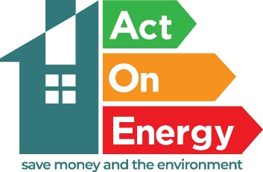

FREE HEATING SYSTEMS THROUGH KEEPING COVENTRY WARM

The Act On Energy service has been commissioned by Coventry City Council to reduce fuel poverty in Coventry and protect those who are most vulnerable to the health effects of
living in cold homes. Keeping warm is an important part of keeping well in the winter particularly for the very young, and those with chronic illness affected by the cold, this could be more prevalent this year due to the increase in respiratory infections in children.

The service provides:
- Heating and insulation measures for the most vulnerable and will include the requirement for individuals to be dependent on benefits or on low incomes and have a health condition and/or disability that is exacerbated by living in a cold home such as boilers and heating system replacements. (these services are subject to eligibility and funding availability).
- A specialist helpline offering support and advice on keeping warm and ways to help reduce your energy bills.
- Home visits to help residents with all their energy needs

For further information please call Act on Energy on the Free phone Advice Line:
0800 988 2881

