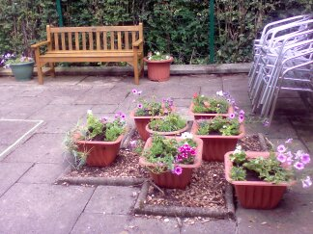
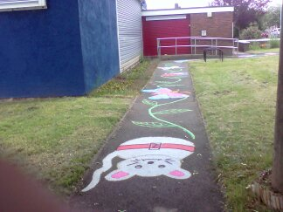
Wolverham Community Centre
Cheltenham Road, Wolverham, Ellesmere Port,Cheshire. CH65 5DS
Activities
Wolverham have a variety of activities that residents can access.
Days | Courses & Classes | Food  These are booked beforehand | Free Computer sessions | Social Events
Monday | Needlecraft Course’s  10am – 12noon Booked session | Snack Café  12noon –1pm  Coming soon |   Computer Drop In  10-12 noon
Monday | Computer Courses  10am – 1pm Booked session | Snack Café  12noon –1pm  Coming soon |  |   Bingo (new)  7-9.pm
Tuesday | Slimming World Classes  7-9am 9-11am & 5-7pm 7-9pm |  | Computer Drop in  10 – 12 noon
Tuesday | Courses - Booked session when advertised
Wednesday | Training Courses (varied hours)  Booked session |   Lunch Club 55+  12 –1.30pm | Computer  Drop in 10- 2pm | Messy Kids Club  5-7pm
Thursday | Supported Creative Learning Booked session |  | Computer  Drop in 10-1pm
Thursday | Circuit training coming soon
Friday | Gentle exercise  1.30 – 2.30pm |   Lunch club 55 +  12 –1.30pm | Computer  Drop in 12-3pm |   Bingo  7pm
Saturday |  | MKP Breakfasts  10 – 12 need to book | Available for hire Parties/Activities/events
Sunday |  | MKP Sunday Lunch  12 – 2pm need to book | Available for hire Parties/Activities/events
Rob Taylor | Chris Brown | Sandra Clarke | Marie Norman | Sarah Norman | Chris Robinson | Erika Neil
0151 356 6761 | 07724544034 | 07732133339 | 07759154446 | 07756981821 | 07974145061 | 07753454805
CWACC Community Centres Contact - ROB TAYLOR 0151 356 6761 - 07917849270
Contact Activities Names or Centre Number 0151 355 4791

