PALS – Positive Action for Little Sutton
&
Little Sutton Sapphires Women’s Institute

are holding our final community litter pick of 2019

Remembrance Parade Litter Pick

Saturday 9 November 2019

10.00 -12.00 at the community centre

help us clear the parade route and other parts of the village of litter ahead of Sunday’s Remembrance Parade.
Refreshments provided after the litter pick.

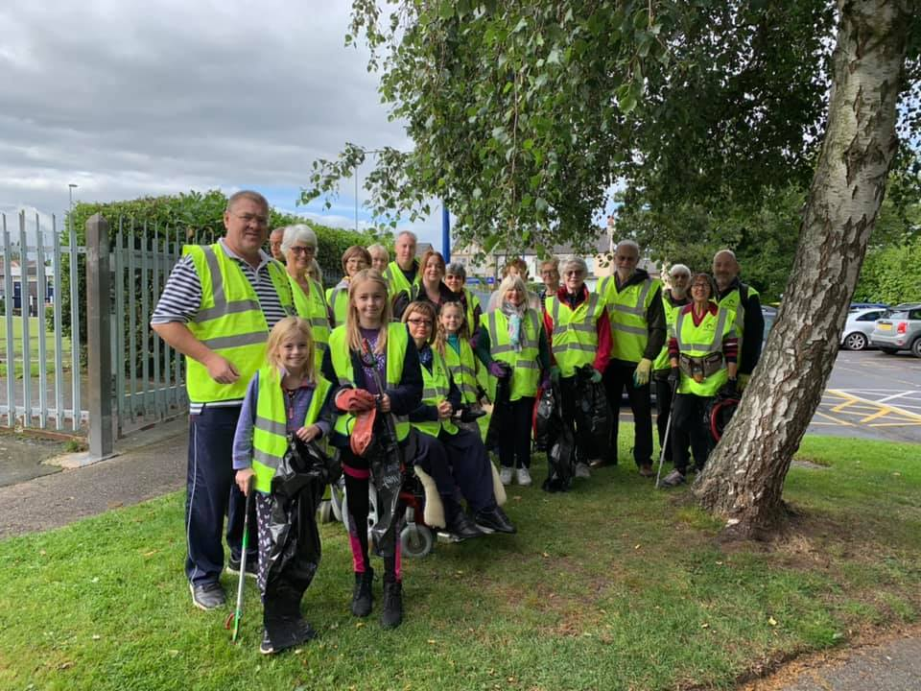



Join us on Facebook :
Little Sutton Sapphires WI Information
PALS – Positive Action for Little Sutton

