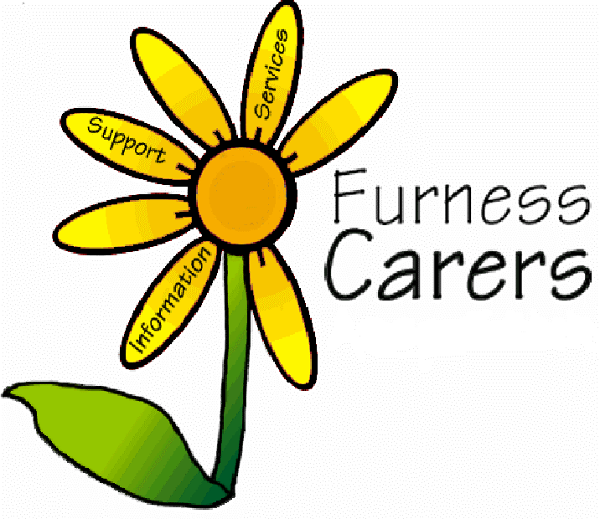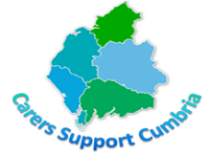 2022

Visible, Valued & Supported

Come and join us in making Unpaid Carers more Visible, Valued & Supported as part of our Queens Jubilee & Carers Week Celebrations

**Wednesday 1st June: 1-3pm: The Queen’s Platinum Jubilee:** We will be hosting a Jubilee Street Party with music, food & children’s entertainment. An afternoon to celebrate the Queen’s Platinum Jubilee. For more details please email: [admin@furnesscarers.co.uk](mailto:admin@furnesscarers.co.uk)

**Monday 6th June:** Adult Carers over 18 years are invited to enjoy a session with **Cumbria Wildlife Trust i**n one of Furness’s great outdoor locations: to book a place email: [admin@furnesscarers.co.uk](mailto:admin@furnesscarers.co.uk)

**Tuesday 7th June:** If you are a Parent of a child or adult with a **SEND** then come along to our Carers Centre for our **Parent Carer Event, FREE** facial & relaxing treatments, **FREE** sensory advice & equipment demo, advice on ways to promote sleep & relaxation and to connect with other Parents and Carers. This event is being hosted by **Hanna Munro Occupational Therapy & Charlotte from Tropic beauty along with Furness Carers**. For more details please email: [admin@furnesscarers.co.uk](mailto:admin@furnesscarers.co.uk)

**Wednesday 8th June:**

* 10am-12pm: **Carers Legal Café** with **Martin Oates from Poole Townsend** at our Carers Centre, Hindpool Community Centre, Nelson Street, Barrow. Just drop-in. For more details please email: [admin@furnesscarers.co.uk](mailto:admin@furnesscarers.co.uk)
* 12.30-2.30pm: **Carer Champion** session for Health Professionals & other interested organisations. To book a place then please email our Carers Health Co-ordination Worker, Sylvia Garnett: [sylviagarnett@furnesscarers.co.uk](mailto:sylviagarnett@furnesscarers.co.uk)
* Come along for information and advice on all things Carer related with **Furness** **Carers** staff & the **LSCFT** **HARRI Bus** at Dane Garth/Furness General Hospital.

**Thursday 9th June: Young Carers** a workshop run by **Theatre Factory** on the themes of Carers Week 2022 – VISABLE, VALUED & SUPPORTED. For more details please email: [admin@furnesscarers.co.uk](mailto:admin@furnesscarers.co.uk)

**Friday 10th June:** 10.30am-12.30pm: **FREE Health & Wellbeing Information Event** in the hall at Hindpool Community Centre. Unpaid Carers, their families and anyone else is welcome to come along and see what **FREE** support is available from local organisations. There will be café style seating in the hall for **FREE tea, coffee, refreshments and Pie and Peas** (until they run out!) For more details please email: [admin@furnesscarers.co.uk](mailto:admin@furnesscarers.co.uk)

**Saturday 18th June: Carers Trip to Liverpool**. For **Adult Carers**, come and have a day out visiting Liverpool with its huge variety of shops, galleries, museums, restaurants and much more there’s something for everyone. Leaving Barrow at 8.30 with pick-ups in Dalton & Ulverston. For more details please email: [admin@furnesscarers.co.uk](mailto:admin@furnesscarers.co.uk)