Carleton Day Service Carlisle celebrated Summer Solstice .

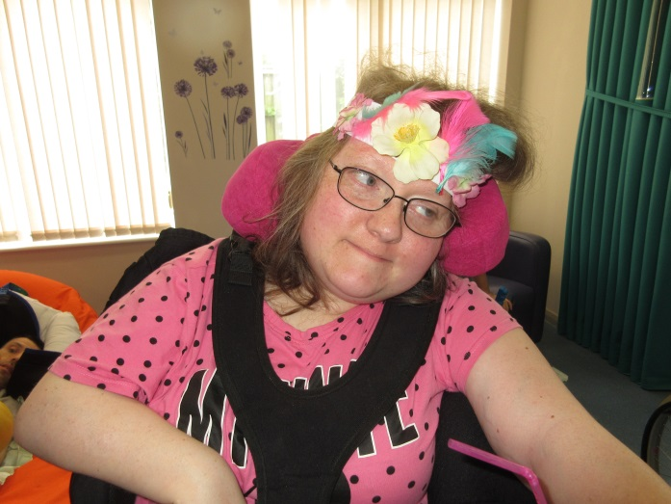 Preparations commenced from 8.7.19 making headbands in our Arts and Crafts Sessions at Carleton Day Service.

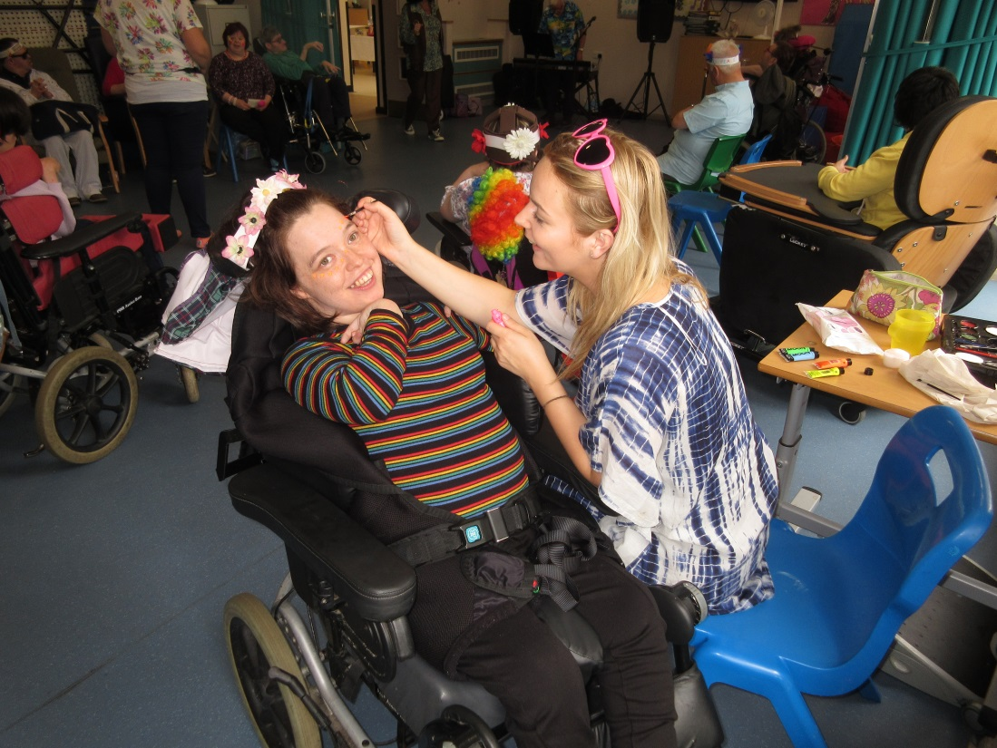

Face Painting from 9.30am on the 10.7.19

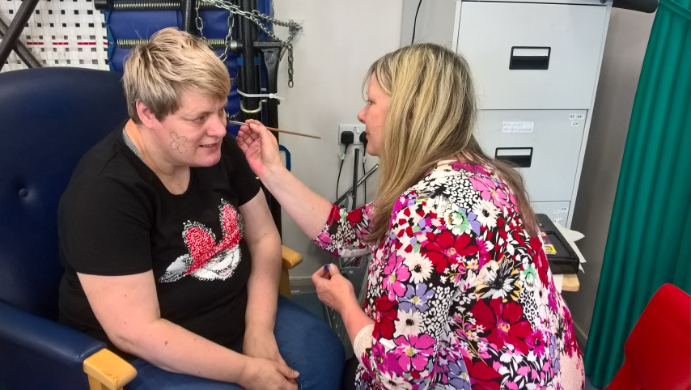

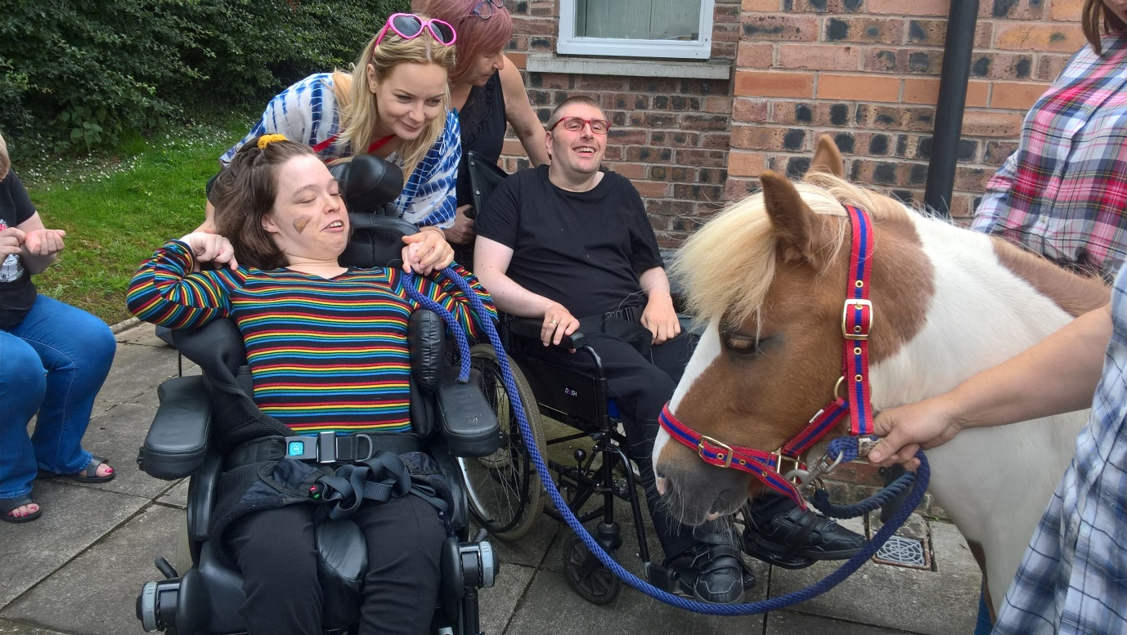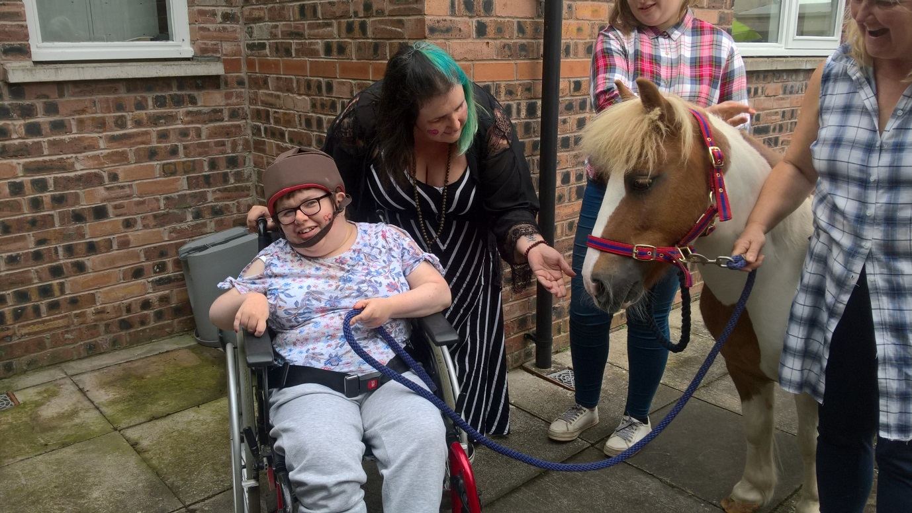

Pony came to visit at 10.30 am .

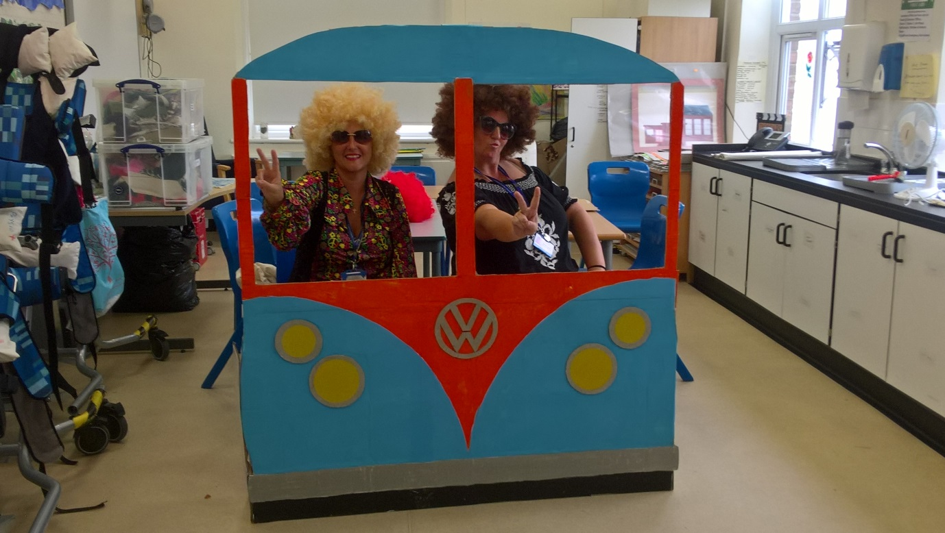

Service Users and Staff made a camper van for a photo shoot.

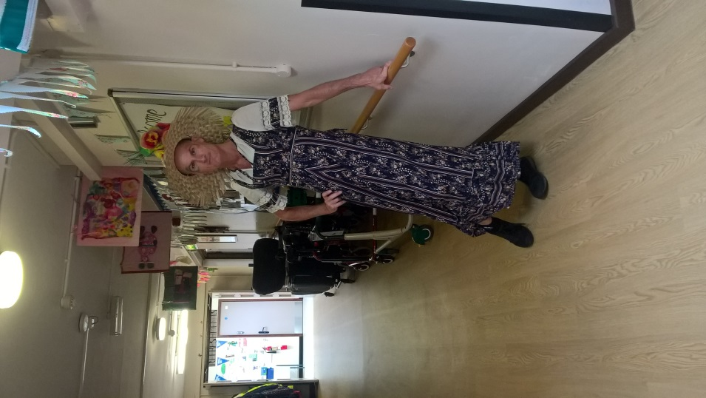 S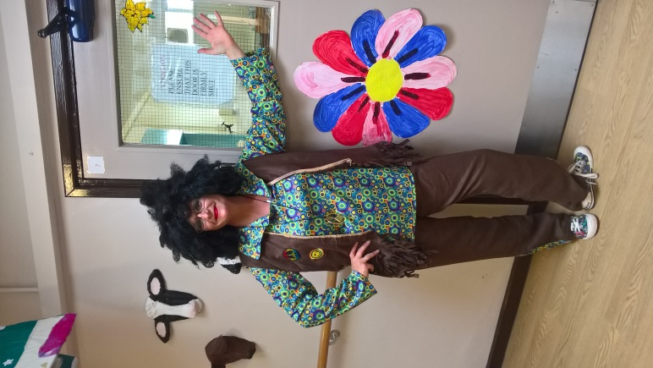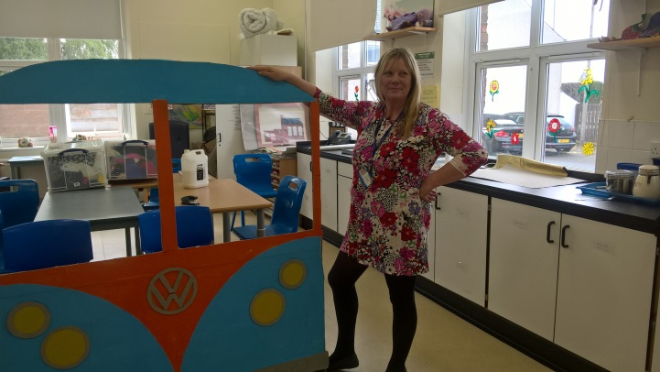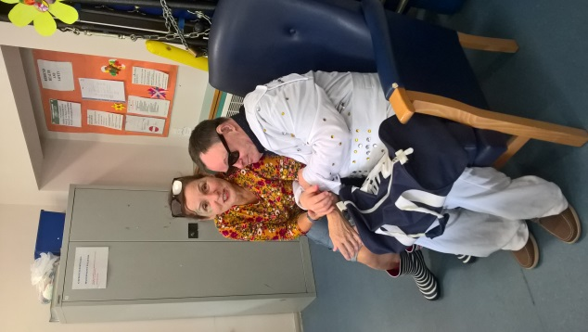

Staff and SU dressed up and the centre was decorated.

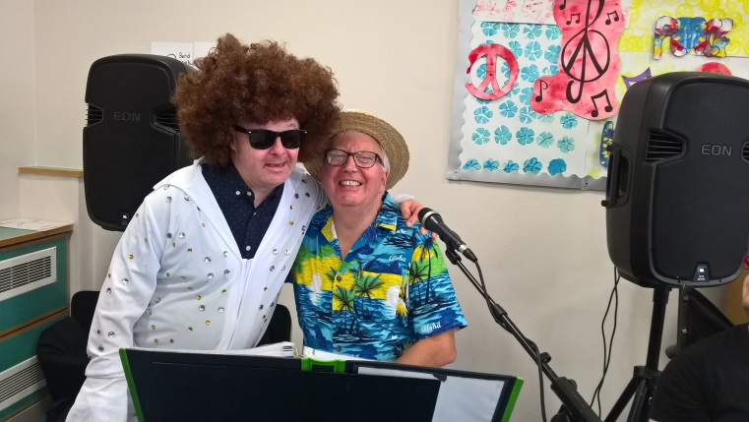 John Slattery on the Keyboard at 1.30

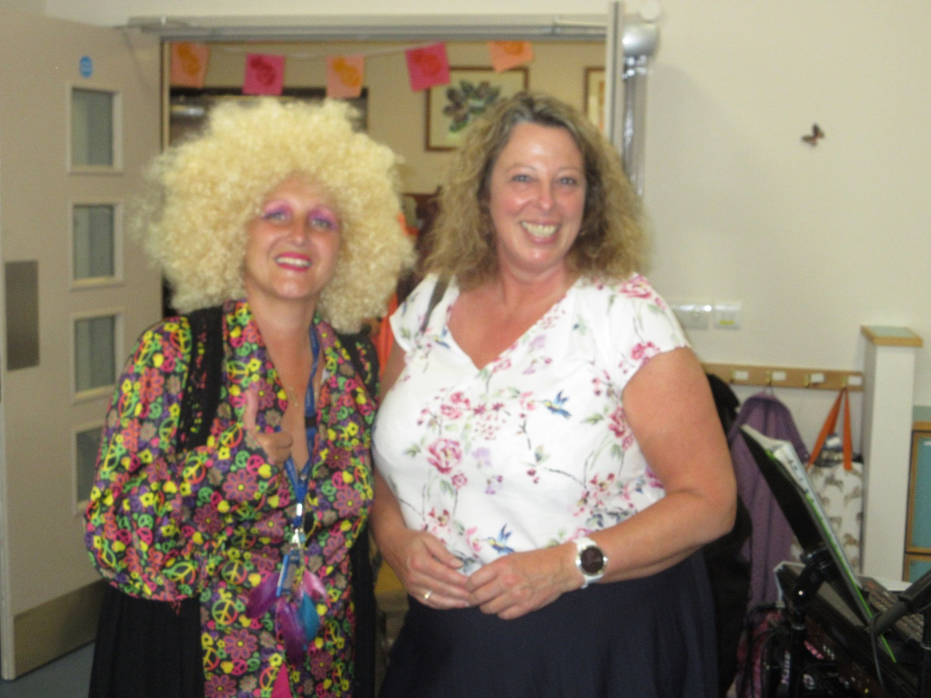

Pam Duke came to visit at 13.45

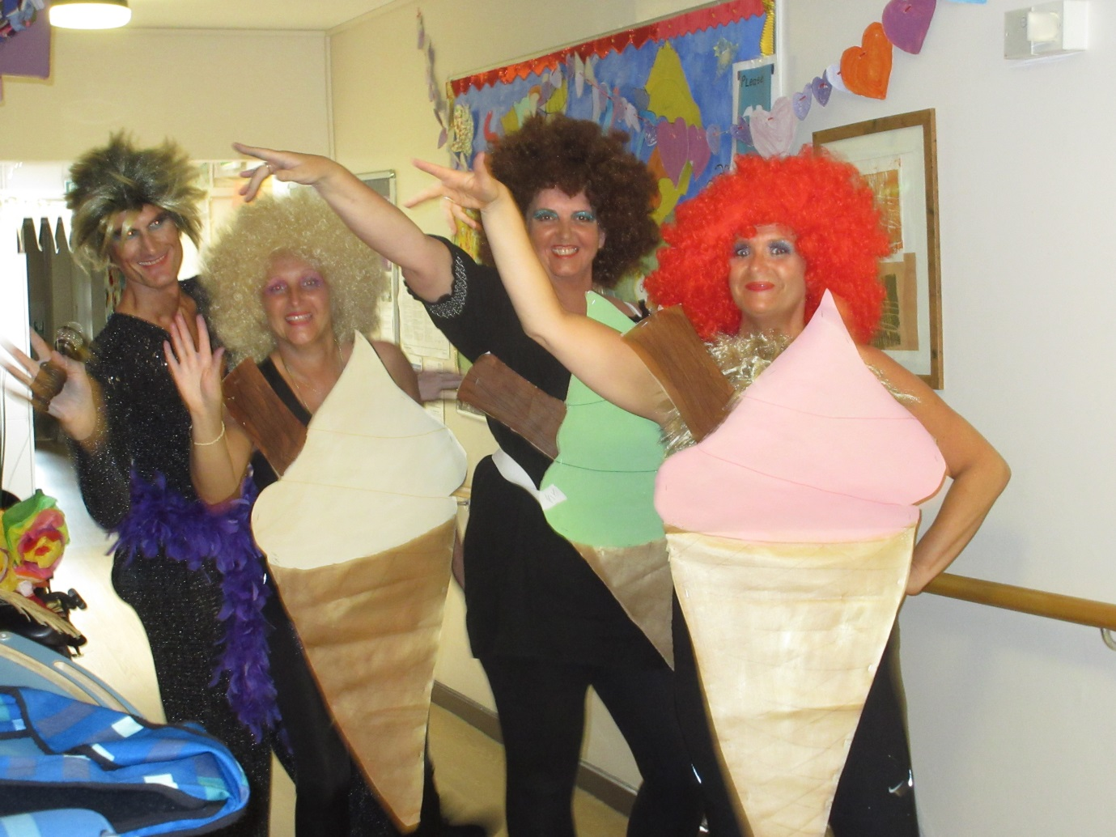

2pm Special Guest appearance from Diane Floss and the Ice Creams.

Diane Floss –Stephen Ward Support Worker

Ice Cream Vanilla –Shirley Ann Tingey Supervisor

Ice Cream Chocolate Mint –Michelle Young Senior Support Officer

Ice Cream Strawberry – Wendy McDougall Support Worker.

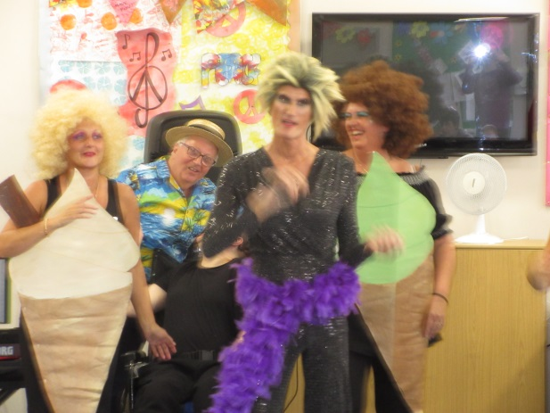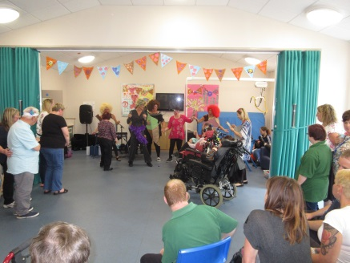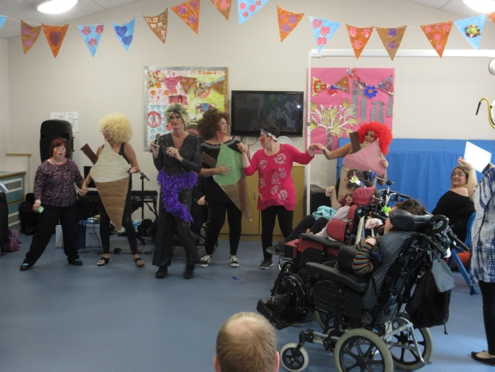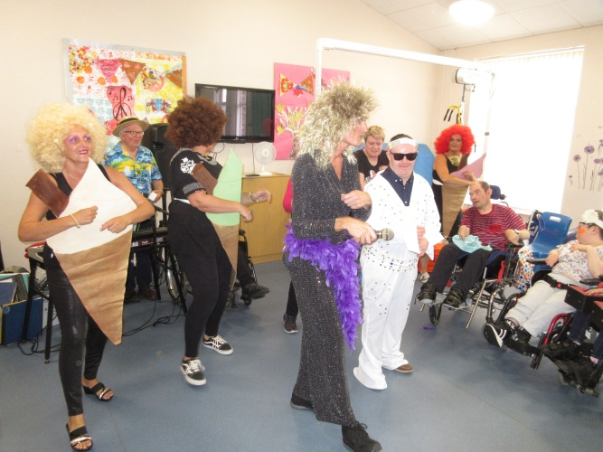

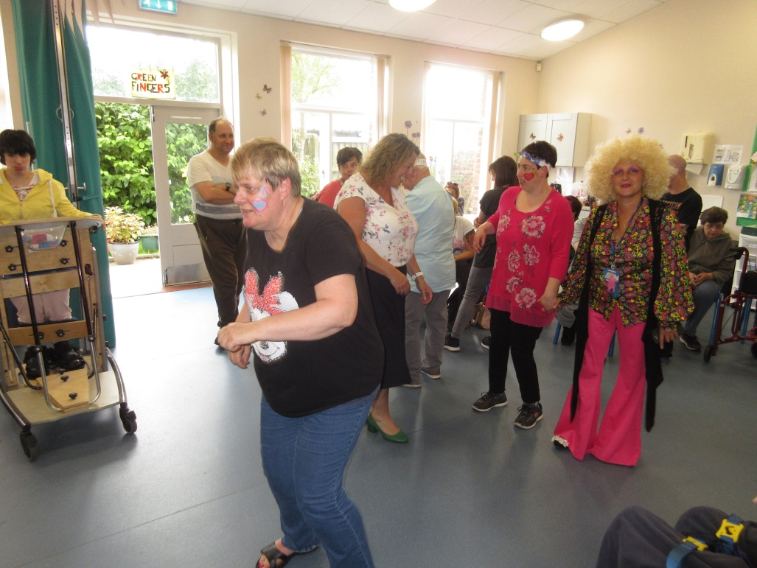

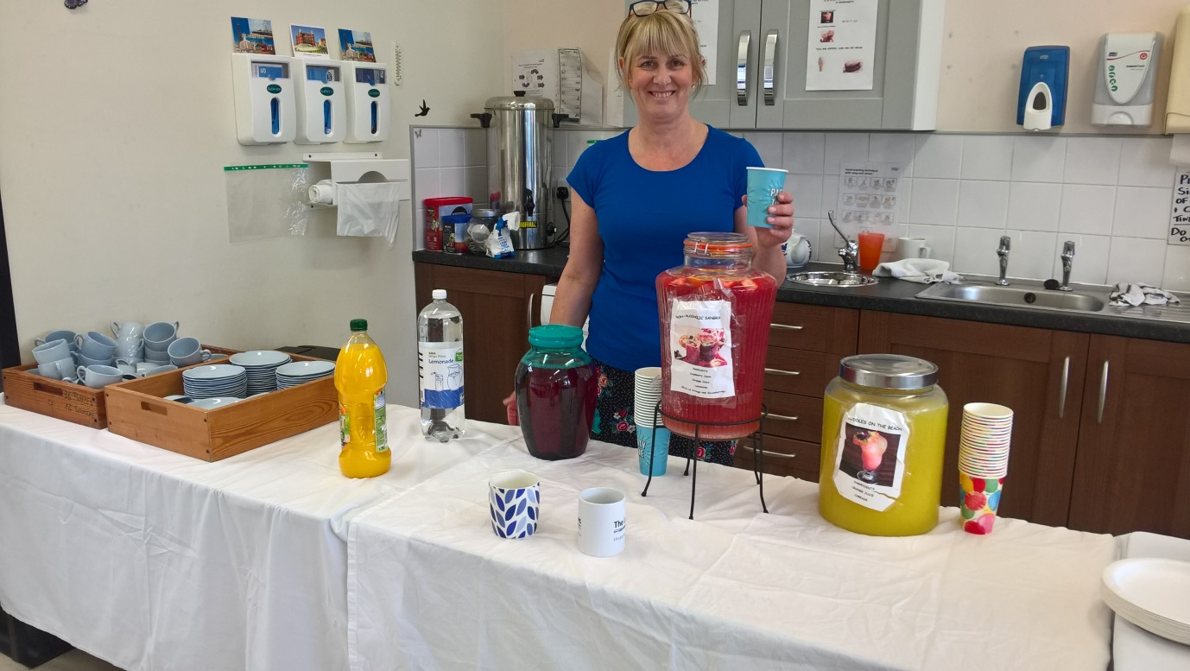

**Refreshments** were hot drinks or Mock tails Cuddles on the beach and none alcoholic Sangria also lovely cakes.

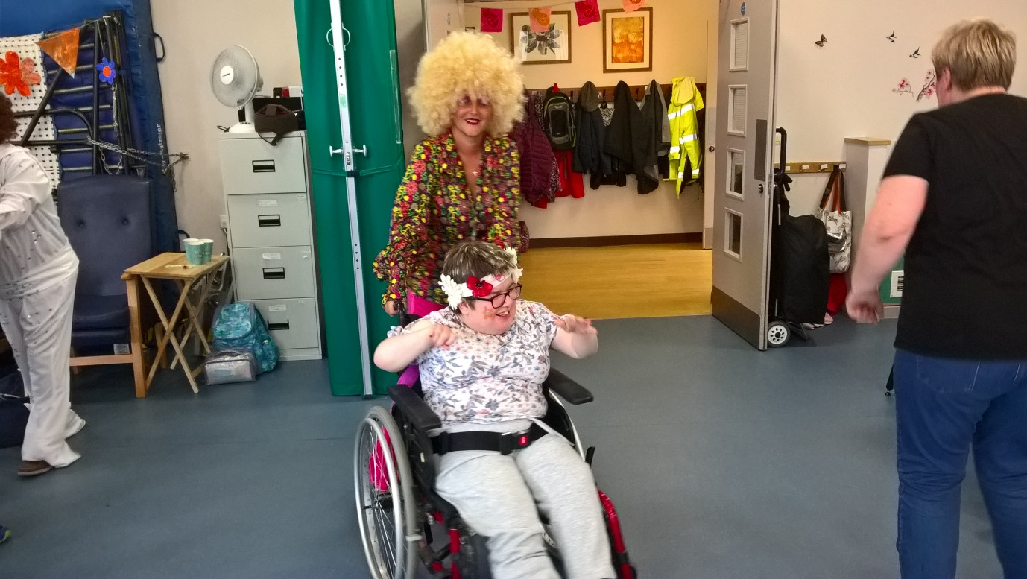

Dancing to John Slattery on the Keyboard 1.30.