People Education and Skills Learning Improvement Service
2nd Floor Cumbria House 117 Botchergate CARLISLE Cumbria CA1 1RD
T: 07388 718117 E: lesley.nixon@cumbria.gov.uk

01 February 2022
Our reference: ES/LIS/LN/AB

The Headteacher and SENCo
All maintained schools, all academies and free schools

Dear Colleague

System-Led SEND Review Process

Further to briefings to CASH, PHA and Area SENCo Networks in the autumn term, and my letter of 19 January, I am pleased to provide you with additional information about the System-Led SEND Review Process, that we are engaging in as part of the Cumbria SEND Improvement Programme, to address some of the issues raised in the Local Area SEND inspection.

This is a system-led approach and, while we have recommended a triad model, it is for individual cluster areas and schools to decide how to facilitate the SEND Review process, undertaking either a full overview of the SEND Review or just an in-depth focus on one section.

The aim is that SENCos will gain insights from peers within clusters; best practice will be spread across schools; and for those schools in need of some direction, peer SENCos will be able to offer advice and ideas. The end review will lead to SENCos being able to reflect on their previous SEND action plan and update these for the current needs.

Learning Improvement Service do not require any paperwork from you upon completion of your review. We appreciate the pressures that colleagues in schools are experiencing and we do not want to add to that pressure. In order to support schools with this improvement programme, and to facilitate engagement in the process, therefore, the grant funding that we are providing will cover two days of teacher release time – one day to review your own school and one day to support the review of another school – to be used at some point over the next 12 months. If you have not already done so, please return your grant acceptance as soon as possible.

The reviews process that we outlined in the autumn term is summarised below, together with links to supporting templates and guidance. If schools require any support with organising their SEND reviews, please contact our Associate SEND Adviser, Hannah Graham at Hannah.Graham@cumbria.gov.uk.

Yours sincerely

Lesley Nixon

LESLEY NIXON
Senior Adviser: Carlisle and Eden

The following documentation, to support with the SEND Review process, is available on the Schools Portal at Reference Library > Learning Improvement Service > SEND:

- Self-evaluation grids (please select the most appropriate template for your setting) – to be completed by the host school prior to the SEND Review
- Mainstream Schools
- Mainstream Schools with nursery and governor led provision
- Mainstream Schools with Strategic Resourced provision
- Early Years
- Special, PRU, AP, ARP Schools
- Sixth Forms
- System-Led SEND Review Record – to be completed during / following the SEND Review
- System-Led SEND Review Record – exemplar – for reference
- NASEN SEND Review Guide – for reference
- Autumn term Cumbria County Council SENCo Network presentation – for reference

Within your cluster, we recommend that schools are to be arranged into triads to support completion of reviews. Schools A, B and C are then to be identified within each triad. This model is described below. We appreciate, however, that clusters may choose to use an alternative model.

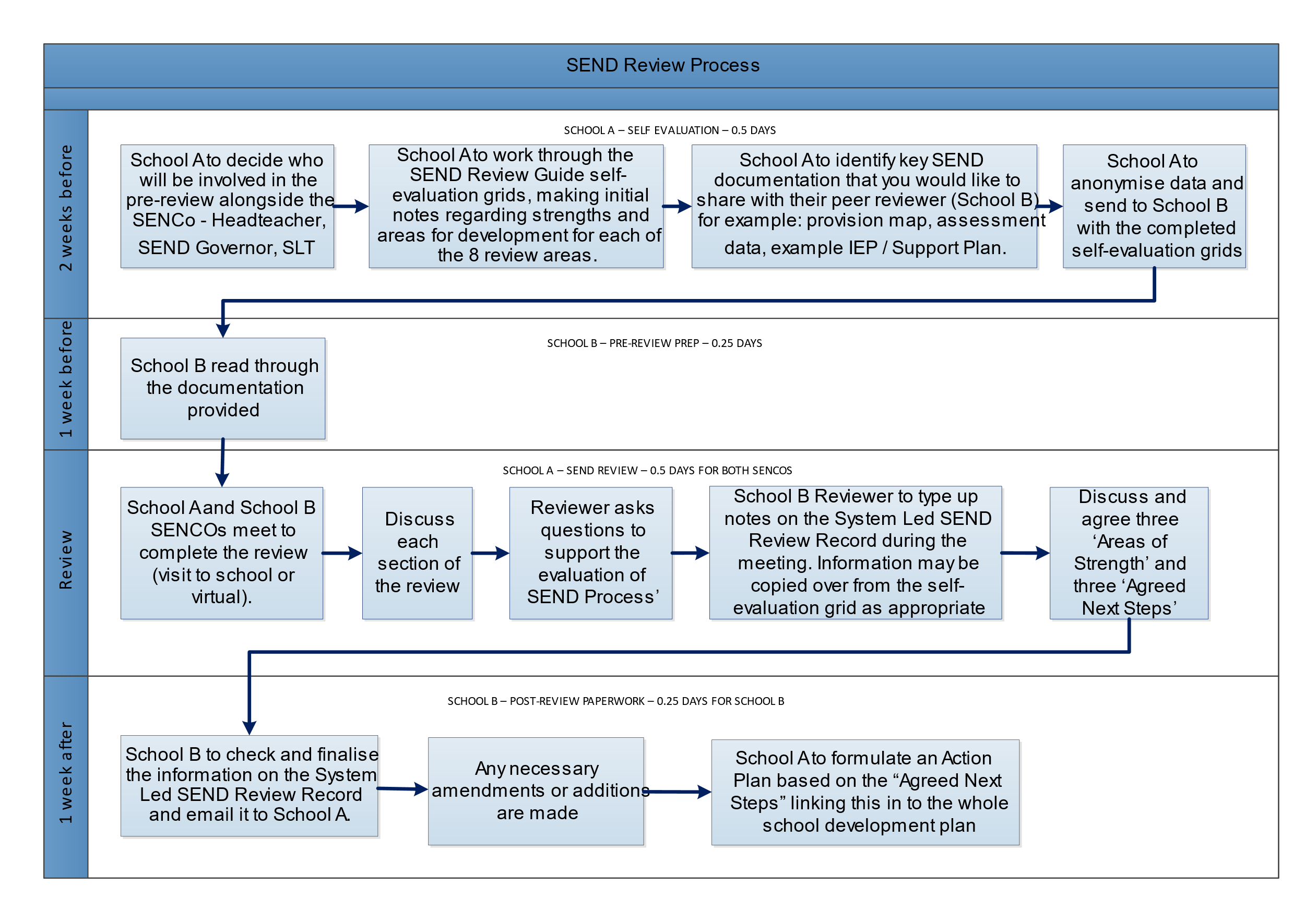
As summarised in the autumn term SENCo Network meetings, the suggested process for completing a SEND Review for School A is as follows:

This process would then be repeated twice, with School C supporting with School B’s SEND review, and School A supporting with School C’s SEND Review.

This System-Led SEND Review process has been designed to enable schools to reflect on their strengths and areas for development. There are eight areas that can be evaluated as part of the SEND Review process. As a school, you may choose to complete all eight, or to concentrate on two or three areas in line with your school priorities. There is no expectation for completed SEND Review paperwork to be shared with the Local Authority – outcomes from the process are for schools to use to inform your SEND and whole school action planning moving forward.

