**School Closure Alerts – Help Guide**

1. Navigate to <https://schools.cumbria.gov.uk/> (site is secured by username/password)  
     
   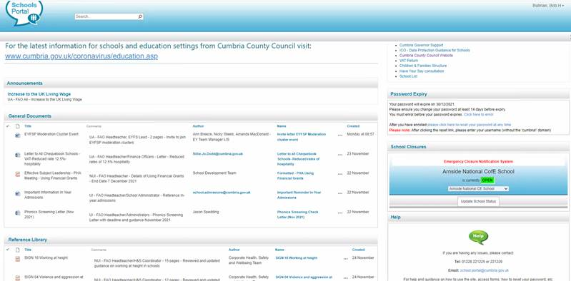
2. On the right-hand side of the home page there is a “School Closures” widget which shows the current open/closed status:  
     
   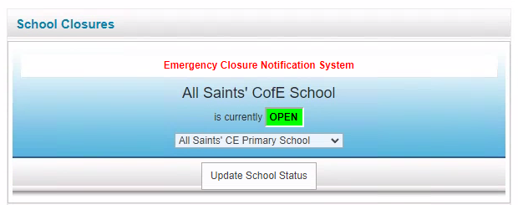

(Each school will only see “their” school in this list)

1. Click the “Update School Status” button
2. In the popup window enter the date and time that the school will close and then re-open:  
     
   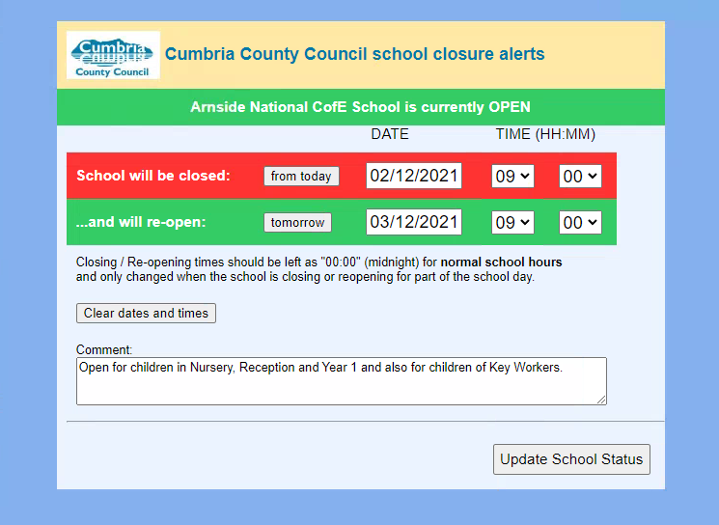
3. Finally click the “Update School Status” button at the bottom to confirm