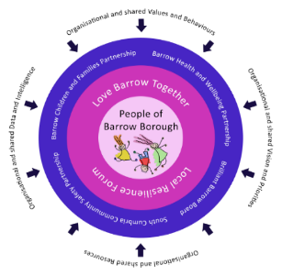
Barrow Local Resilience Forum
Community COVID Recovery Group
Emergency Items & Emergency Financial Support Pilot
Referral Form
Referring Organisation: ……………………………………………………………………………….

Referring Contact Name: …………………………………………………………………………….

Referring Contact Email Address: ……………………………….………………………………….

Referring Contact Phone Number: ………………………………………………………………….

Family/Individual Details:
Contact Name: …………………………………………………………DOB: ………………………

Address: ………………………………………………………………………………………………

Postcode: ……………………………… Telephone No. …………………………………………

No’s of children: …………………… Ages: ………………………………………………………

School(s)/College: …………………………………………………………………………………….

Name of GP/Practice: ………………………………………………………………………………

Tick which is/are required:

White goods:

Cooker Gas Electric

Washing Machine

Do the above require fitting/connection? YES NO

Fridge Freezer

Carpets/Flooring

Bed: Double Quantity Single Quantity

Mattress: Double Quantity Single Quantity

Financial Support (please see criteria): ……………………………………………………………
………………………………………………………………………………………………………….
Reason for Referral/Need: …………………………………………………………….
……………………………………………………………………………………………………………
……………………………………………………………………………………………………………
……………………………………………………………………………………………………………
……………………………………………………………………………………………………………
……………………………………………………………………………………………………………

How will this support benefit the family or individual and how this will prevent any situation escalating? ……………………………………………………………………………………………………….
………………………………………………………………………………………………………….
…………………………………………………………………………………………………………

COVID Impact (if applicable): ………………………………………………………………………

What other agencies are supporting? ……………………………………………………………..

…………………………………………………………………………………………………………

What other financial assistance is the family receiving eg assistance with gas/electric/food parcels and where else have you applied to for support?

…………………………………………………………………………………………………………

……………………………………………………………………………………………………………

Where would you normally try to access funding for this support and what is the reason for not accessing this time?

……………………………………………………………………………………………………………

……………………………………………………………………………………………………………

What further support is required such as budgeting, lifestyle etc.

……………………………………………………………………………………………………………

……………………………………………………………………………………………………………

Please make sure you have consent to pass details on.

PLEASE RETURN TO: smw.walney@gmail.com

Walney Community Trust is part of the Barrow Local Resilience Forum and as such will hold the families’ personal information in order to process the referral for practical assistance in the legitimate interest to ensure that the criteria for accessing practical support are met. We may share this information with other agencies who distribute assistance as part of the same scheme. We will keep this information for up to two years.

