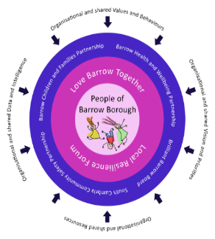
Barrow Local Resilience Forum
Community COVID Recovery Group
Emergency Items & Emergency Financial Support Pilot
General Criteria and Guide
Introduction
Barrow Local Resilience Forum has established a Community COVID Recovery Group to support communities in their recovery of COVID 19 in the Barrow Borough.
A key project for the Community COVID Recovery Group is a pilot to support families or individuals with emergency items and/or emergency financial support in the Barrow Borough.
In agreeing to support referrals the aim is to ensure that the referral process is easy to understand whilst at the same time ensuring sufficient information is gathered to promote value for money, fairness in decision making, public accountability and avoidance of fraud or misuse of money reflecting the highest standards of public sector financial management.
Criteria for Referrals
Support for referrals will only be considered on the referral form and from an organisation currently supporting the family or individual. This can be a School, charity, 3rd sector or statutory agency. Referrals will not be accepted by a family or individual.
Referral forms must demonstrate the need for support for the family or individual. This should identify whether the need is a result of a change in circumstances and/or supporting the need would prevent the current situation for the family or individual escalating.
Referral forms must demonstrate where else financial support is being provided and also explain the reason for applying to the fund instead of where funding is normally sought.
Where there is a request for emergency item(s) these will be sourced as appropriate by Walney Community Trust and supplied direct by Walney Community Trust or the supplier/installer.
Referral forms which are for financial support (excluding fuel vouchers) should be in exceptional circumstances. It should clearly demonstrate the risk without support for example the family/individual is at risk of eviction/homelessness. It should also be demonstrated all other avenues have been explored.
Money will not be given direct to a family or individual.
In all referral circumstances the family or individual should be willing to continue as necessary to engage with an appropriate organisation(s) or service(s).
How the Referral is dealt with
Referrals must be made on the referral form and sent to Walney Community Trust. The referee must obtain consent from the individual or family for details to be passed on.
Walney Community Trust will acknowledge receipt of the referral form. Each referral will be judged on its own merit and upon assessment of the referral form Walney Community Trust may contact the referee for more information.
Walney Community Trust will contact the family or individual to discuss and arrange the support as required.
Walney Community Trust will record all information on a database and use the information to ensure that there is a co-ordinated, multi-agency support for the family or individual and to avoid financial duplication by other organisations.
The information be used for monitoring and evaluation purposes demonstrating how the funding has been spent and outcomes achieved.
The Community COVID Recovery Group will continually monitor and evaluate the pilot process and report to the Barrow Local Resilience Forum.
The Community COVID Recovery Group reserves the right to amend the pilot referral process if necessary.

