Cumbria County Council

EBSA questionnaire
NAME/SCHOOL:

Prevalence of EBSA in your school
What is the number and percentage by year group and percentage as a whole population of children presenting with EBSA issues?

Year Group | Total | Percentage
Whole population | Total | Percentage

Have any of these EBSA young people also got other SEN (such as ASC/SLD/ADHD)

Child (a,b,c – no names) | SEN

Are there other children that you are aware of that may be EBSA but that are not showing up (i.e. recently home-schooled, regular missed attendance for certain subjects)?

On a scale of 1 – 10 how big an issue is this for you as a school where 0 is not at all and 10 would make it at the top of your priorities?

Now 0 ____________________________________________________ 10

Before pandemic 0 ____________________________________________________ 10

Please return to your named EP or carole.mulgrew@cumbria.gov.uk or sue.sanderson@cumbria.gov.uk Many thanks.

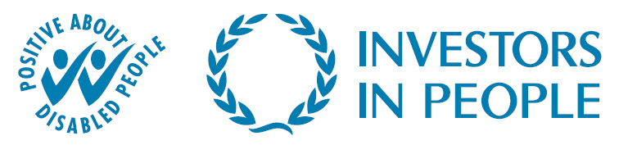
Serving the people of Cumbria

