Coronavirus (COVID-19) Testing Advice for Schools, Parents and Carers
Information from Cumbria County Council Public Health Team; 25 March 2021

Two different types of COVID-19 tests are now available:
- “Rapid” (LFD) tests are processed immediately in a plastic test kit and give results in 30 minutes. They are used to detect cases in people WITHOUT symptoms.
- “Full” (PCR) tests are processed in a laboratory, and give results within 48 hours. They are used to confirm suspected cases of COVID-19, for example in people WITH symptoms.

- Rapid (LFD) tests should NOT be used routinely on children of primary school age or younger
- People who test positive via a Full (PCR) test are exempt from Rapid (LFD) testing for 90 days
- Rapid (LFD) and Full (PCR) tests are NOT the same – see page 3 for more information

Situation | What you should do | Back to school?
Child NOT showing symptoms and NOT a close contact of a positive case | - Primary school child: no testing required  - Secondary school child: continue rapid testing twice a week  - Other adult household members: continue rapid testing twice a week | Attend school as normal
Child has a positive result from a Rapid (LFD) test supervised by a trained tester (e.g. at school or rapid test site) | - Child and household must stay at home for 10 days and follow the ‘stay at home’ guidance  - A follow-up Full (PCR) test is NOT required, and does NOT affect the isolation time | After completing 10-day isolation
Child has a positive result from a Rapid (LFD) test NOT supervised by a trained tester (e.g. at home) | - Child and household must stay at home  - Book a follow-up Full (PCR) test for the child as soon as possible, either online or by phoning 119 if no internet access  - Test site appointments must be booked in advance, and Full (PCR) tests are only available in the mornings (8am – 1pm) | Follow-up PCR positive: After completing 10-day isolation  Follow-up PCR negative:  End isolation and return to school straight away
Child has a positive Full (PCR) test | - Child and household must stay at home for 10 days and follow ‘stay at home’ guidance  - If anyone else in the household develops symptoms, DO NOT use a rapid (LFD) test – book a PCR test. If this is positive, that individual must extend their isolation time, as explained here  - As long as no symptoms, other adult household members can carry out rapid (LFD) testing, but MUST get a ‘full’ (PCR) test if an LFD is positive | After completing 10-day isolation, as long as they are well enough and no temperature for 48 hours.
Child has one or more of the 3 main symptoms of COVID-19 | - Whole household must stay at home and follow ‘stay at home’ guidance.  - Book a Full (PCR) test for the child as soon as possible, either online or by phoning 119 if no internet access  - Test site appointments must be booked in advance, and Full (PCR) tests are only available in the mornings (8am – 1pm)  - DO NOT USE A RAPID (LFD) test. A negative LFD test is not valid in individuals with COVID-19 symptoms. Child cannot return to school for 10 days unless they have a negative Full PCR test. | Full PCR positive: After completing 10-day isolation if well enough and no temperature for 48 hours.  Full PCR negative: Straight away, as long as not isolating for a different reason
Child is ill, but does NOT have one of 3 COVID-19 symptoms | - Primary school child: no testing required  - Secondary school child: continue rapid testing twice a week  - Other adult household members: continue rapid testing twice a week  - Children with vomiting or diarrhoea should remain off school for 48 hours after their symptoms have cleared  - Additional testing may be advised by the school in some instances, e.g. if there have been other positive cases in the last 10 days. | Continue attending school if well enough and no diarrhoea or vomiting for 48 hours
Child is a close contact of a person with a positive Full (PCR) test | - Child should stay at home for 10 full days following close contact with a positive case  - Other household members do not need to stay at home, unless they are also close contacts or are a positive case themselves  - No additional testing is required unless symptoms develop. Secondary school children and adults in the household should continue rapid testing twice a week.  - If child or other household member develops symptoms, DO NOT USE A RAPID (LFD) TEST. Instead, book a Full (PCR) test as soon as possible. | After completing their 10-day isolation period, provided child does not develop symptoms.  PLEASE NOTE: a negative test will NOT shorten the isolation period. Therefore there is no need for additional testing unless symptoms develop.
Child is a close contact of a person with a positive rapid (LFD) test supervised by a trained tester (e.g. at school or rapid test site) | - Child must stay at home for a full 10 days following close contact with case  - If child or other household member develops symptoms, DO NOT USE A RAPID (LFD) TEST. Instead, book a Full (PCR) test as soon as possible. | At end of 10-day isolation period, provided child does not develop symptoms
Child is a close contact of a person with a positive rapid (LFD) test NOT supervised by a trained tester (e.g. at home) | - Child should stay at home whilst awaiting the positive case’s follow-up Full (PCR) test to confirm the result  - Other household members do not need to stay at home, unless they are also close contacts or are a positive case themselves  - If the Full (PCR) result is positive, the child must complete their 10-day isolation period  - If the Full (PCR) result is negative, the child can end their isolation straight away. | Schools will keep families updated about the results of follow-up testing, and let them know when children can return

What is the difference between a rapid COVID-19 test and a full COVID-19 test?

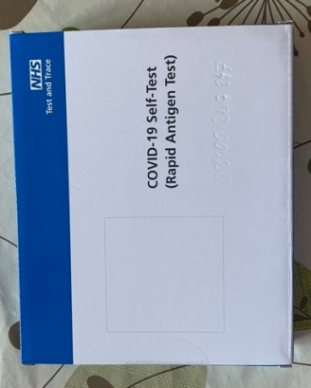
Rapid COVID-19 test
- Also known as a ‘Lateral Flow’ or ‘rapid antigen’ test.
- This is a plastic test kit which gives a result within 30 minutes. The photo shows what a home kit may look like.
- You can complete a rapid test at home, work or school. If you are an essential worker, local centres are available for supervised rapid tests.
- You need to follow the instructions carefully to give an accurate result.
- You record the results yourself following the online guidance
- This type of test is used for people WITHOUT symptoms of COVID-19 to see if they are infectious and able to transmit the virus to others.
- A positive rapid test means a person is likely to be infectious even though they do not have symptoms. The level of sensitivity is high enough to detect the vast majority of these cases.
- Rapid tests should NOT be used if a person has one of the 3 main symptoms of COVID-19. This is because a negative test cannot rule out infection.
- On advice from Public Health England (PHE), pupils in primary schools and children in nursery settings are not included in the rapid asymptomatic testing programme.
- PHE has advised that there are currently limited public health benefits to testing primary-aged pupils with lateral flow devices (LFD). In addition, primary-aged pupils, particularly younger children, may find the LFD testing process unpleasant and are unable to self-swab.
- Positive results from rapid tests taken at home need to be followed up by a Full (PCR) test. This is because the test needs to be verified if not supervised by trained testers.

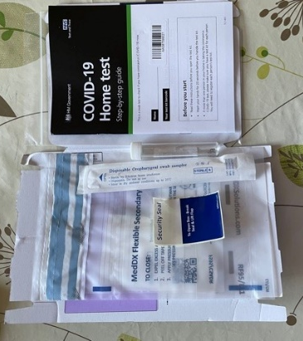
Full COVID-19 test
- A Full test (also known as a ‘PCR’ test) is processed in a laboratory.
- You can take the swab sample for a Full test at a local testing site or at home, but the sample will be sent off and you will receive the result within 48 hours. The photo shows what a home Full test kit looks like.
- This test is used to confirm suspected cases of COVID-19 e.g. where people are showing symptoms or have carried out a non-supervised/home rapid test
- It is more sensitive than a rapid test and will therefore identify cases, even when their level of infectiousness is lower.

For more information on testing, including how to book a test and access rapid testing kits, please see the Government’s COVID-19 testing advice.

