Health and Safety Update February 2021
Health and Safety Update February 2021 1
Risk Assessments 1
School COVID-19 Risk Assessments 1
RIDDOR reporting of COVID-19 1
First Aid 2
Fire Safety 2
Ventilation 2
Disinfecting using fog, mist, and other systems during the coronavirus pandemic. 3
Safety Update- Mac Floormaster SD Scrubber Dryer 3
References and Related documents 3
Contact details 4
Model COVID-19 Risk Assessment for Lateral Flow Antigen testing for Primary and Nursery Staff 5

Risk Assessments

School COVID-19 Risk Assessments
This school operations risk assessment should be regularly reviewed and the control measures already in place must be robustly reinforced and all staff reminded of the main controls to help minimise risks of viral transmission. This is equally important where attendance is limited to only vulnerable children and young people and the children of critical workers.
The latest version of the risk assessment can be found here: COVID-19 Schools Update 07 January

Lateral Flow Testing of Staff in Primary and Nursery Schools Risk Assessment
From the 25th January, Lateral Flow Testing has been made available to Primary and Nursery School settings to carry out twice weekly tests on staff. A model risk assessment is available to support the setting in the process from delivery to disposal. The model risk assessment can be found here
For those schools who have completed their LFT risk assessment, an extra row has been added to address changes in the Government guidance regarding taking LFT tests within 90 days of a positive result.

RIDDOR reporting of COVID-19
There is no requirement under RIDDOR to report incidents of disease or deaths of members of the public, patients, care home residents or service users from COVID-19.

HSE have issued additional guidance regarding what should be reported under the RIDDOR regulations regarding Coronavirus. Details can be found here

First Aid

First Aid Certificate Extensions
First Aid providers have resumed first aid training and assessment, however there are backlogs and limited availability of most courses for First Aid at Work and Emergency First aid at Work certificates requalification. Certificates that expired after 16 March 2020 can remain valid until 31 October or 6 months from the date of expiry whichever is later. All requalification training for these certificates should be completed by 31 March 2021. Face to Face First Aid training is currently not available through Traded Services.

The HSE published guidance on first aid which will support local risk assessments and provide guidance for first aiders. HSE Guidance – First Aid during Coronavirus Outbreak

Fire Safety
Regular fire safety checks must continue as normal where schools remain open. Consider making any adjustments to fire drills to allow for social distancing as appropriate.

Ventilation
Increased ventilation is one of several recommendations to reduce the risk of Coronavirus (COVID-19) transmission indoors and should therefore be used in conjunction with other government advice including working from home, social distancing, wearing of face coverings, good hygiene practices, workplace cleaning and test and trace.

The HSE has issued guidance on Ventilation and air conditioning during the coronavirus (COVID-19) pandemic. This guidance will help identify poorly ventilated areas and provide steps that can be taken to improve ventilation. Whilst the HSE recommends the use of Carbon Dioxide Monitors (CO2) as method to identify high CO2 levels leading to poor ventilation, Building Bulletin 101 Guidelines on ventilation, thermal comfort and indoor air quality in Schools states: The variety of applications for CO detection within educational establishments requires the selection of the most appropriate CO detector for each location. They must be installed and located in accordance with the manufacturer’s instructions.

Where possible ventilation should be provided by opening windows and allowing fresh air to circulate. You may leave internal doors open (to limit the need to use door handles and aid ventilation) but you must consider safeguarding issues and in respect of fire safety ensure that there is an agreed procedure in place to close these behind you at the end of the day or during a drill to mitigate fire spread.

- Mechanical ventilation systems – these should be adjusted to increase the ventilation rate wherever possible, and checked to confirm that normal operation meets current guidance (if possible, systems should be adjusted to full fresh air or, if not, then systems should be operated as normal as long as they are within a single room and supplemented by an outdoor air supply)
- Natural ventilation – opening windows (in cooler weather windows should be opened just enough to provide constant background ventilation and opened more fully during breaks to purge the air in the space).
- Fans and Air cleaning units - desk and ceiling fans can be used provided the area is well ventilated. NOTE: You would need to check your fire risk assessment if you are using desk fans and make sure they have been tested and are safe to use- avoid trailing cables
Heating should be used as necessary to ensure comfort levels are maintained particularly in occupied spaces.

If you have significant concerns that your heating/ventilation systems are not COVID safe you should seek further input from a competent Building Services Engineer in line with CIBSE guidance

Disinfecting using fog, mist, and other systems during the coronavirus pandemic.
HSE guidance on disinfecting premises during the coronavirus pandemic has been updated to include joint advice on risks to health that can be created by using walk-through spraying or misting systems.

Safety Update- Mac Floormaster SD Scrubber Dryer
We recently had a near miss incident reported by one of our schools where a battery in a MAC Floormaster SD500 Scrubber Dryer blew up. The equipment had been serviced but the battery had never been replaced since it was purchased in 2012. Thankfully no one was injured, and no damage was done. However please ensure that if you do have the same equipment, that you check if the batteries need to be replaced.

References and Related documents
Primary Schools Sharing Platform

Children of critical workers and vulnerable children who can access schools or Educational settings

Restricting attendance during the National Lockdown - Schools

Coronavirus (COVID-19) guidance for educational settings

Safe working in education childcare and children's social care

Contact details
The County Council provide access to the advice and support of the Health and Safety Team, Property Team, Public Health and Learning Improvement Service Whatever your query we encourage you to contact us for help and support full contact details for the Health and Safety team can be found on the Schools Portal.
Education Infection Control Call Centre | EducationIPC@cumbria.gov.uk | 0800 783 1968
DfE Helpline |  | 0800 046 8687
Health and Safety Team | healthandsafety@cumbria.gov.uk  Judith.chandler1@cumbria.gov.uk | 01228 221616  07584 534670
Property repairs Portal | Property Repairs Portal  Building.maintenance@cumbria.gov.uk | 01228 221106

Further support can be obtained from your Trade Union and Health and Safety Representatives.

Representative | Trade Union | Email address
Brendan McManus | NASUWT | fbmcmanus@icloud.com
Ann Kay | National Education Union | 81gil@tiscali.co.uk
Stephen Wilkinson | Association of School & College Leaders | stephen.wilkinson@ascl.org.uk
Brian Pearson |  | brian.pearson8@btinternet.com
Chris Brooksbank | National Education Union | chris.brooksbank@exec.neu.org.uk
Thomas Stewart | Unison | thomas.stewart@unisoncumbria.co.uk

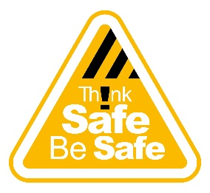

Model COVID-19 Risk Assessment for Lateral Flow Antigen testing for Primary and Nursery Staff
RA Title/ Reference | Model COVID-19 Risk Assessment for Lateral Flow Antigen testing for Primary and Nursery Staff | Activity Description | Provision of LFT testing for Primary and Nursery Staff
Assessment Date |  | Assessor Name
Assessment Team Members/ sign off |  | Planned Review Date | Will be reviewed to reflect any changes in National Guidance
Location(s) | Primary School sites across Cumbria | Number of People Exposed
Overall Residual Risk Level following implementation of effective control measures | Medium Risk (L2xS3) 6 | People Exposed | Primary School Employees  Persons with disability/ risk factors/ pre-existing medical conditions  New/ Expectant Mothers
Assessment Last Updated | 02/02/2021 | Is this an acceptable risk? | Yes/ No
Please call the DfE Coronavirus Helpline 0800 046 8687 if test kits have not arrived on 25th January 2021
Updated to include the continuation of LFT testing within 90 days of a positive COVID-19 PCR test
Hazard Description and How are people at risk | Potential  Risk before controls | Current Control Measures | Additional Control Measures (To be implemented) | Action Details by Whom by When | Residual Risk
Risk of transmission of COVID-19 due to incorrect storage and distribution of Home test kits | L4 x S3  Medium Risk | - How to Guide - Primary Schools EY LFD Testing  - COVID Coordinator and Registration Assistant appointed  - Test kits will be stored in a secure dry place indoors in temperatures between 2⁰ and 30⁰C  - The collection point for distribution of test kits is add location here  - The Registration Assistant will wear an appropriate face covering when distributing the test kits and ensure social distancing of 2 metres is maintained.  - All staff will sign for their test kits using the Test Kit Log  - Each member of staff will be provided with test kits to test twice weekly (3-4 days apart) tests  - Registration assistant will input and record test results into the School’s Test results register | Complete and print off  Test Kit Log and School’s Test results register  Type II Face mask recommended  Sufficient stock delivered to complete two tests per week per person for 3-4 weeks | COVID Coordinator Registration Assistant | L1 xS3  Low Risk
Risk of transmission of COVID-19 due to incorrect application of test | L4 x S3  Medium Risk | - All staff are given access to an Step by Step Guide for COVID-19 Self testing and other resources to follow the process for carrying out the self-test  - Staff are asked to carry out the test in the morning before attending school/nursery and notify the school/nursery of the results online or by phone.  - All staff are reminded of the importance of observing IPC guidance | Provide links to staff |  | L1 xS3  Low Risk
Risk of transmission of COVID-19 within 90 days of a positive PCR test | L3 x S3  Medium | - Staff are encouraged to take an LFD test regardless of whether they have tested positive previously. (See below) and Frequently asked questions |  |  | L2 x S3  Medium Risk
Risk of Data Breaches/ Quality – e.g. Incorrect communication of clinical data | L3 x S3  Medium | - All staff are provided with the School’s Privacy Notice regarding the processing of personal data.  - Controls to be followed in respect of data recording during the testing process | Complete and print off  Privacy Notice |  | L2 x S3  Medium Risk
Waste Management | L3 x S 3  Medium Risk | - All completed test kits can be disposed of in normal household waste. | Waste bag provided with kit |  | L1 x S3  Low Risk

Relevant Safety Procedures and National/ Local Guidance Links |  | Primary Schools Sharing Platform
Assessment Conclusion |  | Providing the stated control measures are implemented and adhered to, the risk of contracting most viral infections including COVID-19 can reduce to a manageable level in normal circumstances.

The role of the COVID-19 Coordinator
- Communicating with stakeholders
- Ensuring staff have the right instructions and that they sign for the test kits using the test kit log
- Reporting incidents and carry our risk management
- Storing and reporting any required data
- Re-order tests when required (advice on how to do this will follow from NHS Test and Trace)

The role of the Registration Assistant (can be the same person)
- Distributing the correct number of test kits to staff and managing the schedule for the distribution of the next sets of kits
- Inputting test results from staff into the school/nursery Test results register
- Send out reminders to participants to communicate their results online or by phone and to the school/nursery
- Responding to staff questions

Should I still take part in the asymptomatic testing programme if I have recently tested positive for COVID-19?
If staff have recently (within 90 days) tested positive for COVID-19, they are likely to have developed some immunity to the virus. However, we are not yet certain
whether individuals can still spread the virus to others. Given the current prevalence of the virus and the pressing need to reduce transmission, we encourage staff to take an LFD test regardless of whether they have tested positive previously as this is a good indicator of high viral load, and therefore infectiousness. If staff have recently tested positive for COVID-19, they should complete their period of isolation before returning to school or nursery and resume twice-weekly testing. If symptoms (other than cough or a loss of, or change in, normal sense of taste or smell) persist, this could be longer than the normal 10-day self-isolation period for confirmed cases. This is described in stay-at-home guidance for households with possible or confirmed coronavirus (COVID-19) infection.
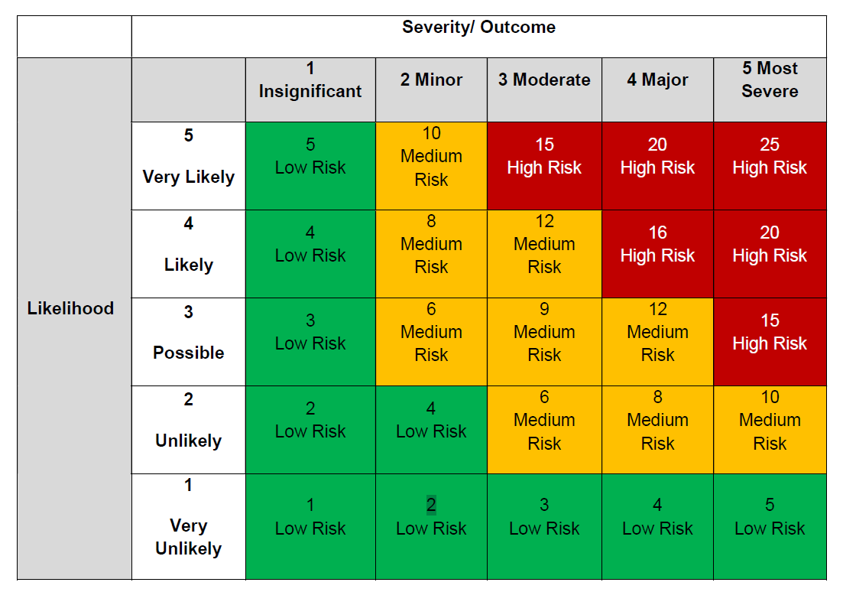
Severity
- Insignificant No Injury
- Minor Minor injuries requiring first aid
- Moderate First Aid/RIDDOR reportable incident
- Major Serious injury/hospital attendance
- Most Severe Disabling injury, long term ill health

Likelihood
- Very unlikely e.g. 1 in 1000,000 chance of it happening
- Unlikely e.g. 1 in 100,000 chance of it happening
- Possible e.g. Likely to occur during standard operations
- Likely e.g. has been known to happen before
- Very likely e.g. it’s almost certain that something will happen

15-25 Unacceptable.
- Stop activity and make immediate improvements
6-12 Tolerable
- Look to improve within a specified timescale
1-5 Acceptable
- No further action, but ensure controls are maintained

The role of the COVID-19 Coordinator
- Communicating with stakeholders
- Ensuring staff have the right instructions and that they sign for the test kits using the test kit log
- Reporting incidents and carry our risk management
- Storing and reporting any required data
- Re-order tests when required (advice on how to do this will follow from NHS Test and Trace)

The role of the Registration Assistant (can be the same person)
- Distributing the correct number of test kits to staff and managing the schedule for the distribution of the next sets of kits
- Inputting test results from staff into the school/nursery Test results register
- Send out reminders to participants to communicate their results online or by phone and to the school/nursery
- Responding to staff questions
whether individuals can still spread the virus to others. Given the current

