previous
The | OVERVIEW  Model risk assessments (School Operations and School Premises) and supporting guidance on operating procedures have been developed for maintained schools and settings in consultation with our Trade Union colleagues and relevant service areas. Each maintained setting should undertake their own risk assessment following this format – Cumbria County Council, as the employer in the above settings will support and guide Governing Bodies and School Leaders to manage a planned and safe gradual return to school but recognise that local decisions to open or not MUST follow a risk-based approach appropriate to the resources and capacity of each individual setting. Other types of schools are welcome to use these models to help their own planning and risk assessment approach but must ensure that they prioritise their own employer’s health and safety management procedures.  This document is a template to be used to help Governing Bodies and Headteachers develop and tailor a site-specific risk assessment in relation to COVID-19. Below is a list of potential of hazards within our premises and the recommended control measures which apply to the majority of settings to aim to help you manage risks to the lowest possible level. Controls shown follow current available guidance and best practice.  Headteachers and Governing Bodies are responsible for monitoring the advice and guidance available, ensuring risk assessments and safe working practices are updated where applicable and cascaded through to employees. They must ensure that compliance is monitored, and any emerging issues addressed appropriately.  You should refer to the CCC guidance provided to accompany this model as well as referenced national guidance. PLEASE NOTE that your risk assessments should outline YOUR agreed control measures following your local planning processes – any additional control measures you identify as being required should be added to the additional controls column, along with who is responsible and a timescale.  All employees working within the premises should receive site specific information on the controls implemented within their workplaces.  Help and support with the development of your risk assessment is available through the County Council’s Corporate Health and Safety Team at healthandsafety@cumbria.gov.uk .  Please note that the Local Authority is liaising with contractors working on its behalf to ensure that they are undertaking effective liaison with occupiers BEFORE attending site – contractors are asked to provide key information in relation to how they are managing infection control.  This risk assessment refers to current national guidance, which is listed at the end of this document, and within accompanying guidance.  Following a request from the Education Planning Group, we have reviewed and updated the Model COVID-19 risk assessment to reflect recent changes to the Government guidance regarding Lockdown and Clinically Extremely Vulnerable Staff.  05/01/2021 This risk assessment has been updated following the latest Government announcement for Cumbria moving into National Lockdown and new arrangements that will affect some schools. This does not replace your existing risk assessment but can be used to review/amend your existing controls. All changes in red.  RA reference Enter your RA ref Activity description COVID-19 - Infection prevention and control – SCHOOL OPERATIONS  Assessment date Enter date Assessor name Headteacher/Delegated Lead  Assessment team members List contributors to RA Planned review date Enter date (reviewed to reflect any changes in National Guidance)  Location Name of school Number of people exposed Enter no. exposed  Overall Residual risk level following implementation of effective control measures Medium risk Recognising the national COVID Alert Level has been raised from 4 to 5. There are currently very high rates of community transmission, with substantial numbers of COVID patients in hospitals and in intensive care. National lockdown in place from 5th January 2021 (review anticipated mid Feb half term). Professionals in Public Health, Health and Safety and Services will continue to work closely with recognised Trade Union Colleagues to promote safe working procedures, suitable safety controls and limit risk. All Primary and Secondary Schools are closed except for Critical Workers and Vulnerable children People exposed All employees Pupils Visitors Contractors Members of the public Vulnerable children/adults Persons with pre-existing medical conditions First aiders New/expectant mothers  Assessment last updated Enter date Is this an acceptable risk? Yes/ No  Hazard description and how people are at risk Current Control Measures (those that are in place) Potential risk Additional Control Measures (to be identified and implemented) Action details by whom by when Residual risk  Hazards in relation to staffing and daily operation All schools have access to Public Health Weekly Outbreak Control Report which provides and overview of the current COVID-19 situation in Cumbria based on available local and national data Further detailed information can be found at The Cumbria Observatory Information posters highlighting the symptoms of COVID19 are placed throughout the premises. - Ongoing communications (posters, emails inductions, briefing, toolbox talks) have been provided to all employees and/or regular visitors. - Staff report prior to coming into school if they are experiencing any of the following symptoms: a high temperature, a new continuous cough, loss of taste or smell. - All staff responsible for ensuring that they are fit and well to attend work. - All staff adhere to any instructions, advice, guidance and site rules provided to them including hand and respiratory hygiene and maintaining social distancing - PHE COVID-19 Testing guidance communicated to staff - Staff are responsible for ensuring that they are up to date with their own routine immunisations. - Individual Risk Assessments carried out for staff who were previously shielding. - Referrals are made to occupational health as appropriate. - Normal pre-employment procedures followed. - Absence/self-isolation cases due to COVID-19 (suspected or confirmed) are reported via the normal reporting procedures. - Normal absence and wellbeing reporting procedures are followed. - Overnight domestic educational visits are not permitted. - Staff (and pupils over the age of 16 where appropriate) are encouraged to download the NHS COVID-19 app and follow the Government guidance: Use of the NHS COVID-19 app in education and childcare settings - Staff and pupils will have their own frequently used equipment such as pens and pencils, which should not be shared with other people. 10 Medium Risk L5 x S2 All staff to be advised that they must inform their manager if they or anyone in their household have been advised to self-isolate, before entering the workplace. Lateral flow testing to be carried out in line with Government Guidance (Secondary Schools) to help detect asymptomatic cases. Whilst in the educational setting it is recommended that the ‘trace’ function of the app is paused. Arrangements to be in place to ensure that classroom-based resources that are shared are cleaned regularly or rotated where possible. (DfE/School- DfE currently deploying testing kits to secondary schools for use post lockdown. 6 Medium Risk L3 x S2  Hazards relating to visitors coming into the setting - All non-essential visits to schools have been stopped - Parents/carers are not allowed in the setting unless absolutely necessary and appointment made with Headteacher - Supply teachers, peripatetic teachers and other temporary staff are permitted to move between schools. - The setting will maintain records of all visitors to support the NHS Test and Trace programme. 10 Medium Risk L5 x S2 Visits to the setting to be restricted to those that are absolutely necessary. Supply teachers etc. to complete risk assessment for specialist visits prior to visit. Student work placements are permitted at the discretion of the Headteacher/Manager. Where face-to-face visits are authorised the Headteacher/Manager has the discretion of requiring all visitors to wear face coverings where social distancing cannot be managed.  Hazards relating to lack of social distancing - Younger children (Early Years) will be kept separate from other groups within the school but will not be expected to distance within their group. - Headteacher/SLT will determine arrangements to manage pupil groups dependant on the school circumstances with the aim of minimising contact between individuals and maintain social distancing wherever possible as detailed in current Government guidance - Children will be supported to maintain social distancing and encouraged not to touch staff where possible. - All staff with younger children and children with complex needs or who need close personal care will try to maintain their distance and minimise time spent within 1 metre of anyone. - Secondary staff will try to maintain a 2-metre distance between themselves, their colleagues and the pupils where possible, limiting time spent within 1 metre of anyone. - School assemblies and collective worship with more than one group will not be held. - Movement around the school will be kept to a minimum and where possible break times and lunch times will be staggered to prevent busy corridors, entrances and exits. - Special arrangements will be considered for staff who work across groups (bubbles) across the school e.g. cover supervisors and PPA staff. - Social distancing limits occupancy in offices and staff rooms – staff instructed to remain with cohort/groups and not mix with others. 10 Medium Risk L5 x S2 Headteacher/Manager in Early Years/Primary settings has the discretion of requiring all staff and visitors to wear face coverings in communal areas. Refer to new Government Guidance Critical workers and vulnerable children who can access schools or educational settings  Setting is classified as National Lockdown High or Very High COVID Alert Level and during National Lockdown - Face coverings to be worn by adults and pupils in year 7 and above when moving around the setting, such as in corridors and communal areas where social distancing cannot be maintained. - Instructions are provided regarding the safe use, removal, storage and disposal of face coverings 10 Medium Risk L5 x S2 Where necessary identify those individuals, who are exempt from wearing face coverings. The setting should ensure they maintain a small contingency supply of masks to ensure that anyone without a face covering can be given one. Download exemptions badges for those who are exempt Face Coverings, when to wear one, exemptions and how to make one  Lack of supervision/ management of groups to comply with current guidance Unable to maintain staffing levels due to infection or isolation - Staffing plan in place to ensure safe staffing levels are achievable, agreed, established and monitored appropriate to group sizes/pupil needs and the activities required. Ratios based on appropriate risk assessment. - Timings of arrivals, lessons and activities in place. - Employees advised of and offered vaccination cover (as this becomes available and appropriate). 10 Medium Risk L5 x S2  SEND/Behaviour management issues Child or young person requiring one-to-one support - Pupils - individual healthcare plans in place for pupils who require them. - Pupils - separate individual risk assessment/healthcare/ behaviour management plans and external support accessed where required to determine if the child or young person can safely attend where one-to-one care or support is not available for them. 10 Medium Risk L5 x S2  Hazards relating to performance activities such as music, dance and drama - Group numbers will be limited to ensure that social distancing measures can be observed. - Where practical, performances will take place outdoors. - Where performances are indoors, rooms will be well ventilated. 10 Medium Risk L5 x S2 Risk assessments to be developed for individual performances.  Hazards relating to school activities outside - Pupil/staff cohorts remain together at all times. - Outside spaces to be used for learning where possible. - Outdoor play equipment to be taken out of use with access prevented by means of suitable barriers OR cleaned regularly, before and after use and between groups. - Where possible outdoor sports will be prioritised. - Any equipment used will be subject to thorough cleaning. 10 Medium Risk L5 x S2 Large indoor spaces can be used maximising natural ventilation flows and ensuring distancing between pupils and good hygiene practices  Hazards in relation to lack of cleaning/ hygiene/waste management Inadequate cleaning and hygiene processes - Cleaning will be carried out in accordance with the current guidance: COVID-19 Cleaning in non-healthcare settings - Suitable signage and visual instructions displayed as required. - Local school-specific risk assessments will identify additional control measures to be followed to prevent cross contamination and infection, e.g. cleaning/kitchen Ras. - When delivering personal/intimate care, staff will wear the normal PPE required as detailed in individual healthcare plan. - Supplies of hand sanitiser available at entrance points and where there are no sinks. - Staff and pupils instructed to wash their hands upon entry to the building, returning from breaks, when changing classrooms, before and after eating, and after they have been to the toilet. - Hand hygiene procedures widely promoted and adhered to with provision/promotion of the use of sanitising hand gel (60% alcohol) as required for those without easy access to suitable handwashing facilities. - Enough handwashing facilities are available sinks, soap and towels. - Where toilet facilities are shared by more than one group, cleaning will be completed between different group usages. 10 Medium Risk L5 x S2 Pupil allergies identified where applicable. Ongoing and regular reminders - promotion of developing national guidance in relation to COVID-19. Obtain copies of safety data sheets for any sanitising products in use. Ensure there are enough waste bins close to wash stations. Where available electric hand dryers can be reconnected.  Transport and travel Reducing the risk of infection on dedicated school transport and public transport and during organised educational visits - Safe transport guidance promoted to staff and parents. - Protocols in place for drop off and pick up. - All offsite school activities suspended. - A Transport risk assessment is available for SEND children. - Transport providers will follow appropriate controls as highlighted in their code of practice. - Schools will record how each person, pupils and staff, travels to and from school (to support NHS Test and Trace). - Pupils who have travelled to school on public transport, wearing face coverings, will be instructed not to touch their face covering during use or when removing them, they will be asked to wash their hands on arrival and dispose of any temporary face coverings into a lidded bin where available (or into a bag and transferred to the bin), or place reusable face coverings into a plastic bag to take home with them. They will then need to wash their hands again. - Where relevant transport for SEND pupils will be subject to individual risk assessment. - Staff and pupils over the age of 11 will still be required to wear face coverings when using public transport – coronavirus-covid-19 safer travel guidance for passengers face-coverings - Overnight domestic educational visits are not permitted. - Individual risk assessments for non-overnight domestic educational visits will include any additional protection measures that may be required. - Local Authority schools must make use of the EVOLVE Notification and Approval System. They will be expected to follow the normal process of risk assessment and log all educational visits onto the EVOLVE database. 10 Medium Risk L5 x S2 Where possible staff should avoid/limit the use of public transport. If this is unavoidable Government guidance is that you need to use a face covering. Staff and pupils are advised to follow the Government Guidance COVID-19 safer travel guidance for passengers Check EVOLVE site for further advice and updates on educational visits. Headteacher  Hazards in relation to pupil and staff wellbeing and mental health Preventing ill health due to anxiety and work-related stress - School Stress risk assessment in place. - Where staff report work-related issues, individual stress risk assessment will be carried out in line with HSE guidance. - Staff will be referred to occupational health as early as possible. - Good communication measure in place and maintained with staff. - All staff aware of their responsibilities to report safety concerns, ill health, damage, defects, accidents or incidents in line with existing school policy. 10 Medium Risk L5 x S2 The Local Authority have produced the following guidance Coronavirus – getting back to school: Supporting emotional wellbeing and learning  Hazards in relation to staff and pupils deemed high risk due to underlying or pre-existing health conditions Pregnancy, asthma etc. - Staff and pupils who have previously been identified as ‘Clinically Extremely Vulnerable’ must follow the current Government guidance during the current National Lockdown period. - Those staff who are at a higher risk due to their underlying or pre-existing health conditions and have been prescribed medication, should where possible carry their prescribed medication with them at all times. - Follow the Government Coronavirus (COVID-19) advice for pregnant employees - Individual risk assessments will be completed for all female staff who have given notification that they are pregnant 10 Medium Risk L5 x S2 Staff who may have increased risk from COVID-19 must raise their concerns with the Headteacher who will explain the measures the school is putting in place to reduce the risk, e.g. for Pregnancy, Asthma etc. If the person cannot undertake their normal duties or are unable to work from home contact your HR provider to discuss any reasonable adjustments. Pupils who have been identified as CEV are advised to stay at home.  Hazards in relation to managing incidents and emergencies First aid/accidents/ incidents/emergencies Staff or pupil becoming unwell with COVID-19 symptoms whilst on site - Suitable follow-up procedures to be taken following potential infection exposure incidents (in line with current Public Health England and updated HSE RIDDOR guidance circulated to schools). - Suitable first aid kits in place, updated to include (where already not supplied) IIR surgical masks, rubber gloves and hand sanitisers for close contact first aid treatment. - At least one person with a paediatric first aid certificate will be on the premises at all times when children aged between 0-24 months are present. - School Emergency Plan/Crisis Management Plan in place. - All staff aware of their responsibilities to report safety concerns, ill health, damage, defects, accidents or incidents in line with existing school policy. - Where a child develops symptoms whilst at school, they will be moved to a room where they can be isolated from others until they can be collected. Where possible the room should be well-ventilated by opening a window. Adult supervision will be provided at all times by a trained member of staff. - Where there is no room to isolate, the child must be moved to an area where they can maintain a 2M distance. - A separate toilet will be used if the child/adult needs to use the bathroom, which will be cleaned and disinfected in line with the current guidance: COVID-19 Cleaning in non-healthcare settings ,before anyone else can use it. 10 Medium Risk L5 x S2 FAW or EFAW certificates that expired after 16 March 2020 can remain valid until 31 October 2020 or 6 months from date of expiry, whichever is later. All requalification training for these certificates should be completed by 31 March 2021. If first aiders are unable to access annual refresher training face-to-face during the pandemic, online refresher training should be undertaken to keep their skills up to date. Setting will make ‘best endeavours’ to have PFA on site for children aged 2-5.  Hazards in relation to eating and safe welfare facilities - Timings in place to ensure safe management of break and lunchtimes. - Adequate welfare facilities provided for all staff and pupils. - Staff and pupils reminded to wash hands before and after eating. 10 Medium Risk L5 x S2 Staff to be encouraged to remain on site during lunch breaks. Where this is not possible staff are reminded to maintain social distancing whilst off site.  Hazards due to the lack of suitable PPE Where carrying out close personal care tasks and physical restraint and unable to maintain 2m social distancing measures - Staff and pupils to be fit/well to attend setting. - Local risk assessments/individual healthcare plans/ behaviour management plans reviewed and followed to identify PPE requirements in line with current guidance. - PPE to be fit for purpose/approved specification. - Where PPE/RPE is provided, staff provided with training and instruction in its use. - PPE will be provided if a child or member of staff becomes ill with symptoms of COVID-19 and the staff who are caring for them are unable to maintain the 2m social distance. PPE measures will include a Type II Fluid Resistant Surgical Mask, apron and gloves. - Local compliance to be monitored by Headteachers as far as reasonably practicable. - Guidance provided to staff in relation to the use and wearing of their own face coverings. - PPE that is normally needed for dealing with an individual child will be available as per individual healthcare plan. 10 Medium Risk L5 x S2 Contact the call centre to order PPE 0800 783 1967 (Manned from 09:00 – 17:00 Monday to Friday, and 10:00 – 14:00 Saturday and Sunday)  Training - All staff will receive appropriate training and updates on the measures contained within this risk assessment. 10 Medium Risk L5 x S2  Monitoring - Current relevant national guidance will be monitored and followed. - Risk assessment and its implementation will be monitored by the SLT on at least a weekly basis, and will take account of wellbeing survey information, weekly LA infection reports, and any critical incident reviews. - Regular feedback will be provided to staff on the risk assessment reviews. 10 Medium Risk L5 x S2  Dissemination - This document will be provided to all staff and be available on request/website.  Assessment conclusion Providing the stated control measures are implemented and adhered to, the risk of contracting most viral infections can reduce to a manageable level in normal circumstances. Compliance with this risk assessment should be monitored and reviewed to ensure control measures remain effective.

To be completed by the Individual undertaking the risk assessment:

Name: Job Title:

Signature: Date:

To be completed by the Head teacher:

I consider this risk assessment to be suitable and sufficient to control the risks to the health and safety of both employees undertaking the tasks involved and any other person who may be affected by the activities.

Name: Job Title:

Signature: Date:

Links to guidance
Staff, pupils and others

Those who are clinically vulnerable, or who are living with someone who is, should follow protective measures guidance.
Children of critical workers and vulnerable children who can access schools or educational settings
Updated Public Health advice for educational settings
Conducting a SEND risk assessment during the Coronavirus outbreak
Guidance on hand cleaning
Kids life skills – self-care- going to the toilet
Government guidance for full opening of Schools during Coronavirus outbreak
Government Guidance Face coverings in Education
Government guidance on shielding and protecting extremely vulnerable persons from COVID-19
https://www.gov.uk/government/publications/coronavirus-covid-19-early-years-and-childcare-closures/coronavirus-covid-19-early-years-and-childcare-closures
https://www.hse.gov.uk/coronavirus/first-aid-and-medicals/first-aid-certificate-coronavirus.htm
https://www.gov.uk/guidance/working-safely-during-coronavirus-covid-19/performing-arts
Coronavirus (COVID-19) advice for pregnant employees

Personal Protective Equipment – PPE

PHE guidance to putting on and removing (Donning and Doffing) PPE

Travel
Safer travel guidance for passengers

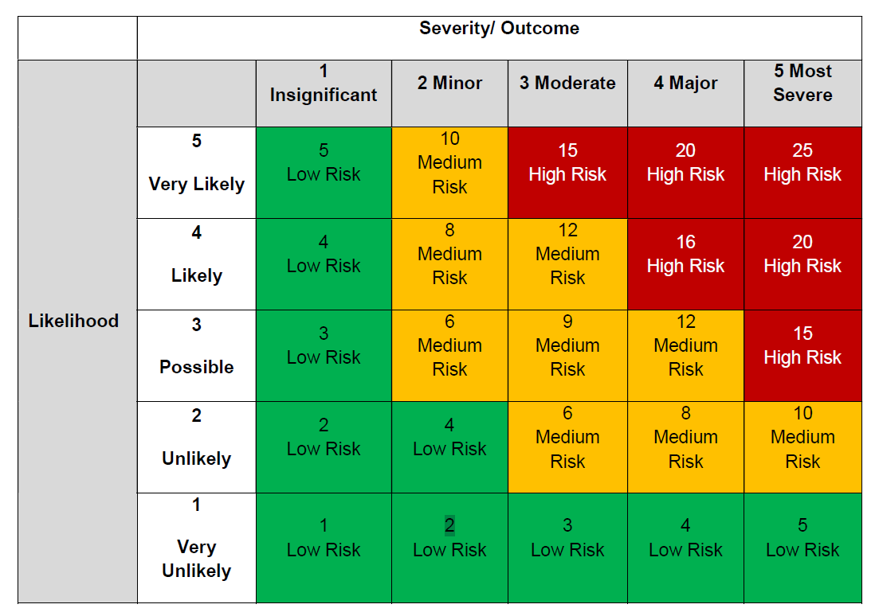

Guidance provided by the HSE, The Royal College of Obstetricians & Gynaecologists and the Royal College of Midwives

