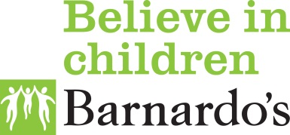

Eden

**Christmas Open Times**

|  |  |
| --- | --- |
| **Christmas Eve**  **Thursday** | **9am – 3pm** |
| **Christmas Day**  **Friday** | **CLOSED** |
| **Monday 28th**  **Boxing Day Bank Holiday** | **CLOSED** |
| **Tuesday 29th** | **9am – 5pm** |
| **Wednesday 30th** | **9am – 5pm** |
| **New Year’s Eve**  **Thursday** | **9am – 5pm** |
| **New Year’s Day**  **Friday** | **CLOSED** |

Please contact **Eden 0 – 19 Child and Family Support Service** on **01768 899901** to discuss how we may be able to support you and your child to fully access and enjoy our activities.

**In an emergency please use our SPA number:**

**07740 516 210**

We have a small amount of money available to support families in the event of an emergency should they be in need of it. Please send an email to **enquiries.eden@barnardos.org.uk** to request a blank grant request form and return to the aforementioned email. Please note that completion doesn’t guarantee the amount recommended as the fund is modest.

**If you have any questions, please don’t hesitate to get in touch with us via the email above.**

Eden